MINISTRY OF EDUCATION AND TRAINING



**Capstone Project Document**

**Easy Chemistry**

|  |  |  |
| --- | --- | --- |
| EC Team | | |
| Group members | Pham Thi Minh Ngoc | 01952 |
|  | Bach Thi Le Thanh | SE02282 |
|  | Nguyen Thuy Hanh | SE02823 |
|  | Tran Anh Tuan | 01763 |
| Supervisor | Mr. Bui Dinh Chien | |
| Capstone Project Code | EC | |

**Hanoi, 12th December, 2014**

Acknowledge

|  |
| --- |
| The success of this project thanks to Mr. Hoang Trong Tue, Mr. Lai Cong Thanh, Mrs. Tran Thi Nga, Mr. Nguyen Tung Nam and specially our instructor Bui Dinh Chien. We also thanks to other friends for their help.  They are people who put many efforts in supporting. Because of them, our project could have a wonderful completion. Besides, we could earn a huge knowledge and create an application which is beautifully designed, simple to use and friendly. |

.

Table of Contents

1 Introduction 9

1.1 Project information 9

1.2 Project members 9

1.3 Our proposal 10

1.4 Product 10

1.4.1 Main Application 10

1.4.2 Administration Application 10

2 Software project management 11

2.1 Software development process 11

2.2 Project Organization 12

2.2.1 Organizational Structure 12

2.2.2 Project Team 12

2.2.3 External Interfaces 14

2.3 Project schedule 15

2.4 Project Millstones 16

2.5 Project Deliverables 16

2.6 Resource 18

2.6.1 Human resource 18

2.6.2 Non-human resource 18

2.7 Risk Management 18

2.7.1 Schedule Risk 18

2.7.2 Scope Risk 19

2.7.3 Resource Risk 19

2.8 Communication Management 20

2.8.1 Communication between Team Members 20

2.8.2 Communication with Supervisor 20

2.8.3 Communication with iOS Technical Supporters 20

2.8.4 Communication with and Chemical Data Consultant 20

2.9 Configuration Management Process 21

2.9.1 CI Identification and Naming Convention 21

2.9.2 Project Infrastructure 22

2.9.3 Version Numbering Rule 24

2.9.4 Directory structure 25

2.9.5 Coding convention 26

2.9.6 Other CM Rules 26

3 Software Requirement Specification 27

3.1 Introduction 27

3.1.1 Purpose 27

3.1.2 Scope 27

3.2 Overall description 27

3.2.1 Product Function 27

3.2.2 User Characteristics 29

3.2.3 Constraints 30

3.3 Important Chemistry Logic and Knowledge 31

3.3.1 Some Basic Knowledge and Important Definition 31

3.3.2 Metals 31

3.3.3 Non-metallic 32

3.3.4 Oxides 32

3.3.5 Bases 33

3.3.6 Acids 33

3.3.7 Salts 33

3.3.8 Ammoniac 34

3.4 Specification Requirement 35

3.4.1 Functionality 35

3.4.2 Non-functional Requirements Specification 52

4 Software Design Specification 54

4.1 Architecture Design 54

4.1.1 Architecture Representation 54

4.1.2 Architectural Goals and Constraints 56

4.1.3 Application Logical View 56

4.1.4 Chemical equation balancing logic 76

4.2 Application Process View 79

4.2.1 Balance chemical reaction 79

4.2.2 Search for Chemical Compound 80

4.2.3 View periodic table 80

4.2.4 View element 81

4.2.5 Change temperature 81

4.2.6 View blocks of element 82

4.2.7 View searched history 82

4.2.8 View balanced history 83

4.2.9 About 83

4.2.10 View Fun Fact List 84

4.2.11 View Fun Fact detail 84

4.3 Server Process View 85

4.3.1 Login 85

4.3.2 Logout 86

4.3.3 Edit Profile 87

4.3.4 View Account List 88

4.3.5 Add Account 89

4.3.6 Modify Account 90

4.3.7 Delete Account 91

4.3.8 View Fun Fact List 92

4.3.9 Add Fun Fact 93

4.3.10 Modify Fun Fact 94

4.3.11 Delete Fun Fact 95

4.4 Data Design 96

4.4.1 ERD 96

4.4.2 Table Diagram 98

4.4.3 Element table 100

4.4.4 ElementPeriod table 101

4.4.5 ElementGroup table 102

4.4.6 ElementBlock table 102

4.4.7 ElementDescription table 102

4.4.8 SupplyRisk 102

4.4.9 Occurrence 103

4.4.10 ChemicalCompound table 103

4.4.11 ChemicalCompoundState table 104

4.4.12 ChemicalCompoundDescription table 104

4.4.13 SearchedCompoundHistory 105

4.4.14 BalancedEquationHistory 105

4.4.15 Account 105

4.4.16 Fun Fact 106

4.5 Screen Design 107

4.5.1 Screen Flow 107

5 Software Source Code 129

5.1 Main application 129

5.2 Administration application 130

6 Software Testing 131

6.1 Test Plan 131

6.1.1 Requirement for Test 131

6.1.2 Test Strategy 133

6.1.3 Test Type 133

6.1.4 Test stage 135

6.2 Resource 136

6.2.1 Human Resource 136

6.2.2 Test Management 136

6.3 Test Environment 138

6.3.1 Hardware 138

6.3.2 Software 138

6.4 Test milestones 139

6.5 Deliverables 140

6.6 Test Report 141

7 User Guide 143

7.1 Installation Guide 143

7.1.1 English Version 143

7.1.2 Japanese Version 143

7.2 User Manual 144

7.2.1 Main Application 144

7.2.2 Administration Application 149

8 Conclusion 156

Future works 156

9 Appendixes 157

9.1 Meeting minutes 157

9.2 Progress Report 159

9.3 Q&A 161

9.4 Database 161

10 Reference 162

Definition and acronyms

|  |  |  |
| --- | --- | --- |
| Acronym | Definition | Note |
| EC | Easy Chemistry |  |
| CI | Configuration Item |  |
| CM | Configuration Management |  |
| PM | Project Manager |  |

# Introduction

## Project information

|  |  |
| --- | --- |
| * Project name: | Easy Chemistry |
| * Project code: | EC |
| * Project type: | Mobile Application |
| * Project Category: | New development |
| * Business domain: | Chemistry knowledge |
| * Project manager: | Pham Thi Minh Ngoc |
| * Timeline: | 5th September, 2014 to 19th December, 2014 |

## Project members

* Supervisor:

|  |  |  |
| --- | --- | --- |
| Full name | E-mail | Title |
| Bui Dinh Chien | chienbui@gmail.com | Lecturer |

* Team member:

|  |  |  |  |
| --- | --- | --- | --- |
| Full name | Roll number | E-mail | Position |
| Pham Thi Minh Ngoc | 01952 | ngocptm01952@fpt.edu.vn | Leader |
| Bach Thi Le Thanh | SE02282 | thanhbtlse02282@fpt.edu.vn | Member |
| Nguyen Thuy Hanh | SE02823 | hanhntse02823@fpt.edu.vn | Member |
| Tran Anh Tuan | 01763 | tuanta01763@fpt.edu.vn | Member |

## Our proposal

Chemistry is not really a hard subject in school, but a lot of people feel it a little bit hard to study. It’s because they lack of basic knowledge of chemistry, if you lost the core knowledge of chemistry then you lost it all.

Therefore, Easy Chemistry Application was developed as a box of basic knowledge about chemistry on smart phone such as some detail about chemical element, chemical compound, the Periodic table, and some fun facts about chemistry. This application is not only provides the basic information of chemistry, but also help users balancing the chemical reactions.

## Product

The product of our project includes 2 separated parts that using 2 different databases. They are Main **Application** and **Administration Application**.

### Main Application

**Main Application** is an iPhone application whose name is Easy Chemistry (Hóa học không khó). This application has 6 main features below:

* Balance Chemical Reaction
* Search Chemical Compound
* View Periodic Table
* View Fun Facts List
* View History
* About

### Administration Application

**Administration Application** is a small windows form tool support admin in managing server database. This application has 5 main functions below:

* Login
* Logout
* Edit Profile
* Manage Fun Facts
* Manage Accounts

# Software project management



## Software development process

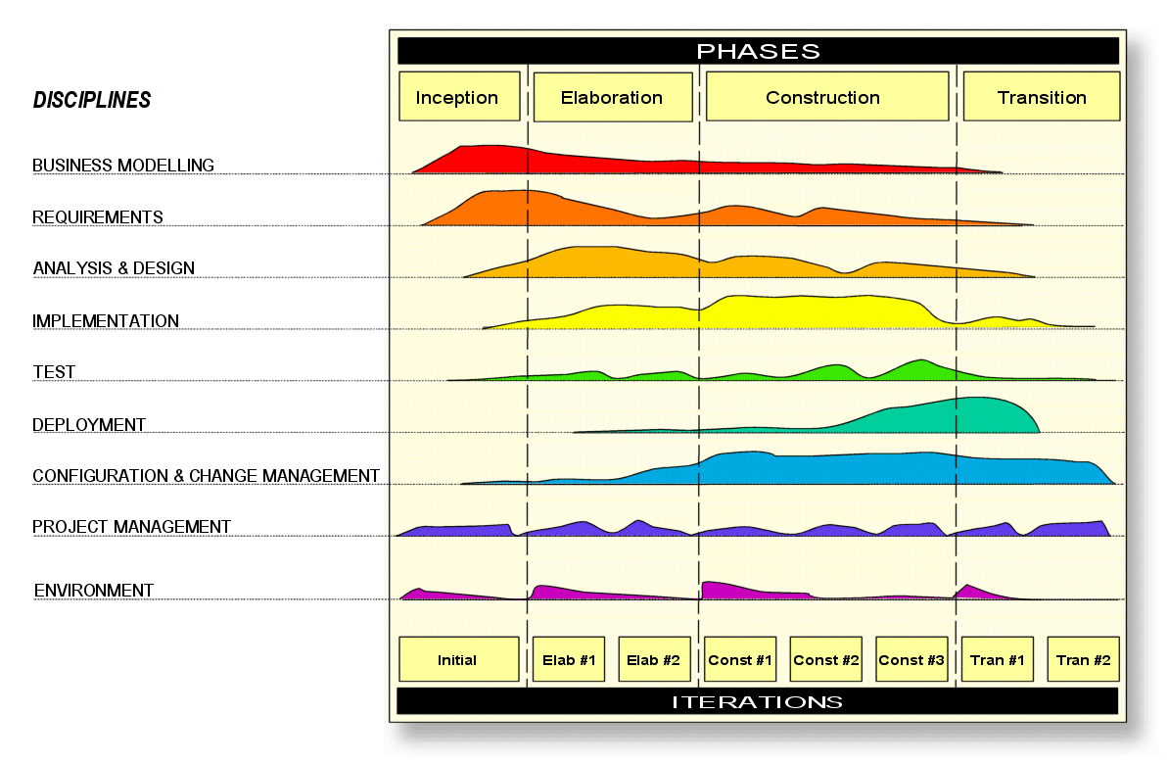

Figure : RUP model

In this project, we use the RUP development as software process model.

## Project Organization

### Organizational Structure

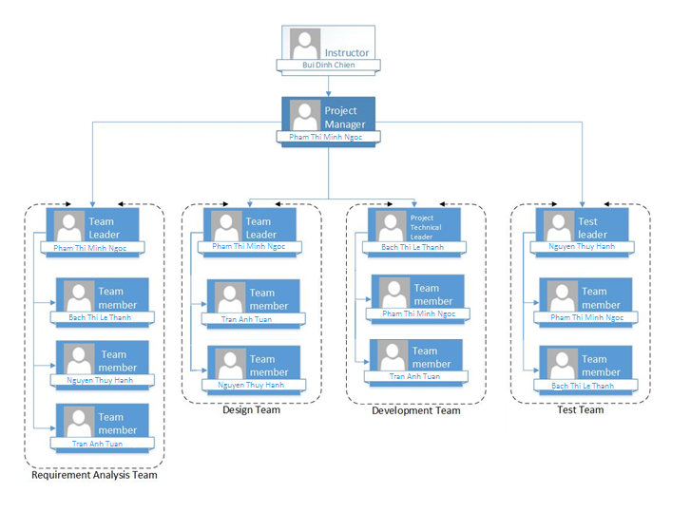

Figure : Organizational structure chart

### Project Team

|  |  |  |  |  |  |  |
| --- | --- | --- | --- | --- | --- | --- |
| Role | Responsibility | Full name | | % Effort | Start date | End date |
| Instructor | * Provide templates & tool * Review deliverables * Review project status * Resolve escalated issues * Consultant | Bui Dinh Chien | | 10% | September 8th, 2014 | December 17th, 2014 |
| PM | Have overall responsibility of the project:   * Project planning and scheduling * Task assignment and tracking * Reporting * Ensure delivery as per contract * Interface with other departments as per need * Prepare and manage the CM plan | Pham Thi Minh Ngoc | | 100% | September 8th, 2014 | December 17th, 2014 |
| Requirement Analysis Team | | | | | | |
| Team Leader | Review and Tracking Requirement | Pham Thi Minh Ngoc | | 100% | September 5th, 2014 | December 9th, 2014 |
| Team member | Create SRS document | Bach Thi Le Thanh | | 100% | September 5th, 2014 | December 9th, 2014 |
| Team member | Create SRS document | Nguyen Thuy Hanh | | 100% | September 5th, 2014 | December 9th, 2014 |
| Team member | Draw UC diagram | Tran Anh Tuan | | 100% | September 5th, 2014 | December 9th, 2014 |
| Design Team | | | | | | |
| Team Leader | Review and Tracking Design  Identify main UI, | | Pham Thi Minh Ngoc | 100% | September 15th, 2014 | November 6th, 2014 |
| Designer #1 | Draw prototype, Architecture Design | | Nguyen Thuy Hanh | 100% | September 15th, 2014 | November 6th, 2014 |
| Designer #2 | Database Design | | Tran Anh Tuan | 100% | September 15th, 2014 | November 6th, 2014 |
| Development Team | | | | | | |
| PLT | * Training IOS * Define coding convention * Coding | | Bach Thi Le Thanh | 100% | September 5th, 2014 | December 9th, 2014 |
| Developer #1 | Coding | | Pham Thi Minh Ngoc | 100% | September 5th, 2014 | December 9th, 2014 |
| Developer #2 | Coding | | Tran Anh Tuan | 100% | September 5th, 2014 | December 9th, 2014 |
| Test Team | | | | | | |
| Test leader | * Training IOS * Define coding convention * Coding | | Bach Thi Le Thanh | 100% | September 5th, 2014 | December 9th, 2014 |
| Tester #1 | Coding | | Pham Thi Minh Ngoc | 100% | September 5th, 2014 | December 9th, 2014 |
| Tester #2 | Coding | | Tran Anh Tuan | 100% | September 5th, 2014 | December 9th, 2014 |

### External Interfaces

#### FPT University’s Interfaces

|  |  |  |  |
| --- | --- | --- | --- |
| Department | Contact Person | Contact address | Responsibility |
| Management and Training Department | Phan Ngoc Ha | hapn@fsoft.com | Assign supervisor |
| Management and Training Department | Ngo Thi Vinh Ha | hatv@fpt.edu.vn | Receive capstone project register |

#### Others

|  |  |  |  |
| --- | --- | --- | --- |
| Department | Contact Person | Contact address | Responsibility |
| Freelancer | Hoang Trong Tue | tueht.ever@gmail.com | Support iOS Technical |
| Development Team of Newwave solutions SJC company | Lai Cong Thanh | laicongthanh7@gmail.com | Support iOS Technical and PHP Technical |
| Instructor of chemistry gifted students | Tran Thi Nga | 0982236404 | Support chemistry knowledge |
| Gifted student | Nguyen Tung Nam | 0904983382 | Support chemistry knowledge |

## Project schedule

Below are the image of task list used to assign and tracking tanks. Refer to EC_MasterSchedule.mpp to see more detail.

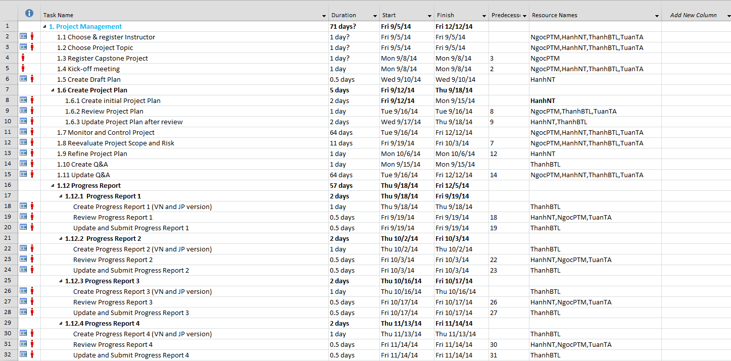

Figure : Task list

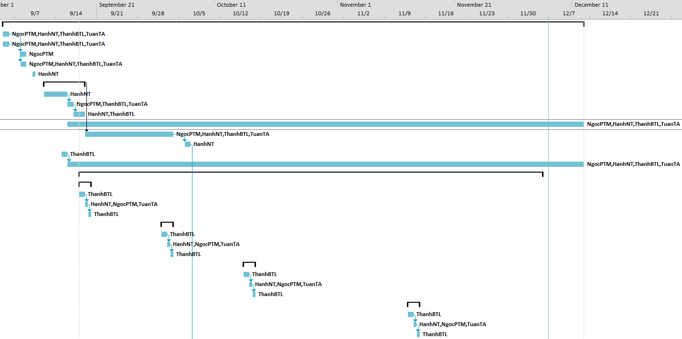

Figure : Gantt chart

## Project Millstones

|  |  |  |  |
| --- | --- | --- | --- |
| No | Milestone | Completion Date | Verification |
| 1 | Project Start | September 8th,2014 | Instructor approval |
| 2 | Submit report 1 | September 19th,2014 | Instructor approval |
| 3 | Submit report 2 | October 3rd, 2014 | Instructor approval |
| 4 | Submit report 3 | October 17th, 2014 | Instructor approval |
| 5 | Submit report 4 | November 11th, 2014 | Instructor approval |
| 6 | Submit report 5 | November 28th, 2014 | Instructor approval |
| 7 | Submit report 6 | December 5th, 2014 | Instructor approval |
| 9 | Defend project | December 12th,2014 | Instructor approval |

## Project Deliverables

|  |  |  |  |  |
| --- | --- | --- | --- | --- |
| No | Deliverable | Committed Delivery date | Description of Deliverable | Delivery media |
| 1 | Capstone project register | September 8th, 2014 |  | Hard copy |
| 2 | Software Requirement Specifications - SRS | December 17th, 2014 |  | Hard copy |
| 3 | Project plan | September 18th, 2014 |  | Hard copy |
| 4 | Q&A Management | December 12th, 2014 | Written in English and Japanese | Hard copy |
| 5 | Progress report 1 | September 19th, 2014 | Written in English and Japanese | Hard copy |
| **Subproject 1** | | | | |
| 6 | Architecture design | September 23rd, 2014 |  | Hard copy |
| 7 | Screen design | September 16th, 2014 |  | Hard copy |
| 8 | Database design | September 24th, 2014 |  | Hard copy |
| 9 | Detail Design | September 29th, 2014 |  |  |
| 10 | Progress report 2 | October 3rd, 2014 | Written in English and Japanese | Hard copy |
| 11 | Test plan | October 7th, 2014 |  | Hard copy |
| 12 | Test case | October 10th, 2014 |  | Hard copy |
| 13 | Progress report 3 | October 17th, 2014 | Written in English and Japanese | Hard copy |
| 14 | Source code | October 31st, 2014 |  | Hard copy |
| 15 | Unit test report | October 31st, 2014 | Unit test case | Hard copy |
| 16 | Test report | October 31st, 2014 |  | Hard copy |
| 17 | Quality report | October 31st, 2014 |  | Hard copy |
| **Subproject 2** | | | | |
| 18 | Architecture design | November 4th, 2014 |  | Hard copy |
| 19 | Screen design | November 4th, 2014 |  | Hard copy |
| 20 | Database design | November 4th, 2014 |  | Hard copy |
| 21 | Detail Design | November 6th, 2014 |  | Hard copy |
| 22 | Test plan | November 10th, 2014 |  | Hard copy |
| 23 | Test case | November 11th, 2014 |  | Hard copy |
| 24 | Progress report 4 | November 14th, 2014 | Written in English and Japanese | Hard copy |
| 25 | Source code | December 5th, 2014 |  | Hard copy |
| 26 | Unit test report | December 5th, 2014 | Unit test case | Hard copy |
| 27 | Test report | December 5th, 2014 |  | Hard copy |
| 28 | Quality report | December 5th, 2014 |  | Hard copy |
| 29 | Progress report 5 | November 28th, 2014 |  | Hard copy |
| 30 | Source code | December 10th, 2014 |  | Hard copy |
| 31 | User manual | December 12th, 2014 |  | Hard copy |
| 32 | Installation guide | December 12th, 2014 |  | Hard copy |
| 33 | Progress report 6 | December 12th, 2014 |  | Hard copy |

## Resource

Human resource

* Team members
* Supervisor
* iOS Technical Supporter
* Instructor of chemistry gifted student
* Chemistry gifted student

### Non-human resource

* Equipment: Desktop, laptop, iPhone 5/5S.
* Building: Ocha Teahouse - no. 1, alley 9, Tran Thai Tong Rd, Cau Giay district, Hanoi.
* Building: Room A3, Detech Building

## Risk Management

### Schedule Risk

|  |  |  |  |  |  |  |  |
| --- | --- | --- | --- | --- | --- | --- | --- |
| ID | Description | Avoidance plan | Contingency plan | Probability | | Impact | Status |
| 1 | Study schedule maybe change while executing project | Define constraints and discuss with the university before the semester status | * Change the project plan * Request a meeting with the university | | Low | High | Not yet active |
| 2 | Project duration maybe requested to cut down by the University or FPT Software Cooperation | Define assumptions and request the university and the company to confirm about the duration | * Request to decrease the scope of the project * Change the project plan | | Low | High | Not yet active |
| 3 | An unrealistic project deadline was set | Project plan must be reviewed by team members and instructor | * Request a discussion between all team members | | Medium | High | Activated /Solved |

### Scope Risk

|  |  |  |  |  |  |  |
| --- | --- | --- | --- | --- | --- | --- |
| ID | Description | Avoidance plan | Contingency plan | Probability | Impact | Status |
| 1 | Scope definition is changed late in the project | Discuss with FPT University before creating project plan | Request a meeting with the university | Low | High | Not yet active |

### Resource Risk

|  |  |  |  |  |  |  |
| --- | --- | --- | --- | --- | --- | --- |
| ID | Description | Avoidance plan | Contingency plan | Probability | Impact | Status |
| 1 | Team members have accidents, get some problem with their health | * Keep in touch with each team member * Encourage them to work if their health are not too bad | * Keep in touch with each team member regularly * Remind them to concentrate to get high achieves so they won’t need to overtime * Control team member’s task | Medium | Medium | Activated /Solved |
| 2 | Team members have conflicts | * Organize weekly meeting between team members * Hold team building frequently | PM must find the root cause and solve the problem | Medium | Medium | Activated /Solved |
| 3 | Equipment of team members are broken in the middle of the project | While executing a project, member have to keep their equipment carefully | * Borrow other person equipment while buying the new one or repairing | Medium | Medium | Activated /Solved |
| 4 | Team members lack of skills and experiences about iOS and Xcode | Organize training with iOS technical supporter | Organize training with iOS technical supporter | Medium | Medium | Activated /Solved |

## Communication Management

### Communication between Team Members

* **Face-to-face meeting:** at least twice a week at Wednesday and Saturday. This is the fastest way of communication to solve big problems in the project and members can help out each other easily.
* **E-mail and message:** Gmail and Facebook are used for members to keep tracking other team member’s progress and team members can also help each other online.
* **Mobile Phone:** is using for emergency situation to directly contact to others.
* **Collaboration tool:** Tortoise SVN and Dropbox is used for document and source code management.

### Communication with Supervisor

* **Face-to-face meeting:** Weekly on every Friday afternoons to make sure that supervisor can keep tracking of the team’s progress.
* **E-mail:** Gmail is the fastest way to get advice and document checking from supervisor.
* **Mobile phone:** is used to get time and place arranged for the meeting every weeks.

### Communication with iOS Technical Supporters

* **Face-to-face meeting:** We have a face-to-face meeting twice at the beginning of the project to helps members to training the new technical. We also have to arrange an appointment for some technical problem cases happen.
* **Mobile phone:** is used to arrange appointment and also contact directly to Supporters to solve problems.

### Communication with and Chemical Data Consultant

* **Face-to-face meeting:** We have a face-to-face meeting every next week on Tuesday to review the chemical reaction logic and chemical compounds data.
* **E-mail:** is used to quick review and support for chemical data.

## Configuration Management Process

### CI Identification and Naming Convention

|  |  |  |
| --- | --- | --- |
| No | Configuration Items | Naming convention |
| **Project Management** | | |
| 1 | Project Plan | EC_ProjectPlan_v[version number]  For example: EC_ProjectPlan_v1.1 |
| **Requirement & Design** | | |
| 2 | SRS | EC_SoftwareRequirementsSpecification_v[version number]  For example: EC_SoftwareRequirementsSpecification_v1.0 |
| 3 | Architectural Design | EC_ArchitectureDesign_v[version number]  For example: EC_ArchitectureDesign_v0.2 |
| 4 | Screen Design | EC_ScreenDesign_ v[version number]  For example: EC_ScreenDesign_v1.2 |
| 5 | Data Design | EC_DataDesign_v[version number]  For example: EC_DataDesign_v10.2 |
| **Source Code** | | |
| 6 | Source Code | EC_SourceCode_ v[version number][Tested/Untested]  For example: EC_SourceCode_v1.0Tested |
| **Support Document** | | |
| 7 | User Manual | EC_UserManual_v[version number]  For example: EC_UserManual_v[version number] |
| **Test** | | |
| 8 | Unit Test Plan | EC_UnitTestPlan_v[version number]  For example: EC_UnitTestPlan_v1.0 |
| 9 | Integration Test Plan | EC_IntegrationTestPlan_v[version number]  For example: EC_IntegrationTestPlan_v1.0 |
| 10 | System Test Plan | EC_SystemTestPlan_v[version number]  For example: EC_SystemTestPlan_v1.0 |
| 11 | Unit Test Case | EC_UnitTestCase-[Test Name]_v[version number]  For example: EC_UnitTestCase-Search_v1.0 |
| 12 | Integration Test Case | EC_IntegrationTestCase-[Test Name] v[version number]  For example: EC_IntegrationTestCase-Search_v1 |
| 13 | System Test Case | EC_SystemTestCase-[Test Name]_v[version number]  For example: EC_SystemTestCase-Search_ v1.0 |
| 14 | Test data | EC_TestData_v[version number]  For example: EC_TestData_v1.0 |
| 15 | Test Result | EC_TestReport_v[version number]  For example: EC_TestReport_v1.0 |
| **Process** | | |
| 16 | Guideline | EC_ [Name Of Guideline]Guideline_v[version number]  For example: EC_UnitTestGuideline_v1.0 |
| 17 | Convention | EC_[Name Of Convention]Conventions_v[version number]  For example: EC_CodingConventions_v1.0 |
| 18 | Template | EC_Template-[Name Of Template]_v[version number]  For example: EC_Template-ChangeRequestForm_v1.0 |
| 19 | Checklist | EC_[Name Of Checklist]Checklist_v[version number]  For example: EC_ReviewChecklist_v1.0 |
| **File Type** | | |
| 20 | MS Word | *.doc |
| 21 | MS Excel | *.xls |
| 22 | MS PowerPoint | *.mpp |
| 23 | MS Project Plan | *.mpp |
| 24 | MS Visio | *.vsd or *.vsdx |
| 25 | Images | *.png or *.jpg or *.jpeg or *.bmp or *.gif |

### Project Infrastructure

Below is the list of tools and infrastructure requirements needed for development environment.

#### Software

|  |  |  |
| --- | --- | --- |
| Category | Software name | Version |
| Operating System | Microsoft Windows 8 | Professional |
| Mac OS | OSX Yosemite, OSX Mavericks |
| Office tools | Microsoft Office | 2007, 2013 |
| Task tracking | Microsoft Project | 2013 |
| Design tools | Astah Community | 6.8.0 |
| Wireframe Sketcher | 4.3.2 |
| www.draw.io |  |
| Developments tools | Xcode | 6.1 |
| JetBrains PhpStorm | 7.1.4 |
| Database tool | SQLite Manager | 0.8.1 |
| MySQL |  |
| Source version control | TortoiseSVN | 1.8.8 |
| Documentation | Microsoft Office Word | 2007, 2013 |
| Microsoft Office Excel | 2007, 2013 |
| Microsoft PowerPoint | 2013 |
| UI design tool | Adobe Photoshop | CS6 |

#### Hardware

* Personal computer for developing and testing with the minimum configuration: 2GB RAM, 80GB of hard disk, Intel Core 2 Dou.
* The iPhone 5 and iPhone 5S for testing with the minimum configuration: 16GB.
* Internet network connection with minimum speech 512kbit/s.

#### Other infrastructure

* Rooms for meeting and working.
* Internet and mobile phone services for communication.

### Version Numbering Rule

* ***For documents:***

Each file has a version number as part of its identity. This version number is physically represented as a 2-part string with the following format:

<version>.<revision>

For example, version 1.0 indicates 1 as the version, and 0 as the revision number.

The original version will be numbered 0.1. Subsequent revisions will be numbered 0.2, 0.3 and so on. The approved version will be 1.0.

* **Version number:** appears to the left of the decimal. It is changed only when the core content of the item is significance changed. For example: when an item is completely overhauled, with substantial internal changes, the version 1.0 would become version 2.0.
* **Revision number:** appears to the right of the decimal. It is changed when the existing content is changed, but the main (or core) content is remained. The normal sequence of revision is 1.1, 1.2, and so on.
* ***For Software source files:***

Software executables and support files are generally identified by name and version number. The version number is physically represented as a 3-part string with the following format:

<version>.<revision><update>

For example, version 1.1a indicates 1 as the version, 0 as the revision number, and a as the update level.

* **Version number:** appears to the left of the decimal. It is changed only when the core content of the item is significance changed, as when moving from one are of the development tool to another, when an application is completely overhauled, or the user interface changes fundamentally. In this case, version 1.1a would become version 2.0.
* **Revision number:** appears to the right of the decimal. It is changed when new features, functionality or other content are added or significantly changed. In normal case, the core architecture or user interface have been extended or limited in some manner. The most common reason for changing the revision number is adding a new module or other functionality to the software. The normal sequence of revision is 1.0, 1.1 and 1.2 and so on.
* **Update level:** is appended or incremented when the only change to the software item is to correct one or more defects, without the addition of any new function. Version 1.1 would become v1.1a, 1.1b and so on. This updating is overridden when a combination revision, involving bug fixes and new feature additions, is performed. In such a case, the software revision number is incremented and any update indicator is dropped, as in v1.1b to 1.2.

### Directory structure

|  |  |  |
| --- | --- | --- |
| Main folder | Sub-folder | Purpose |
| Documents | Meeting minutes | Store project meeting minutes |
| Q&A | Store QA Management Sheet version English and version Japanese |
| Report | Store project report |
| Final deliverable | Report 1 | Store final deliverables of phase 1 |
| Report 2 | Store final deliverables of phase 2 |
| Report 3 | Store final deliverables of phase 3 |
| Report 4 | Store final deliverables of phase 4 |
| Report 5 | Store final deliverables of phase 5 |
| Report 6 | Store final deliverables of phase 6 |
| Plan |  | Store project plan, Task list |
| Resource | Reference materials | Store Reference materials needed in project |
| Template | Store template needed in project |
| Tool | Store tool needed in project |
| WIP | middy  ( m=month, d=day, y= year )  ( Example: 090814 ) | Tracking working process  Store project deliverable |
| Working space | Each team members has a folder.  ( Example: Them) | Team member’s working area |
| Archive | Baseline Name | To released versions of CIs at baselines |

### Coding convention

#### Naming convention

* Using prefix “EC” (means Easy Chemistry) for each classes or constants
  + For example: ECBalancingViewController
* Naming class: Use the uppercase letter for the first character
* Naming variables:
* Start the name with a lowercase letter and capitalize the first letter of embedded words.
* Start the name with a verb.
* Don’t use prefixes

For example:

|  |
| --- |
| - (void)invokeWithTarget:(id)target;  - (void)selectTabViewItem:(NSTabViewItem *)tabViewItem; |

* Use keywords before all arguments.

|  |  |
| --- | --- |
| - (void)sendAction:(SEL)aSelector toObject:(id)anObject forAllCells:(BOOL)flag; | Right. |
| - (void)sendAction:(SEL)aSelector :(id)anObject :(BOOL)flag; | Wrong. |

* Make the word before the argument describe the argument.

|  |  |
| --- | --- |
| - (id)viewWithTag:(NSInteger)aTag; | Right. |
| - (id)taggedView:(int)aTag; | Wrong. |

#### Comment convention

- Write comment for all methods and important logic

### Other CM Rules

* **Email subject naming convention:** All email related to the Easy Chemistry project must have prefix [EasyChemistry]. For example: [EasyChemistry] Progress Report 1.
* **Document changing rule:** When a member want to modify a document, he/she must update version of that document with appropriate description for the modification.

# Software Requirement Specification



## Introduction

### Purpose

The purpose of this document is to provide some detailed description of the project call Easy Chemistry, which is an iOS application that provides basic knowledge about chemical. Especially, this application will help user balance the chemical equations quickly. Users, especially students, can understand chemistry in the easiest way.

This document is used for supervisor and team members of Easy Chemistry project.

### Scope

Easy Chemistry is an application that built on iOS platform, in which people especially students can have some basic knowledge about chemistry. This application will have to:

* Help users balancing chemical equations that given by users.
* Allow users to search for basic information of chemical.
* Show the periodic table and allow users choose a chemical element for more information.
* Users can look back for information of 10 latest chemical equations that balanced and 10 latest chemical will stored in history list.
* Provide some fun facts about chemistry, some easy reactions that users can do it at home.
* Provide some information about EC application.

## Overall description

### Product Function

#### Main Application

* **Balance Chemical Reaction:**

Users fill the reactants and the products of the chemical reaction, Easy Chemistry application will help users to balance the reaction.

* **Search Chemical Compound:**

Allow users to search for some information about chemical compound by filling the searching box.

* **View Periodic Table:**

Display the simple Periodic table.

* **Change Temperature:**

Allow users to control the temperature bar that can change the temperature up or down to see element’s state of all element in the periodic table change. Each element will change the state of matter depend on their own melt and boil temperature.

* **View Chemical Element:**

Allow users to choose every single chemical element in the table to have the detail information.

* **View History:**

Allow users to look back the list of 10 latest balanced chemical reaction and 10 latest searched chemical compound information.

* **View Fun Facts:**

Allow users to choose a fun fact to have some funny information about chemistry.

* **About:**

Display the walkthrough of the application to help users use this application easier. Also some information about Developer Team.

#### Admin Application

* **Login:**

Allow users to login to the administrator application.

* **Manage Account:**

Allow users to view the accounts list and take another actions.

* **Add Account:**

Allow users to add another administrator account.

* **Modify Account:**

Allow users to modify a selected account.

* **Delete Account:**

Allow users to delete a selected account.

* **Manage Fun Facts:**

Allow users to view the fun facts list and take another actions.

* **Add Fun Fact:**

Allow users to add another fun fact.

* **Modify Fun Fact:**

Allow users to modify a selected fact.

* **Delete Fun Fact:**

Allow users to delete a selected fact.

### User Characteristics

There is there type of users in EC Application.

* **Users:** people who interested at the basic knowledge of chemistry.
* **Root Admin:** people who manage account and fun facts.
* **Admin:** people who manage fun facts

The table below will lists user classes and functions that user can use in EC.

|  |  |
| --- | --- |
| User Class | Function |
| Root Admin | Login  Edit Profile  View Account List  Add Account  Modify Account  Delete Account  View Fun Fact List  Add Fun Fact  Modify Fun Fact  Delete Fun Fact  Logout |
| Admin | Login  Edit Profile  View Fun Fact List  Add Fun Fact  Modify Fun Fact  Delete Fun Fact  Logout |
| User | Balance Chemical Reaction  Search Chemical Compound  View Periodic Table  Change Temperature  View s block  View p block  View d block  View f block  View Chemical Element  View Fun Facts List  View Fun Fact  View History  About |

### Constraints

Environmental requirements to install the main requirement: iOS 7.0 or higher. Devices must be an iPhone 5 or iPhone 5S.

## Important Chemistry Logic and Knowledge

This section contains the important chemistry reaction logic and knowledge that using in this project.

### Some Basic Knowledge and Important Definition

* **Single substances** are created from one chemical element such as H2, Cl2 and O2.
* **Compounds** are substances made up of two or more chemical elements. Depending on the conditions that the compound may be in three states: solid, liquid and gas.
* **Valence** of elements (or group of atoms) is the number of its combination power with other atoms.
* There are **four types of chemical reaction**:
* Synthesis reaction: two or more simple substances combine to form a more complex substance.
* Decomposition reaction: a more complex substance breaks down into its simple parts.
* Single replacement reaction: a single uncombined element replaces another in a compound; in other words, one element trades places with another element in a compound.
* Double replacement reaction: the anions and cations of two compounds switch places and form two entirely different compounds
* **Oxide** is the compound of two elements which one of them is oxygen.
* **Acidic oxide** is non-metallic oxide.
* **Basic oxide** is an oxide of metal.
* At the right temperature, **hydrogen pharmacological effects with single-oxidants** that create water, and oxygen in oxide of metal (Basic oxide) that create water and respectively metal).
* **Acid molecule** composed of one or more hydrogen atoms combine with acid radicals such as Cl, SO4 and NO3.
* **Base molecule** composed of one metal atoms combine with one or more of the hydroxide group.
* **Salt molecule** composed of one or more metal atoms combine with one or more acid radicals.

### Metals

* **Activity Series of Metals:** *K Na Ba Ca Mg Al Zn Fe Ni Sn Pb H Cu Hg Ag Pt Au*
* **React with non-metallic:**
* React with oxygen, creates oxides.
* React with other non-metallic (high temperature), creates salts
* **React with water:** In the activity series of metals, metals that before Mg react able with water under normal conditions (that’s mean only K, Na, Ba, Ca), creates Base liquid and releases hydrogen.
* **React with acids:** 
  + **H2SO4:** (not include Pt, Au)
* Reacts with metals before H in the Activity Series of Metals, creates salt and release hydrogen
* Reacts with all metals, creates salts and water, release SO2 or H2S
* **HNO3:** (not include Pt, Au), creates salts, water and release gas (NO, N2O, N2, NH4NO3 or NO2).Exception: Sn reacts with HNO3, create H2SnO3 (acid), water and NO2.
* **HCl:** Only reacts with metals before H in the activity series of metals.
* **Other acid:** balance anyway.
* **React with salt liquid:** metals that stronger in activity series of metals (not include Na, K, Ca) can replace the weaker metals in the salt liquid to create new metals and new salts.

Exception: Cu + 2FeCl3 → CuCl2 + 2FeCl2

Cu + Fe2(SO4)3 → CuSO4 + 2FeSO4

* **React with basic oxides:** Stronger metals can react with weaker basic oxides in the high temperature to create metals.
* **Some other exception case:**
* Zn reacts with base, creates salt with the ZnO2 radical and release hydrogen.
* Al reacts with base, creates salt with AlO2 radical and release hydrogen.
* K + H2 = 2HK

### Non-metallic

* **React with hydrogen.**
* **React with metals** to create salts.
* **React with oxygen** to create acidic oxides.
* **Exception case:**
* H2 + O2 → H2O
* Cl2 + NaOH → NaCl + NaClO + H2O
* Cl2 + KOH → 5KCl + KClO3 + 3H2O
* Cl2 + H2O → HCl + HClO
* Cl2 not directly reacts with O2

### Oxides

* **Basic oxides** (CaO, Na2O, Li2O, BaO, K2O) **react with water** to create base.
* **Basic oxides react** **with acids** to create salts and water.
* **Basic oxides** (CaO, Na2O, Li2O, BaO, K2O**) react with acidic oxides** to create salts.
* **Acidic oxides** (not include SiO2) **react with water** to create acid.

Exception: 3NO2 + H2O → HNO3 + 2NO

* **Acidic oxides react with base** (NaOH, Ca(OH)2, KOH, Ba(OH)2) to create salts and water.

Exception: 2NO2 + 2NaOH → NaNO2 + NaNO3 + H2O

* **Amphoteric oxides: react able with both bases and acids** to create salts and water.

Exception: PbO2 + HCl → PbCl2 + Cl2 + H2O / PbCl4 + H2O

MnO2 + HCl → MnCl2 + Cl2 + H2O

Mn3O4 + HCl → MnCl2 + Cl2 + H2O

Au2O3 + NaOH → Na[Au(OH)4]

Au2O3 + KOH →K[Au(OH)4]

Al2O3 + NaOH → Na[Al(OH)4]

Au2O3 + HCl → HAuCl4 (acid) + H2O

* **Neutral oxides**: is the non-metallic oxide that cannot create salt. **Not react able with water, acids and bases**. In other case: balance anyway.

### Bases

* **Neutral hydroxide react able with bases, acids, salts and water**.

Exception: Al(OH)3 + NaOH → Na[Al(OH)4] (similar to KOH and AuOH)

Cr(OH)3 + NaOH → Na[Cr(OH)4]

Cr(OH)3 + KOH → K[Cr(OH)4]

Cr(OH)3 + AuOH → Au[Cr(OH)4]

Be(OH)2 + NaOH → Na2[Be(OH)4] (similar to KOH and AuOH)

Pb(OH)4 + NaOH → Na2[Pb(OH)6] (similar to KOH and AuOH)

Au(OH)3 + NaOH → Na[Au(OH)4] (similar to KOH)

* **Decomposition reaction** create basic oxides and water. (only insoluble bases)
* Bases (NaOH, Ca(OH)2, KOH, Ba(OH)2) Decomposition reaction to create salts and water.
* **React with acids** to create salts and water.
* **React with salts** to create new salts and new bases. Exception: if the product is AgOH, then it always decomposes to Ag2O and H2O.

### Acids

* **React with metals:** mention above
* **React with bases:** mention above
* **React with basic oxides:** mention above
* **React with salts** to create new salts and new acids
* If the product is **H2CO3**, then is always **decomposes** to **H2O and CO2**
* **HNO3:**
* Reacts with non-metallic to create new acids, water and release NO2 or NO.
* HNO3 + H2S → S2 + NO + H2O
* HNO3 + HI → I2 + NO2 + H2O/ HNO3 + HI → HIO3 + NO2 + H2O.
* HNO3 + SO2 → H2SO4 + NO + H2O
* HNO3 + FeO → Fe(NO3)3 + NO2 + H2O

### Salts

* **React with salts** to create 2 new salts
* **React with metals**: mention above
* **React with acids:** mention above
* **React with bases:** mention above
* **Sulfide salts react with oxygen** to create high valence oxides and SO2.
* **Decompose salts:** creates new substances
* **Nitrate salts:**
* If the metal of the nitrate salts is a soluble metal, then the products are nitrite salt and oxygen.
* If the metal of the nitrate salts is from Mg to Cu (in the activity series of metals), then the products are oxide of its metal, NO2 and O2.
* If the metal of the nitrate salts if after Cu (in the activity series of metals), then the products are its metal, NO2 and O2.
* **Carbonate salts:**
* If the metal of the carbonate salts is from Cu backward (in the activity series of metals), then the products are oxide of its metal and CO2.
* If the metal of the carbonate salts is after Cu (in the activity series of metals), then the products are its metal, O2 and CO2.
* **Hydrogen Carbonate salts**: products are carbonate salt of its metal, CO2 and water.
* **Sulfate salts:**
  + If the metal of the sulfate salts is from Mg to Cu (in the activity series of metals), then the products are oxide of its metal, SO2 and O2.
  + If the metal of the sulfate salts if after Cu (in the activity series of metals), then the products are its metal, SO2 and O2.
* **Others**: balance anyway

### Ammoniac

* **React with acids** to create salts
* **React with salts** to create new salts
* **React with oxygen** to create nitrogen and water or nitrogen oxide and water
* **React with chlorine** to create nitrogen and hydrogen chloride
* **React with bases** to create salt or metals, nitrogen and water
* **Decompose** to create nitrogen and hydrogen

## Specification Requirement

### Functionality

#### Main Application

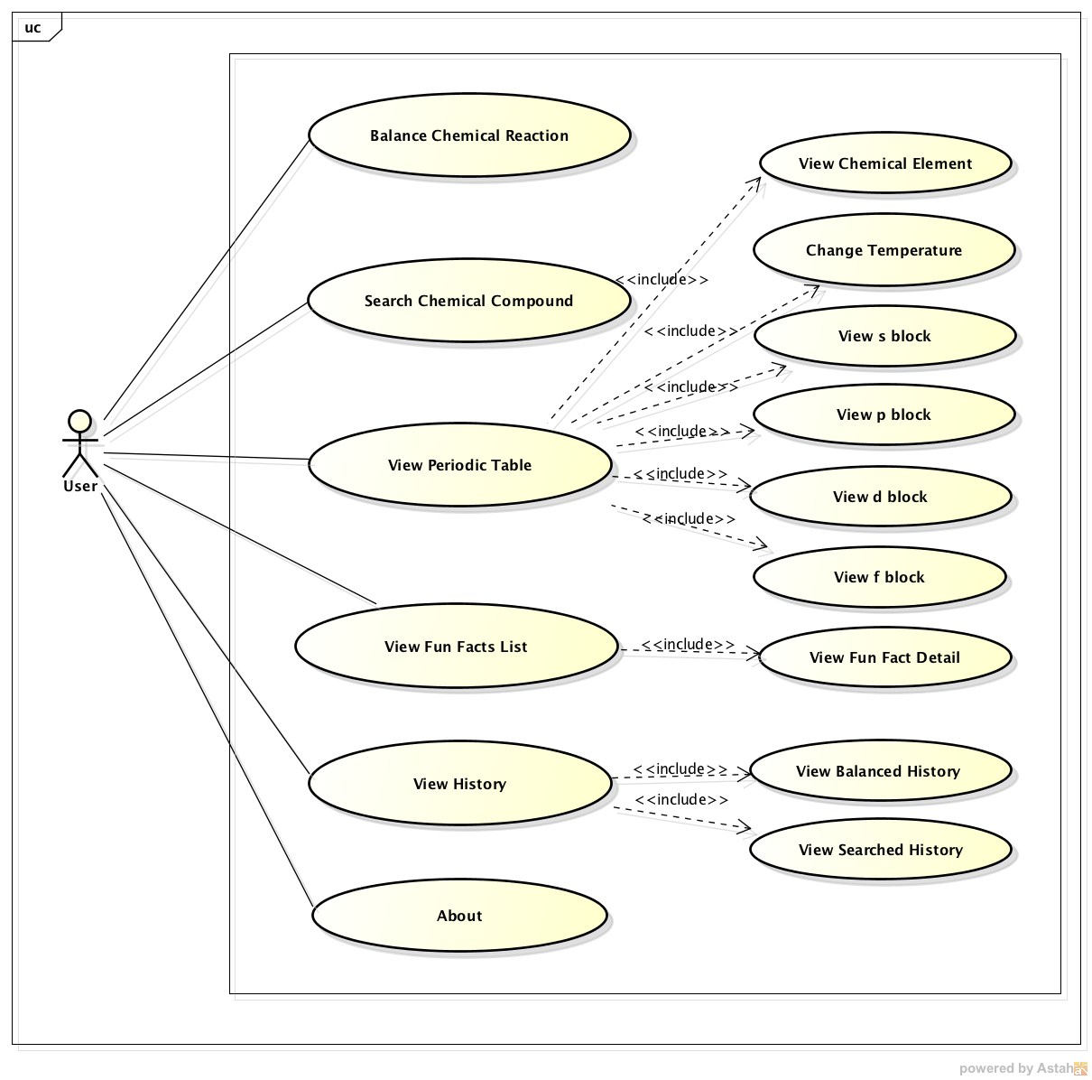

Figure : Main Application Use Case Diagram

##### Balance Chemical Reaction

|  |  |  |
| --- | --- | --- |
| Use Case Name | Balance Chemical Reaction | |
| Reference |  | |
| Trigger | User tap on “Cân bằng” on the Main Screen | |
| Basic Path | Member’s action | System response |
|  | 1. Select “Cân bằng” button on the Main Screen | Redirect to Balance Chemical Reaction screen |
| 1. Fill the reactants and products of a chemical reaction |  |
| 1. Select “Cân bằng” button | Balance the chemical reaction |
| 1. Select “Xoá” button | Clear all the reactants, products that user filled and the balanced numbers if the chemical reaction balanced |
| 1. Select “Hoá học không khó” button | Redirect to the Main Screen |
| Alternative Paths |  | |
| Post Condition | Balance Chemical Reaction Screen is displaying | |
| Exception Paths | If user fills the wrong reactant, screen will show the notice “Không tìm thấy chất hoá học này, hãy thử lại!”  If user fills the wrong product, screen will show the notice “Không tìm thấy chất hoá học này, hãy thử!”  If user fills the wrong reaction, screen will show the notice “Không xảy ra phản ứng này!”  If user fill the reactant that not suitable with the product, screen will show the notice “Phương trình không đúng!”  If user doesn’t fill at least 1 reactant, the screen will show the notice “Hãy nhập đầy đủ chất phản ứng!”  If user doesn’t fill at least 1 product, the screen will show the notice “Hãy nhập đầy đủ chất sản phẩm!”  If user doesn’t fill reactants and products, the screen will show the notice “Hãy nhập chất phản ứng và chất sản phẩm”  If user only fill 1 reactant and 1 product, the screen will show the notice “Hãy nhập đầy đủ chất sản phẩm” | |
| Other |  | |

##### Search Chemical Compound

|  |  |  |
| --- | --- | --- |
| Use Case Name | Search Chemical Compound | |
| Reference |  | |
| Trigger | User fills “Tìm kiếm chất” box on the Main Screen | |
| Basic Path | Member’s action | System response |
|  | 1. User fills “Tìm kiếm chất” box on the Main Screen |  |
| 1. Select “Tìm” button on the Main Screen | Redirect to the Chemical Compound Detail Information screen that contain the chosen information |
| 1. Select “Hoá học không khó” button | Redirect to the Main Screen |
| Alternative Paths |  | |
| Post Condition | EC application display all results | |
| Exception Paths |  | |
| Other |  | |

##### View Periodic Table

|  |  |  |
| --- | --- | --- |
| Use Case Name | View Periodic Table | |
| Reference |  | |
| Trigger | User tap on “Bảng tuần hoàn” on the Main Screen | |
| Basic Path | Member’s action | System response |
|  | 1. Select “Bảng tuần hoàn” button on the Main Screen | Redirect to “Periodic Table” screen |
| 1. Select “Hoá học không khó” button | Redirect to the Main Screen |
| Alternative Paths | On the Periodic Table Screen, tap on “tất cả” button. | |
| Post Condition | EC application display the Periodic Table | |
| Exception Paths |  | |
| Other |  | |

##### View Chemical Element

|  |  |  |
| --- | --- | --- |
| Use Case Name | View Chemical Element | |
| Reference |  | |
| Trigger | User tap on a Chemical Element in the Periodic Table | |
| Basic Path | Member’s action | System response |
|  | 1. Select a Chemical Element | Redirect to the Element screen that contain the chosen element information |
| 1. Select “Bảng tuần hoàn” button | Redirect to Periodic Table Screen |
| Alternative Paths |  | |
| Post Condition | EC Application display information of a chosen element. | |
| Exception Paths |  | |
| Other |  | |

##### View s block

|  |  |  |
| --- | --- | --- |
| Use Case Name | View s block | |
| Reference |  | |
| Trigger | User tap on “s” button on Periodic Table Screen | |
| Basic Path | Member’s action | System response |
|  | 1. Tap on “s” button | Show only element in “s” block is in colors, the other was gray |
| 1. Select “Hoá học không khó” button | Redirect to the Main Screen |
| Alternative Paths |  | |
| Post Condition | EC Application display only element in “s” block is in colors | |
| Exception Paths |  | |
| Other |  | |

##### View p block

|  |  |  |
| --- | --- | --- |
| Use Case Name | View p block | |
| Reference |  | |
| Trigger | User tap on “p” button on Periodic Table Screen | |
| Basic Path | Member’s action | System response |
|  | 1. Tap on “p” button | Show only element in “p” block is in colors, the other was gray |
| 1. Select “Hoá học không khó” button | Redirect to the Main Screen |
| Alternative Paths |  | |
| Post Condition | EC Application display only element in “p” block is in colors | |
| Exception Paths |  | |
| Other |  | |

##### View d block

|  |  |  |
| --- | --- | --- |
| Use Case Name | View d block | |
| Reference |  | |
| Trigger | User tap on “d” button on Periodic Table Screen | |
| Basic Path | Member’s action | System response |
|  | 1. Tap on “d” button | Show only element in “d” block is in colors, the other was gray |
| 1. Select “Hoá học không khó” button | Redirect to the Main Screen |
| Alternative Paths |  | |
| Post Condition | EC Application display only element in “d” block is in colors | |
| Exception Paths |  | |
| Other |  | |

##### View f block

|  |  |  |
| --- | --- | --- |
| Use Case Name | View f block | |
| Reference |  | |
| Trigger | User tap on “f” button on Periodic Table Screen | |
| Basic Path | Member’s action | System response |
|  | 1. Tap on “s” button | Show only element in “f” block is in colors, the other was gray |
| 1. Select “Hoá học không khó” button | Redirect to the Main Screen |
| Alternative Paths |  | |
| Post Condition | EC Application display only element in “f” block is in colors | |
| Exception Paths |  | |
| Other |  | |

##### Change Temperature

|  |  |  |
| --- | --- | --- |
| Use Case Name | Change Temperature | |
| Reference |  | |
| Trigger | User change temperature by bar on the Periodic Table Screen | |
| Basic Path | Member’s action | System response |
|  | 1. Change the temperature by slide the temperature bar left and right | All elements on the periodic table change colors |
| 1. Select “Hoá học không khó” button | Redirect to the Main Screen |
| Alternative Paths |  | |
| Post Condition | All elements on the periodic table change the colors depend on their own melt and boil temperature | |
| Exception Paths |  | |
| Other |  | |

##### View Fun Facts List

|  |  |  |
| --- | --- | --- |
| Use Case Name | View History | |
| Reference |  | |
| Trigger | User tap on “Hoá học vui” on the Main Screen | |
| Basic Path | Member’s action | System response |
|  | 1. Select button “Hoá học vui” on the Main Screen | Redirect to the Fun Facts List screen |
| 1. Select “Hoá học không khó” button | Redirect to the Main Screen |
| Alternative Paths |  | |
| Post Condition | EC Application display the list of Chemical Fun Facts | |
| Exception Paths |  | |
| Other |  | |

##### View Fun Fact

|  |  |  |
| --- | --- | --- |
| Use Case Name | View Fun Fact | |
| Reference |  | |
| Trigger | User selects a single Fact on the Fun Facts List Screen | |
| Basic Path | Member’s action | System response |
|  | 1. Select a fact on Fun Facts List Screen | Redirect to the Fun Fact screen that contain the chosen fact information |
| 1. Select “Hoá học không khó” button | Redirect to the Main Screen |
| Alternative Paths |  | |
| Post Condition | EC Application display the information of a chosen fact | |
| Exception Paths |  | |
| Other |  | |

##### View History

|  |  |  |
| --- | --- | --- |
| Use Case Name | View History | |
| Reference |  | |
| Trigger | User tap on “Lịch sử” on the Main Screen | |
| Basic Path | Member’s action | System response |
|  | 1. Select button “Lịch sử” on the Main Screen | Redirect to the Balance History screen |
| 1. Select tab “Cân bằng” or “Tìm kiếm” on the screen (Default is the “Cân bằng” tab) | Show the tab |
| 1. Select “Hoá học không khó” button | Redirect to the Main Screen |
| Alternative Paths |  | |
| Post Condition | EC Application display 10 latest balanced chemical reactions. | |
| Exception Paths |  | |
| Other |  | |

##### View Balanced History

|  |  |  |
| --- | --- | --- |
| Use Case Name | View Balanced History | |
| Reference |  | |
| Trigger | User tap on “Lịch sử” on the Main Screen | |
| Basic Path | Member’s action | System response |
|  | 1. Tap on “Lịch sử” on the Main Screen | Show the list of 10 latest balanced chemical reactions |
| 1. Select each reaction | Show the detail of the reaction that balanced |
| 1. Select “Hoá học không khó” button | Redirect to the Main Screen |
| Alternative Paths | While in tab “Tìm kiếm” in History, user can tap on “Cân bằng” to check the list of 10 latest balanced chemical reactions | |
| Post Condition | EC application display the list of 10 latest balanced chemical reactions | |
| Exception Paths |  | |
| Other |  | |

##### View Searched History

|  |  |  |
| --- | --- | --- |
| Use Case Name | View Search History | |
| Reference |  | |
| Trigger | User tap on “Lịch sử” on the Main Screen then select “Tìm kiếm” tab | |
| Basic Path | Member’s action | System response |
|  | 1. Select “Searched” tab on the  “History” screen | Show the list of 10 latest Searched items |
| 1. Select each item | Show the detail of the searched item |
| 1. Select “Hoá học không khó” button | Redirect to the Main Screen |
| Alternative Paths |  | |
| Post Condition | EC application display the list of 10 latest searched chemical compounds | |
| Exception Paths |  | |
| Other |  | |

##### About

|  |  |  |
| --- | --- | --- |
| Use Case Name | About | |
| Reference |  | |
| Trigger | User selects button “Giới thiệu” on the Main Screen | |
| Basic Path | Member’s action | System response |
|  | 1. Select “Giới thiệu” button on the Main Screen | Redirect to About screen |
| 1. Select “Hoá học không khó” button | Redirect to the Main Screen |
| Alternative Paths |  | |
| Post Condition | EC application display the information of the application | |
| Exception Paths |  | |
| Other |  | |

#### Administration Application

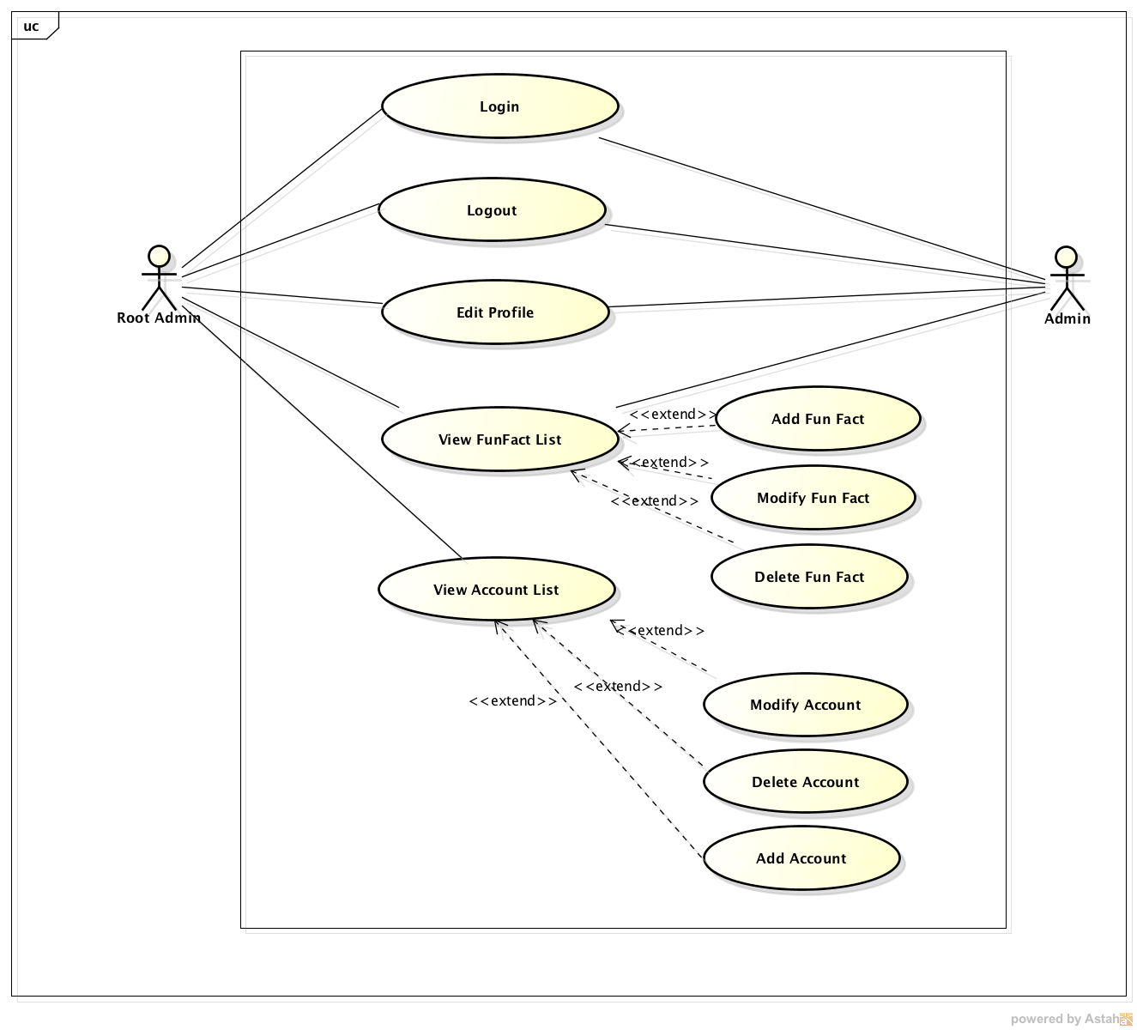

Figure : Administration Application Use Case Diagram

##### Login

|  |  |  |
| --- | --- | --- |
| Use Case Name | Login | |
| Reference |  | |
| Trigger | Application link | |
| Basic Path | Member’s action | System response |
|  | 1. Enter username and password |  |
| 1. Click on “Đăng nhập” button | Redirect to Index Screen |
| Alternative Paths |  | |
| Post Condition | User logged in | |
| Exception Paths | If user enter the wrong username, password or both; the screen with show the notice “Tên đăng nhập hoặc mật khẩu không đúng!”  If user did not enter the username or password or both; the screen with show the notice “Vui lòng nhập đầy đủ tên đăng nhập và mật khẩu!” | |
| Other |  | |

##### Edit Profile

|  |  |  |
| --- | --- | --- |
| Use Case Name | View Edit Profile | |
| Reference |  | |
| Trigger | Click on “Sửa thông tin cá nhân” on the Main Screen | |
| Basic Path | Member’s action | System response |
|  | 1. Click on “Sửa thông tin cá nhân” | Redirect to Edit Profile Screen |
| 1. Change the needed information |  |
|  | 1. Click on “Đặt lại” button to reset the information (optional) |  |
|  | 1. Click on “Sửa” button to add an account | Redirect to Account Screen |
| Alternative Paths |  | |
| Post Condition | Account edited | |
| Exception Paths | If password box is blank, the screen will show the notice “Bạn chưa nhập mật khẩu”  If re-enter password box is blank, the screen will show the notice “Bạn chưa nhập lại mật khẩu”  If user re-enter password that not matched with the password above, the screen will show the notice “Mật khẩu không khớp”  If fullname box is blank, the screen will show the notice “Bạn chưa nhập họ và tên”  If birthday box is blank, the screen will show the notice “Bạn chưa nhập ngày sinh”  If user did not enter an email, the screen will show the notice “Bạn chưa nhập email”  If user did not add a photo, the screen will show the notice “Bạn chưa thêm ảnh”  If user enters username less than 8 characters, the screen will show the notice "Tên đăng nhập phải nhiều hơn 8 kí tự"  If user enters password less than 8 characters, the screen will show the notice "Mật khẩu phải nhiều hơn 8 kí tự"  If user enter wrong format of email, the screen will show the notice “Không đúng định dạng email”  If user enter wrong format of birthday, the screen will show the notice “Không đúng định dạng ngày sinh”  If user enter wrong format of photo, the screen will show the notice “Không đúng định dạng ảnh” | |
| Other |  | |

##### Manage Account

|  |  |  |
| --- | --- | --- |
| Use Case Name | View Accounts List | |
| Reference |  | |
| Trigger | Click on “Tài khoản” on the Main Screen | |
| Basic Path | Member’s action | System response |
|  | 1. Click on “Tài khoản” | Redirect to Account Screen |
| Alternative Paths |  | |
| Post Condition | Account Management Screen display | |
| Exception Paths |  | |
| Other |  | |

##### Add Account

|  |  |  |
| --- | --- | --- |
| Use Case Name | Add Account | |
| Reference |  | |
| Trigger | On Account Management Screen, click on “Thêm mới” button | |
| Basic Path | Member’s action | System response |
|  | 1. Click on “Thêm mới” button | Redirect to Add Account Screen |
| 1. Fill the information of an account to every field |  |
| 1. Click on “Đặt lại” to clear every information (optional) |  |
| 1. Click on “Thêm mới” button to add an account | Redirect to Account Screen |
| Alternative Paths |  | |
| Post Condition | Account added to the database | |
| Exception Paths | If user did not enter username, the screen will show the notice “Bạn chưa nhập tên đăng nhập”  If user did not enter password, the screen will show the notice “Bạn chưa nhập mật khẩu”  If user did not re-enter password, the screen will show the notice “Bạn chưa nhập lại mật khẩu”  If user re-enter password that not matched with the password above, the screen will show the notice “Mật khẩu không khớp”  If user did not enter fullname, the screen will show the notice “Bạn chưa nhập họ và tên”  If user did not enter birthday, the screen will show the notice “Bạn chưa nhập ngày sinh”  If user did not enter an email, the screen will show the notice “Bạn chưa nhập email”  If user did not add a photo, the screen will show the notice “Bạn chưa thêm ảnh”  If user enters username less than 8 characters, the screen will show the notice "Tên đăng nhập phải nhiều hơn 8 kí tự"  If user enters password less than 8 characters, the screen will show the notice "Mật khẩu phải nhiều hơn 8 kí tự"  If user enter wrong format of email, the screen will show the notice “Không đúng định dạng email”  If user enter wrong format of birthday, the screen will show the notice “Không đúng định dạng ngày sinh”  If user enter wrong format of photo, the screen will show the notice “Không đúng định dạng ảnh” | |
| Other |  | |

##### Modify Account

|  |  |  |
| --- | --- | --- |
| Use Case Name | Modify Account | |
| Reference |  | |
| Trigger | Choose an account then click on “Sửa” | |
| Basic Path | Member’s action | System response |
|  | 1. Click on an account that needed to modify information |  |
|  | 1. Click on “Sửa” | Redirect to Modify Account Screen |
| 1. Change the information of an account |  |
| 1. Click “Đặt lại” to reset the information (optional) |  |
| 1. Click “Sửa” button to modify an account | Redirect to Account Screen |
| Alternative Paths |  | |
| Post Condition | Account edited | |
| Exception Paths | If password box is blank, the screen will show the notice “Bạn chưa nhập mật khẩu”  If re-enter password box is blank, the screen will show the notice “Bạn chưa nhập lại mật khẩu”  If user re-enter password that not matched with the password above, the screen will show the notice “Mật khẩu không khớp”  If fullname box is blank, the screen will show the notice “Bạn chưa nhập họ và tên”  If birthday box is blank, the screen will show the notice “Bạn chưa nhập ngày sinh”  If email box is blank, the screen will show the notice “Bạn chưa nhập email”  If user did not add a photo, the screen will show the notice “Bạn chưa thêm ảnh”  If user enters username less than 8 characters, the screen will show the notice "Tên đăng nhập phải nhiều hơn 8 kí tự"  If user enters password less than 8 characters, the screen will show the notice "Mật khẩu phải nhiều hơn 8 kí tự"  If user enter wrong format of email, the screen will show the notice “Không đúng định dạng email”  If user enter wrong format of birthday, the screen will show the notice “Không đúng định dạng ngày sinh”  If user enter wrong format of photo, the screen will show the notice “Không đúng định dạng ảnh” | |
| Other |  | |

##### Delete Account

|  |  |  |
| --- | --- | --- |
| Use Case Name | Delete Account | |
| Reference |  | |
| Trigger | Choose an account then click on “Xoá” | |
| Basic Path | Member’s action | System response |
|  | 1. Click on an account that needed to delete |  |
|  | 1. Click on “Xoá” |  |
| 1. Click on “Yes” button | Redirect to Account Screen |
| Alternative Paths |  | |
| Post Condition | Account deleted | |
| Exception Paths |  | |
| Other |  | |

##### Manage Fun Fact

|  |  |  |
| --- | --- | --- |
| Use Case Name | View Fun Facts List | |
| Reference |  | |
| Trigger | Click on “Hoá học vui” on the Main Screen | |
| Basic Path | Member’s action | System response |
|  | 1. Click on “Hoá học vui” | Redirect to Fun Fact Screen |
| Alternative Paths |  | |
| Post Condition | Application display Fun Fact Management Screen | |
| Exception Paths |  | |
| Other |  | |

##### Add Fun Fact

|  |  |  |
| --- | --- | --- |
| Use Case Name | Add Fun Fact | |
| Reference |  | |
| Trigger | Click on “Thêm mới” button | |
| Basic Path | Member’s action | System response |
|  | 1. Click on “Thêm mới” button | Redirect to Add Fun Fact Screen |
| 1. Fill the information of a fact |  |
| 1. Click on “Đặt lại” to clear every information (optional) |  |
| 1. Click on “Thêm mới” button to add an account | Redirect to Fun Fact Screen |
| Alternative Paths |  | |
| Post Condition | New Fun Fact added to the database | |
| Exception Paths | If user did not enter title, the screen will show the notice “Chưa nhập tiêu đề”  If user did not enter content, the screen will show the notice “Chưa nhập nội dung”  If user did not add a photo, the screen will show the notice “Bạn chưa thêm ảnh”  If user enters title less than 4 characters, the screen will show the notice “Tiêu đề phải nhiều hơn 4 kí tự”  If user chooses photo with wrong format: .exe, .doc, .xsl,...", the screen will show the notice “Không đúng định dạng ảnh" | |
| Other |  | |

##### Modify Fun Fact

|  |  |  |
| --- | --- | --- |
| Use Case Name | Modify Fun Fact | |
| Reference |  | |
| Trigger | Choose a fun fact then click on “Sửa” | |
| Basic Path | Member’s action | System response |
|  | 1. Click on a fact that needed to modify information |  |
|  | 1. Click on “Sửa” | Redirect to Modify Fun Fact Screen |
| 1. Change the information of a fact |  |
| 1. Click “Đặt lại” to reset the information (optional) |  |
| 1. Click “Sửa” button to modify a fact | Redirect to Fun Fact Screen |
| Alternative Paths |  | |
| Post Condition | A Fun Fact edited | |
| Exception Paths | If the title is blank, the screen will show the notice “Chưa nhập tiêu đề”  If the content is blank, the screen will show the notice “Chưa nhập nội dung”  If user did not add a photo, the screen will show the notice “Bạn chưa thêm ảnh”  If user enters title less than 4 characters, the screen will show the notice “Tiêu đề phải nhiều hơn 4 kí tự” | |
| Other |  | |

##### Delete Fun Fact

|  |  |  |
| --- | --- | --- |
| Use Case Name | Delete Fun Fact | |
| Reference |  | |
| Trigger | Choose a fact then click on “Xoá” | |
| Basic Path | Member’s action | System response |
|  | 1. Click on a fun fact that needed to delete |  |
|  | 1. Click on “Xoá” |  |
| 1. Click on “Yes” button | Redirect to Fun Fact Screen |
| Alternative Paths |  | |
| Post Condition | Fun Fact Deleted | |
| Exception Paths |  | |
| Other |  | |

##### Logout

|  |  |  |
| --- | --- | --- |
| Use Case Name | Delete Fun Fact | |
| Reference |  | |
| Trigger | Click on “Thoát” on every screen that you want | |
| Basic Path | Member’s action | System response |
|  | 1. Click on “Thoát” | Redirect to the Login Screen |
| Alternative Paths |  | |
| Post Condition | User logout of the system | |
| Exception Paths |  | |
| Other |  | |

### Non-functional Requirements Specification

#### Usability

* Interface should be simple, easy-to-use, clear.
* Provide an introduction to support users.

#### Reliability

* Chemical Compounds and Chemical Elements information must be reliable.
* Chemical Reaction Balancing must be reliable.
* Search result return must be correctly.

#### Performance

* Maximum response time for display information must be smaller than 0.5s
* Maximum balance chemical reaction time for display must be smaller than 0.5s

#### Portability

* An iPhone 5 or iPhone 5S with iOS version 7.0 or higher

#### Availability

Percentage of availability time is about 95-97%, we cannot control cases of force majeure such as power failure or network disconnection.

#### Maintainability

* The output of the project must include naming conventions and coding standards documentations. Code implementation must be easy to maintain.
* All code must be comment clearly, including class and method documentations.
* The design of the system must be loosely coupled that chances on some module will not affect others.

All errors, strange or sensitive situations must be logged to supporting for bug fixing and maintenance.

#### Interfaces

##### User Interface

* User interface will be designed base on Flat Design.
* User interface must be attractive to make a motivation for users to study.
* Each User interface element must be arranged logically, not overlapped over each other, allowing user access easily.

##### Hardware Interfaces

* Main Application: iOS devices (an iPhone 5 or iPhone 5s) that installed iOS 7.0 or higher.
* Administration Application: A computer has internet connection.

##### Software Interfaces

* iOS Framework

# Software Design Specification



## Architecture Design

### Architecture Representation

#### Overall System Architectural

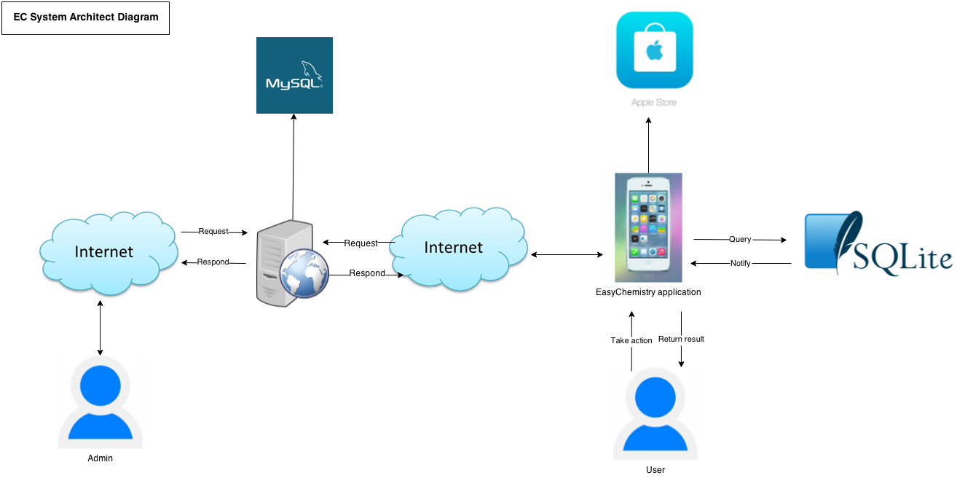

Figure : Overall system architecture

The EC system includes Easy Chemistry application, server and two main kinds of actor: Admin and User.

User uses the application. The application queries data from local SQLite database or insert data into this database. Then, SQLite database returns result on screen for user. New version of the application that has updated functions and new functions will be pushed to the Apple Store then User can download and use the updated application.

Admin takes responsibility of adding new Fun Facts to MySQL database in server. Then the application automatically downloads Fun Facts from server when the device is connecting to the internet.

#### EC Application Architecture

##### Main Application

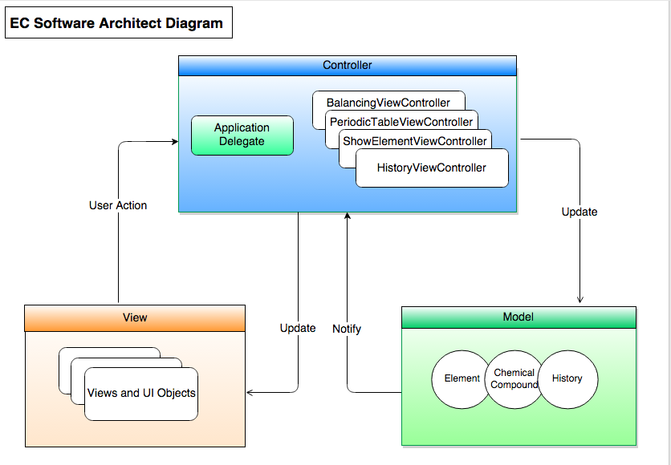

Figure : EC Main Application Architecture

EC Main Application uses Model – View – Controller design pattern.

User actions in the view layer that create or modify data are communicated through a controller object and result in the creation or updating of a model object. When a model objects changes, it notifies a controller object, which updates the appropriate view objects.

##### Administration Application

N/A

### Architectural Goals and Constraints

#### Design and Implement Strategy

* Basing on use case diagram to design package diagram and class diagram, sequence diagram.
* User Interface is designed based on Apple’s design style for iOS.

#### Design Tools

|  |  |  |
| --- | --- | --- |
| No | Tool Name | Function |
| 1 | www.draw.io | System Architect chart, Application Architect chart |
| 2 | Astah community | Design sequence diagram, package diagram, class diagram, ERD, table diagram |

### Application Logical View

#### Overview

EC application’s package is created to follow MVC design pattern. Below is EC application package diagram.

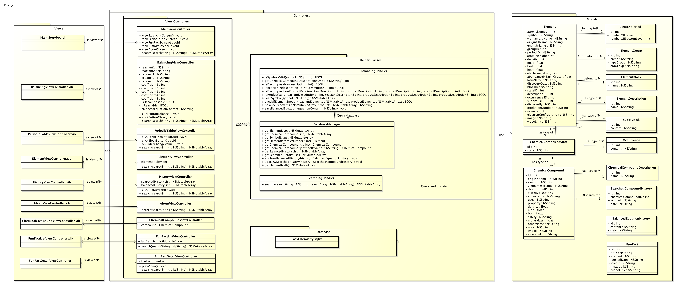

Figure : EC Application Package Diagram

|  |  |  |
| --- | --- | --- |
| Package | Description | Note |
| View Controllers | Contain all controller classes that handle functions corresponding to user actions |  |
| Helper Classes | Contain all helper classes that support controller classes and a class to interact with database |  |
| Views | Contain UI files, such as Main.storyboard, .xib files… |  |
| Database | Contain .sqlite file and sqlite library |  |
| Models | Contain all Entity classes | About Entity classes’ details, refer to EC Data Design file. |

#### Architecturally Significant Design Packages

##### View Controllers Package

###### MainViewController class

Attribute:

N/A

Method

|  |
| --- |
| viewBalancingScreen () |
| * **Return:** void * **Visibility:** public * **Purpose:** * Handle when user click button Balancing Reaction to open Balancing screen |
| **Parameters:** N/A |

|  |
| --- |
| viewPeriodicTableScreen () |
| * **Return:** void * **Visibility:** public * **Purpose:** * Handle when user click button Periodic Table to open Periodic Table screen |
| **Parameters:** N/A |

|  |
| --- |
| viewFunFactScreen () |
| * **Return:** void * **Visibility:** public * **Purpose:** * Handle when user click button Fun Fact to open Fun Fact screen |
| **Parameters:** N/A |

|  |
| --- |
| viewHistoryScreen () |
| * **Return:** void * **Visibility:** public * **Purpose:** * Handle when user click button History to open History screen |
| **Parameters:** N/A |

|  |
| --- |
| viewAboutScreen () |
| * **Return:** void * **Visibility:** public * **Purpose:** * Handle when user click button About to open About screen |
| **Parameters:** N/A |

|  |  |  |  |
| --- | --- | --- | --- |
| search() | | | |
| * **Return:** NSMutableArray * **Visibility:** public * **Purpose:** * Search for a compound * Return array of results | | | |
| **Parameters** | | | |
| **No.** | **Parameter** | **Type** | **Description** |
| 1 | searchString | NSString | The compound string to be searched |

###### BalancingViewController class

Attribute

|  |  |  |  |
| --- | --- | --- | --- |
| Attributes | Type | Visibility | Description |
| reactant1 | NSString | Private | Symbol of the first reactant |
| reactant2 | NSString | Private | Symbol of the second reactant |
| product1 | NSString | Private | Symbol of the first product |
| product2 | NSString | Private | Symbol of the first product |
| product3 | NSString | Private | Symbol of the first product |
| coefficient1 | int | Private | Coefficient of reactant 1 |
| coefficient2 | int | Private | Coefficient of reactant 2 |
| coefficient3 | int | Private | Coefficient of product 1 |
| coefficient4 | int | Private | Coefficient of product 2 |
| coefficient5 | Int | Private | Coefficient of product 3 |
| isDecomposable | BOOL | Private | Flag to check if a reactant can be decomposable |
| isReactable | BOOL | Private | Flag to check if 2 reactants can react to each other |
| balancedEquationContent | NSString | Private | Content string of balanced Equation |

Method

|  |
| --- |
| clickButtonBalance() |
| * **Return:** void * **Visibility:** public * **Purpose:** * Handle when user click button Balance to balance reaction |
| **Parameters:** N/A |

|  |
| --- |
| clickButtonClear() |
| * **Return:** void * **Visibility:** public * **Purpose:** * Handle when user click button Clear to reset screen |
| **Parameters:** N/A |

|  |  |  |  |
| --- | --- | --- | --- |
| search() | | | |
| * **Return:** NSMutableArray * **Visibility:** public * **Purpose:** * Search for a compound * Return array of results | | | |
| **Parameters** | | | |
| **No.** | **Parameter** | **Type** | **Description** |
| 1 | searchString | NSString | The compound string to be searched |

###### PeriodicTableViewController class

Attribute

N/A

Method

|  |
| --- |
| clickEachElementButton() |
| * **Return:** void * **Visibility:** public * **Purpose:** * Handle when user click each element button to view element’s detail |
| **Parameters:** N/A |

|  |
| --- |
| clickBlockButton() |
| * **Return:** void * **Visibility:** public * **Purpose:** * Handle when user click each block button to view elements of block |
| **Parameters:** N/A |

|  |
| --- |
| onSliderChangeValue() |
| * **Return:** void * **Visibility:** public * **Purpose:** * Handle when user drag temperature slider to change value |
| **Parameters:** N/A |

|  |  |  |  |
| --- | --- | --- | --- |
| search() | | | |
| * **Return:** NSMutableArray * **Visibility:** public * **Purpose:** * Search for a compound * Return array of results | | | |
| **Parameters** | | | |
| **No.** | **Parameter** | **Type** | **Description** |
| 1 | searchString | NSString | The compound string to be searched |

###### ElementViewController class

Attribute

|  |  |  |  |
| --- | --- | --- | --- |
| Attributes | Type | Visibility | Description |
| element | Element | Private | Element to be displayed |

Method

|  |  |  |  |
| --- | --- | --- | --- |
| search() | | | |
| * **Return:** NSMutableArray * **Visibility:** public * **Purpose:** * Search for a compound * Return array of results | | | |
| **Parameters** | | | |
| **No.** | **Parameter** | **Type** | **Description** |
| 1 | searchString | NSString | The compound string to be searched |

###### HistoryViewController class

Attribute

|  |  |  |  |
| --- | --- | --- | --- |
| Attributes | Type | Visibility | Description |
| searchedHistoryList | NSMutableArray | Private | List of SearchedCompoundHistory to be displayed |
| balancedHistoryList | NSMutableArray | Private | List of BalancedEquationHistory to be displayed |

Method

|  |
| --- |
| clickHistoryTab () |
| * **Return:** void * **Visibility:** public * **Purpose:** * Handle when user click on each tab to view balanced equations or searched compounds |
| **Parameters:** N/A |

|  |  |  |  |
| --- | --- | --- | --- |
| search() | | | |
| * **Return:** NSMutableArray * **Visibility:** public * **Purpose:** * Search for a compound * Return array of results | | | |
| **Parameters** | | | |
| **No.** | **Parameter** | **Type** | **Description** |
| 1 | searchString | NSString | The compound string to be searched |

###### AboutViewController class

Attribute

N/A

Method

|  |  |  |  |
| --- | --- | --- | --- |
| search() | | | |
| * **Return:** NSMutableArray * **Visibility:** public * **Purpose:** * Search for a compound * Return array of results | | | |
| **Parameters** | | | |
| **No.** | **Parameter** | **Type** | **Description** |
| 1 | searchString | NSString | The compound string to be searched |

###### ChemicalCompoundViewController class

Attribute

|  |  |  |  |
| --- | --- | --- | --- |
| Attributes | Type | Visibility | Description |
| compound | NSMutableArray | Private | List of ChemicalCompounds |

Method

N/A

###### FunFactListViewController class

Attribute

|  |  |  |  |
| --- | --- | --- | --- |
| Attributes | Type | Visibility | Description |
| funFactList | NSMutableArray | Private | List of FunFacts to be displayed |

Method

|  |  |  |  |
| --- | --- | --- | --- |
| search() | | | |
| * **Return:** NSMutableArray * **Visibility:** public * **Purpose:** * Search for a compound * Return array of results | | | |
| **Parameters** | | | |
| **No.** | **Parameter** | **Type** | **Description** |
| 1 | searchString | NSString | The compound string to be searched |

###### FunFactDetailViewController class

Attribute

|  |  |  |  |
| --- | --- | --- | --- |
| Attributes | Type | Visibility | Description |
| funFact | FunFact | Private | The FunFact to be displayed in detail |

Method

|  |
| --- |
| playVideo() |
| * **Return:** void * **Visibility:** public * **Purpose:** * Handle when user click on video to play |
| **Parameters:** N/A |

|  |  |  |  |
| --- | --- | --- | --- |
| search() | | | |
| * **Return:** NSMutableArray * **Visibility:** public * **Purpose:** * Search for a compound * Return array of results | | | |
| **Parameters** | | | |
| **No.** | **Parameter** | **Type** | **Description** |
| 1 | searchString | NSString | The compound string to be searched |

##### Helper Classes package

###### BalancingHandler class

Attribute:

N/A

Method:

|  |  |  |  |
| --- | --- | --- | --- |
| isSymbolValid() | | | |
| * **Return:** BOOL * **Visibility:** public * **Purpose:** * Check if a symbol is valid. * Return YES if symbol is valid, return NO if not.   (A symbol is valid when it contains only literal letter, positive numeric character, “.”, “(”, “)”, “[”, “]”. Must not have two continuous lowercase literal letter) | | | |
| **Parameters** | | | |
| **No.** | **Parameter** | **Type** | **Description** |
| 1 | symbol | NSString | the symbol to be checked |

|  |  |  |  |
| --- | --- | --- | --- |
| getChemicalCompoundDescription() | | | |
| * **Return:** int * **Visibility:** public * **Purpose:** * Check description of compound (for example: acid, base, metal…) * Return int value that corresponds to the description | | | |
| **Parameters** | | | |
| **No.** | **Parameter** | **Type** | **Description** |
| 1 | symbol | NSString | the symbol to be checked |

|  |  |  |  |
| --- | --- | --- | --- |
| isDecomposable() | | | |
| * **Return:** BOOL * **Visibility:** public * **Purpose:** * Check if the reactant can be decomposed. * Return YES if it is decomposable, return NO if not. | | | |
| **Parameters** | | | |
| **No.** | **Parameter** | **Type** | **Description** |
| 1 | description | int | the description of compound to be checked |

|  |  |  |  |
| --- | --- | --- | --- |
| isReactable() | | | |
| * **Return:** BOOL * **Visibility:** public * **Purpose:** * Check if two reactants can react to each other. * Return YES if it is react able, return NO if not. | | | |
| **Parameters** | | | |
| **No.** | **Parameter** | **Type** | **Description** |
| 1 | description1 | int | the description of the reactant 1 |
| 2 | description2 | int | the description of the reactant 2 |

|  |  |  |  |
| --- | --- | --- | --- |
| isDecompositionProductValid() | | | |
| * **Return:** BOOL * **Visibility:** public * **Purpose:** * Check if the products of the decomposition reaction are valid * Return YES if products are valid, return NO if not. | | | |
| **Parameters** | | | |
| **No.** | **Parameter** | **Type** | **Description** |
| 1 | reactantDescription1 | int | the description of the reactant that be decomposed |
| 2 | productDescription1 | int | the description of the product 1 |
| 3 | productDescription2 | int | the description of the product 2 |
| 4 | productDescription3 | int | the description of the product 3 |

|  |  |  |  |
| --- | --- | --- | --- |
| isProductValid() | | | |
| * **Return:** BOOL * **Visibility:** public * **Purpose:** * Check if the products of the reaction are valid when two reactants react to each other * Return YES if products are valid, return NO if not. | | | |
| **Parameters** | | | |
| **No.** | **Parameter** | **Type** | **Description** |
| 1 | reactantDescription1 | int | the description of the reactant 1 |
| 2 | reactantDescription2 | int | the description of the reactant 2 |
| 3 | productDescription1 | int | the description of the product 1 |
| 4 | productDescription2 | int | the description of the product 2 |
| 5 | productDescription3 | int | the description of the product 3 |

|  |  |  |  |
| --- | --- | --- | --- |
| readSymbol() | | | |
| * **Return:** NSMutableArray * **Visibility:** public * **Purpose:** * Read and separate the symbol of compound to array of unique chemical elements and its number inside this compound. * Return this array of unique chemical elements and its number | | | |
| **Parameters** | | | |
| **No.** | **Parameter** | **Type** | **Description** |
| 1 | symbol | NSString | the symbol to be read |

|  |  |  |  |
| --- | --- | --- | --- |
| checkIfElementEnough() | | | |
| * **Return:** BOOL * **Visibility:** public * **Purpose:** * Check if the amount of unique elements in product side is equal to the amount of unique elements in reactant side. (For example: There are Fe, H and O elements in reactant side. Those elements also need to have in product side.) * Return YES if elements are enough, return NO if not. | | | |
| **Parameters** | | | |
| **No.** | **Parameter** | **Type** | **Description** |
| 1 | reactantElements | NSMutableArray | Array of unique elements in reactant side |
| 2 | productElements | NSMutableArray | Array of unique elements in product side |

|  |  |  |  |
| --- | --- | --- | --- |
| balance() | | | |
| * **Return:** NSString * **Visibility:** public * **Purpose:** * Balance the chemical equation required by user * Return the content string of balanced equation | | | |
| **Parameters** | | | |
| **No.** | **Parameter** | **Type** | **Description** |
| 1 | reactants | NSMutableArray | Array of reactants |
| 2 | products | NSMutableArray | Array of products |

|  |  |  |  |
| --- | --- | --- | --- |
| saveBalancedEquation() | | | |
| * **Return:** void * **Visibility:** public * **Purpose:** * Save the content string of balanced equation to database | | | |
| **Parameters** | | | |
| **No.** | **Parameter** | **Type** | **Description** |
| 1 | equationContent | NSString | the content string of balanced equation to be saved |

###### SearchingHandler class

Attribute:

N/A

Method:

|  |  |  |  |
| --- | --- | --- | --- |
| search() | | | |
| * **Return:** NSMutableArray * **Visibility:** public * **Purpose:** * Search for a compound * Return array of results | | | |
| **Parameters** | | | |
| **No.** | **Parameter** | **Type** | **Description** |
| 1 | searchString | NSString | The compound string to be searched |

|  |  |  |  |
| --- | --- | --- | --- |
| saveSearchedHistory() | | | |
| * **Return:** void * **Visibility:** public * **Purpose:** * Save the searched compound to database | | | |
| **Parameters** | | | |
| **No.** | **Parameter** | **Type** | **Description** |
| 1 | compoundSymbol | NSString | the symbol of compound to be saved |

###### DatabaseManager class

Attribute:

N/A

Method:

|  |
| --- |
| getElementList() |
| * **Return:** NSMutableArray * **Visibility:** public * **Purpose:** * Get all Elements from database * Return array of all Elements from database |
| **Parameters:** N/A |

|  |
| --- |
| getChemicalCompoundList() |
| * **Return:** NSMutableArray * **Visibility:** public * **Purpose:** * Get all Chemical Compounds from database * Return array of all Compounds from database |
| **Parameters:** N/A |

|  |
| --- |
| getSymbolList() |
| * **Return:** NSMutableArray * **Visibility:** public * **Purpose:** * Get all Symbols of Compounds from database * Return array of all Symbols from database |
| **Parameters:** N/A |

|  |  |  |  |
| --- | --- | --- | --- |
| getElement() | | | |
| * **Return:** Element * **Visibility:** public * **Purpose:** * Get an Element by its atomic number from database * Return the Element | | | |
| **Parameters** | | | |
| **No.** | **Parameter** | **Type** | **Description** |
| 1 | atomicNumber | int | The atomic number of element |

|  |  |  |  |
| --- | --- | --- | --- |
| getChemicalCompound() | | | |
| * **Return:** Chemical Compound * **Visibility:** public * **Purpose:** * Get an Chemical Compound by its id from database * Return the Chemical Compound | | | |
| **Parameters** | | | |
| **No.** | **Parameter** | **Type** | **Description** |
| 1 | id | int | The id of compound in table |

|  |  |  |  |
| --- | --- | --- | --- |
| getChemicalCompoundBySymbol() | | | |
| * **Return:** Chemical Compound * **Visibility:** public * **Purpose:** * Get an Chemical Compound by its symbol from database * Return the Chemical Compound | | | |
| **Parameters** | | | |
| **No.** | **Parameter** | **Type** | **Description** |
| 1 | symbol | NSString | The symbol of compound in table |

|  |
| --- |
| getBalancedHistoryList() |
| * **Return:** NSMutableArray * **Visibility:** public * **Purpose:** * Get all Balanced Histories from database * Return array of all Balanced Histories from database |
| **Parameters:** N/A |

|  |
| --- |
| getSearchedHistoryList() |
| * **Return:** NSMutableArray * **Visibility:** public * **Purpose:** * Get all Searched Histories from database * Return array of all Searched Histories from database |
| **Parameters:** N/A |

|  |  |  |  |
| --- | --- | --- | --- |
| addNewBalancedHistory() | | | |
| * **Return:** void * **Visibility:** public * **Purpose:** * Save a new Balanced History to database | | | |
| **Parameters** | | | |
| **No.** | **Parameter** | **Type** | **Description** |
| 1 | history | BalancedEquationHistory | The history to be saved |

|  |  |  |  |
| --- | --- | --- | --- |
| addNewSearchedHistory() | | | |
| * **Return:** void * **Visibility:** public * **Purpose:** * Save a new Searched History to database | | | |
| **Parameters** | | | |
| **No.** | **Parameter** | **Type** | **Description** |
| 1 | history | SearchedEquationHistory | The history to be saved |

|  |
| --- |
| getElementMelt() |
| * **Return:** NSMutableArray * **Visibility:** public * **Purpose:** * Get melt temperature of all elements * Return array of temperatures |
| **Parameters:** N/A |

### Chemical equation balancing logic

#### Chemical equation balancing algorithm

Turn chemical equation to a homogeneous equation system and find solutions. The solutions of system are also the coefficients of chemical reaction equation.

For example:

x1 Al2O3  + x2 HCl-> x3 AlCl3 + x4 H2O

Al: 2x1  - x3  = 0

O: 3x1  - x4 = 0

H: x2  -2x4 = 0

Al: x2 - 3x3  = 0

Turn above equation system to a matrix:

$$\left[\begin{matrix}\begin{matrix}2 & 0 & \begin{matrix}-1 & 0\end{matrix} \\ 3 & 0 & \begin{matrix}0 & -1\end{matrix}\end{matrix} \\ \begin{matrix}0 & 1 & \begin{matrix}0 & -2\end{matrix} \\ 0 & 1 & \begin{matrix}-3 & 0\end{matrix}\end{matrix}\end{matrix}\left|\begin{matrix}0 \\ \begin{matrix}0 \\ \begin{matrix}0 \\ 0\end{matrix}\end{matrix}\end{matrix}\right.\right]$$

Using Gauss elimination to reduce matrix to be in reduced row echelon form:

Let x4  = 1. Then x3 = 2/3; x2 = 2 ; x1 = 1/3

Convert above solutions to integer:

x4  = 3 ; x3 = 2; x2 = 6 ; x1 = 1

or x1  =1; x2 = 6; x3 = 2 ; x4 = 3

Now, the balanced reaction is: Al2O3  + 6HCl-> 2AlCl3 + 3H2O

#### Balancing Flow Chart

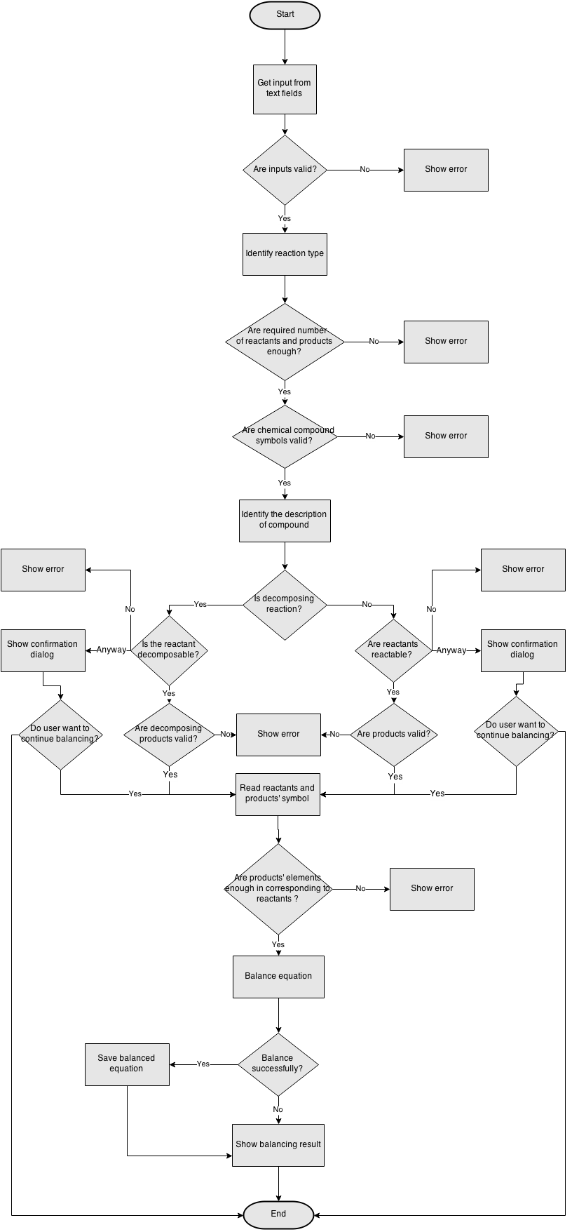

Figure 10: Balancing Flow Chart

#### Read Compound Flow Chart

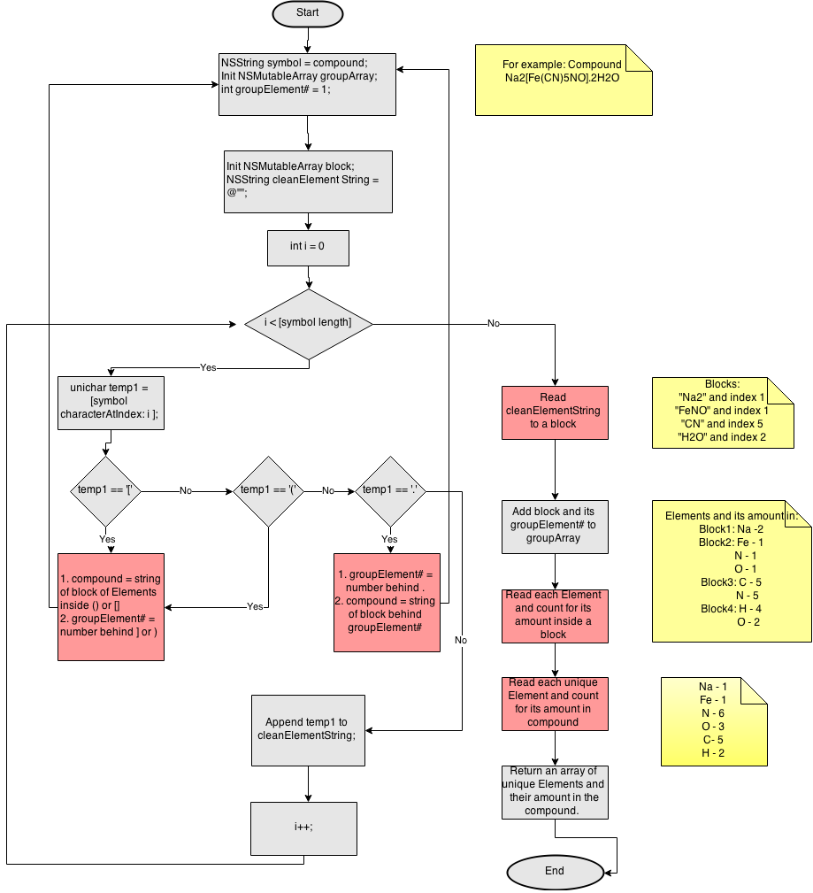

Figure 11: Read Compound Flow Chart

## Application Process View

### Balance chemical reaction

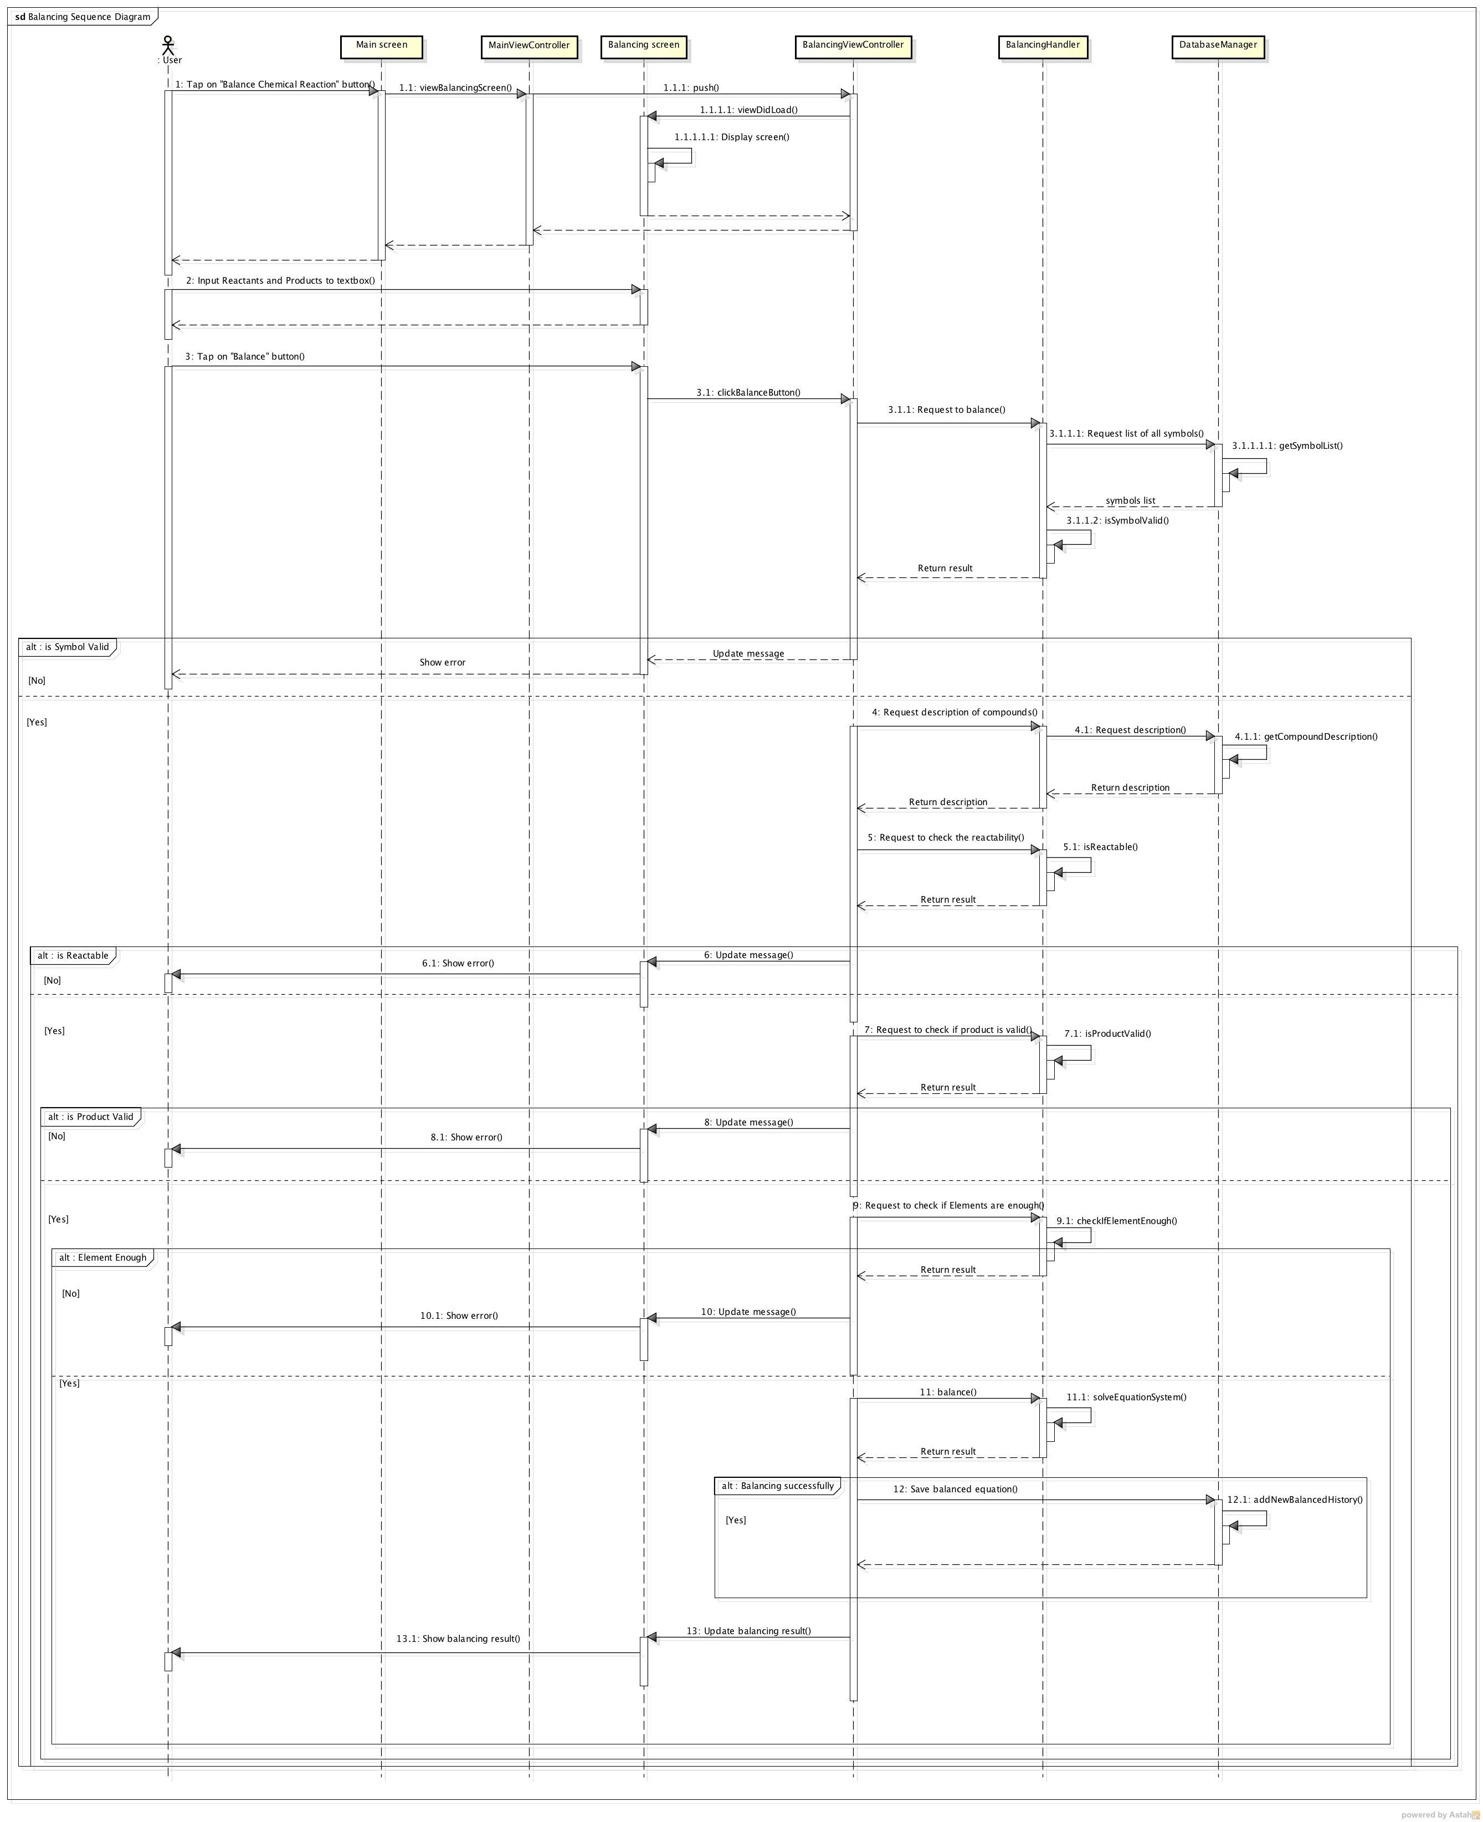

Figure : Balancing Sequence Diagram

### Search for Chemical Compound

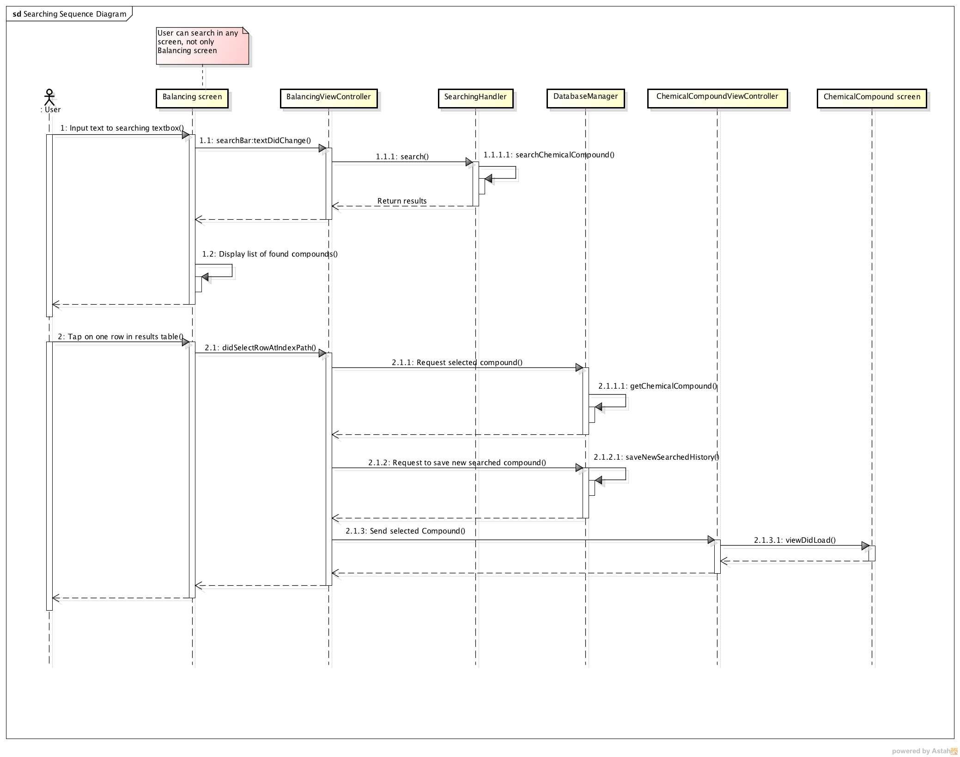

Figure : Searching Sequence Diagram

### View periodic table

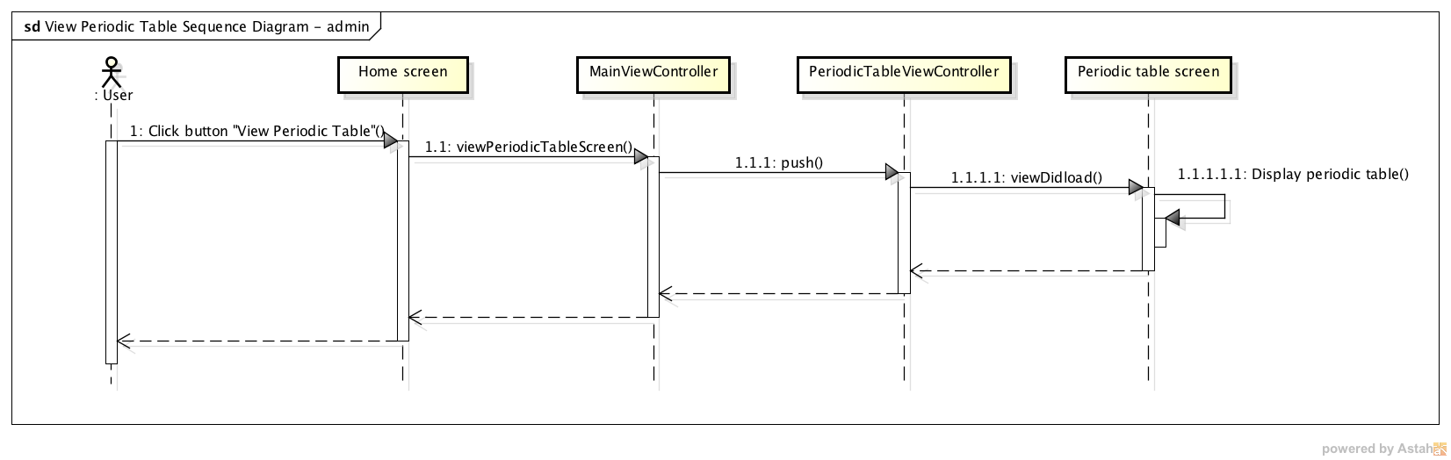

Figure : View Periodic Table Sequence Diagram

### View element

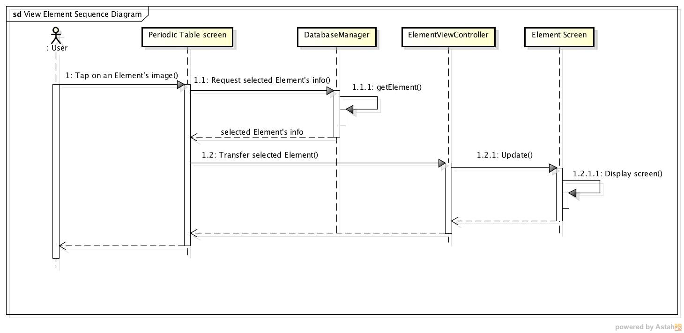

Figure : View Element Sequence Diagram

### Change temperature

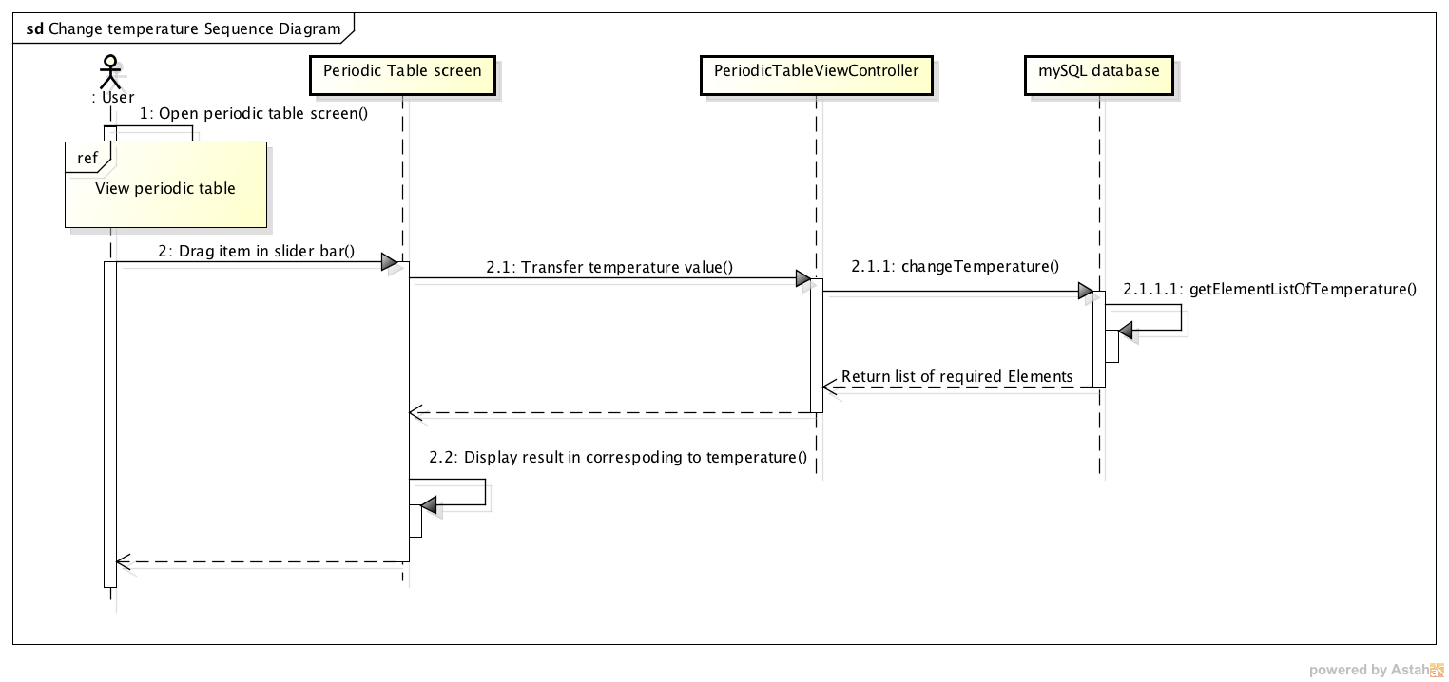

Figure : Change temperature sequence diagram

### View blocks of element

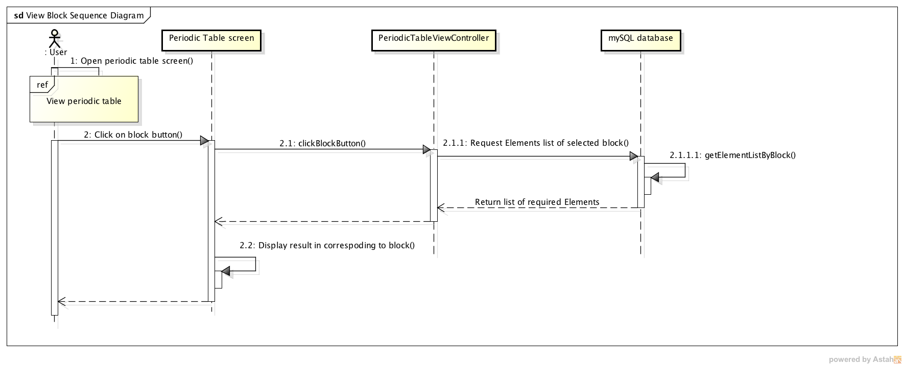

Figure : View block of element sequence diagram

### View searched history

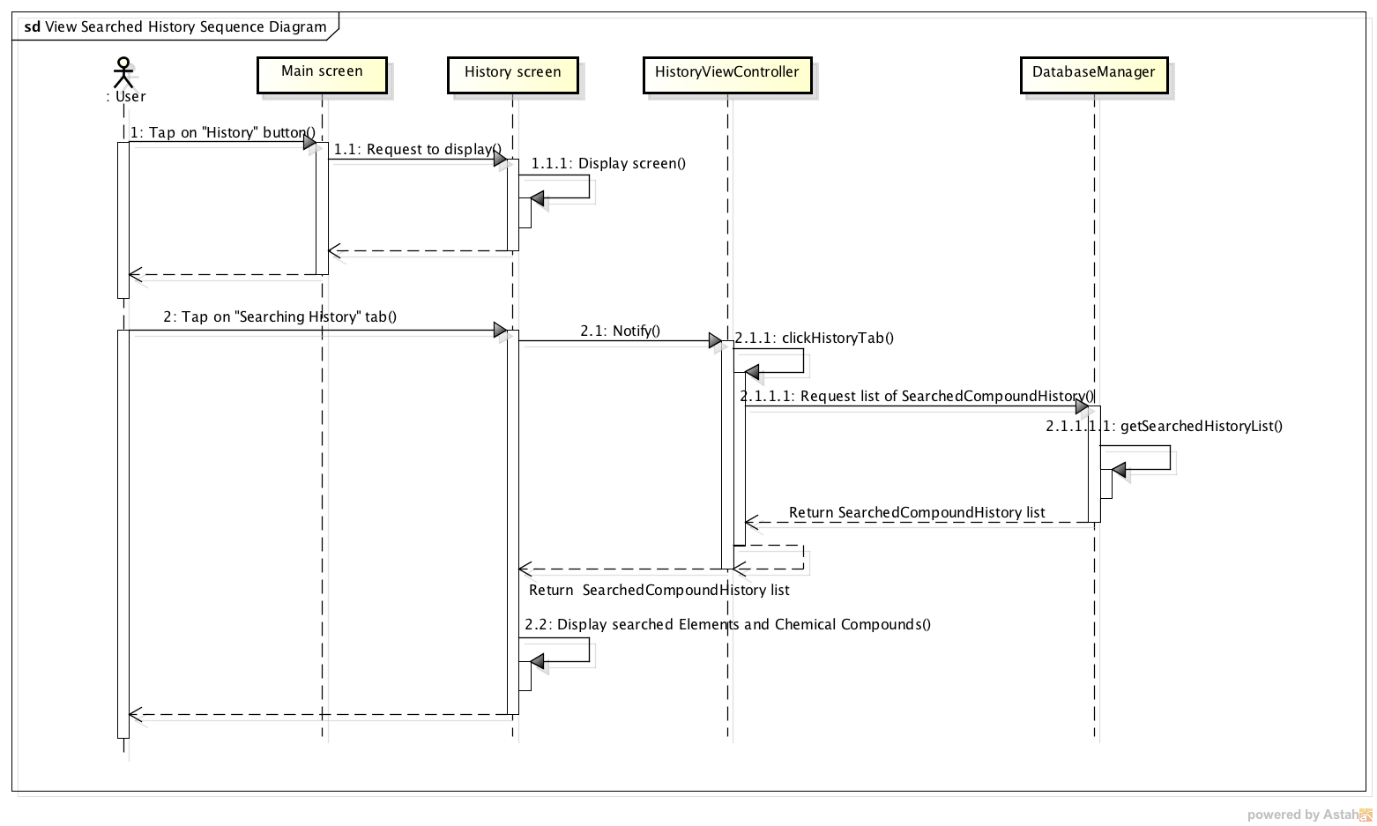

Figure : View Searched History Sequence Diagram

### View balanced history

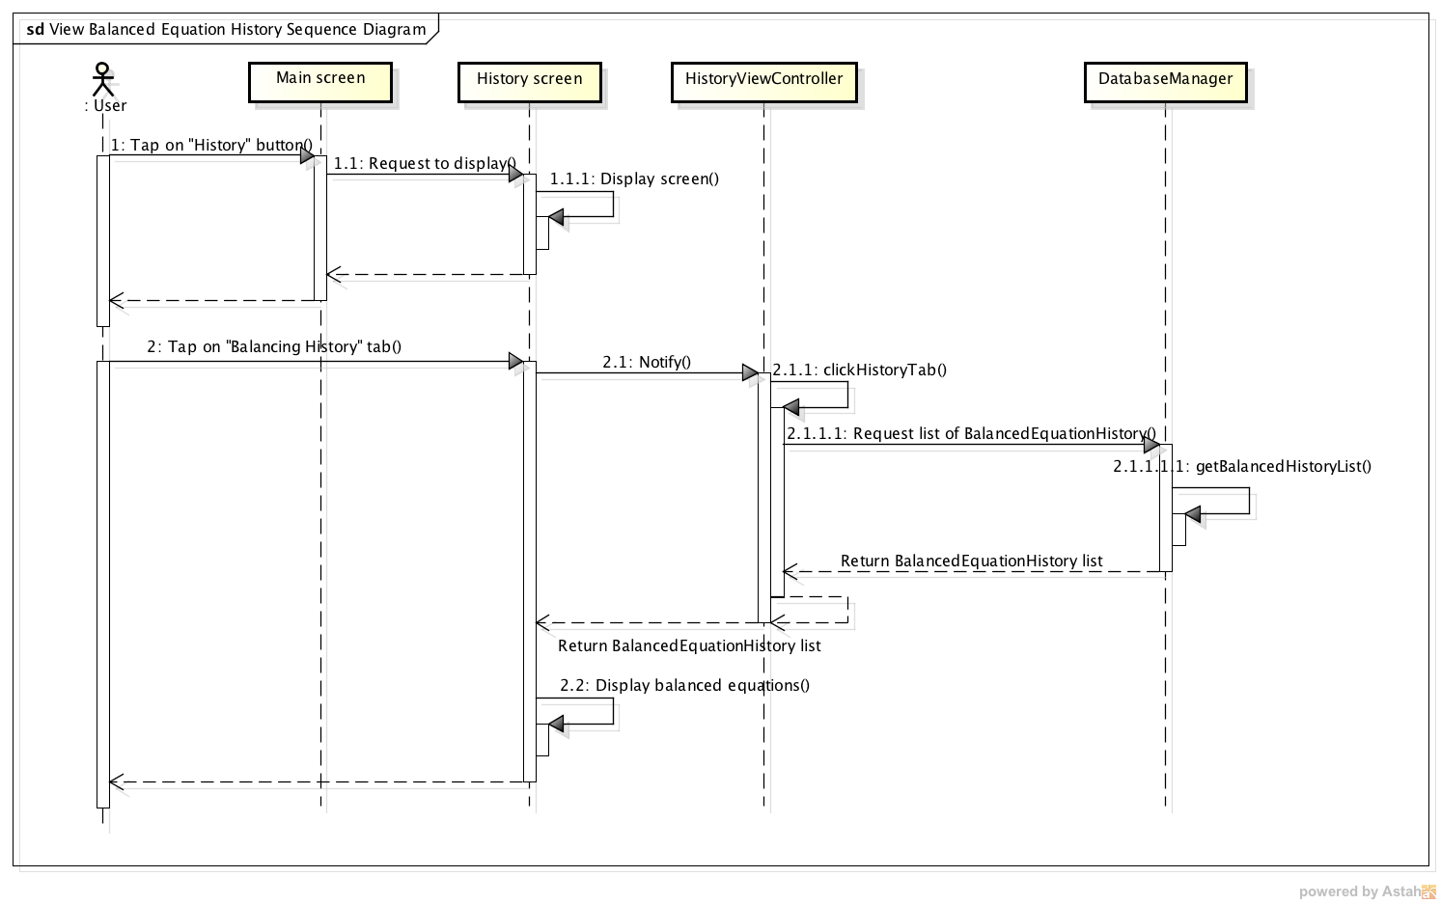

Figure : View Balanced Equation History Sequence Diagram

### About

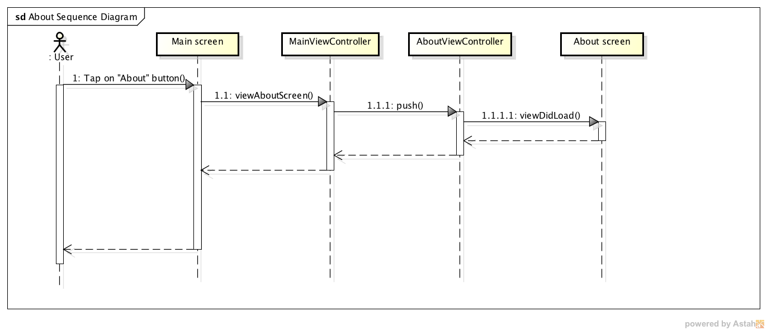

Figure : About Sequence Diagram

### View Fun Fact List

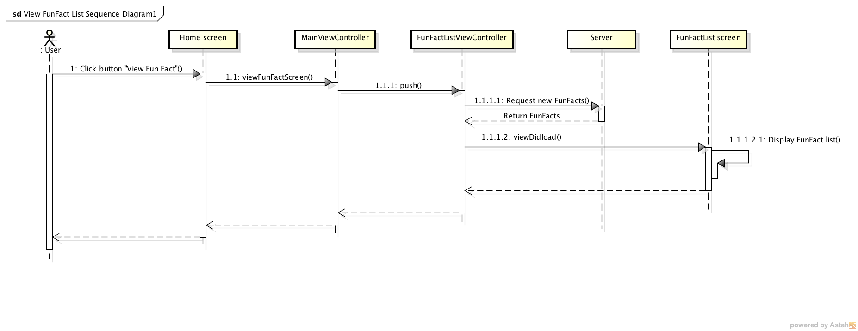

Figure : View Fun Fact List sequence diagram

### View Fun Fact detail

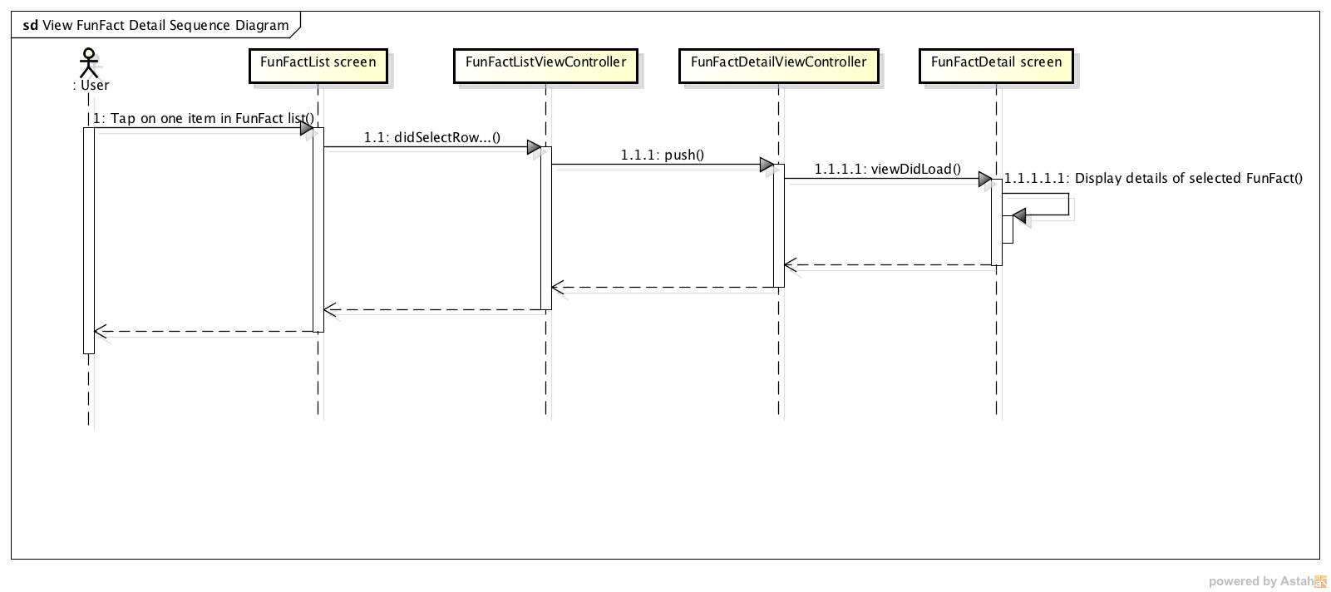

Figure : View Fun Fact Detail sequence diagram

## Server Process View

### Login

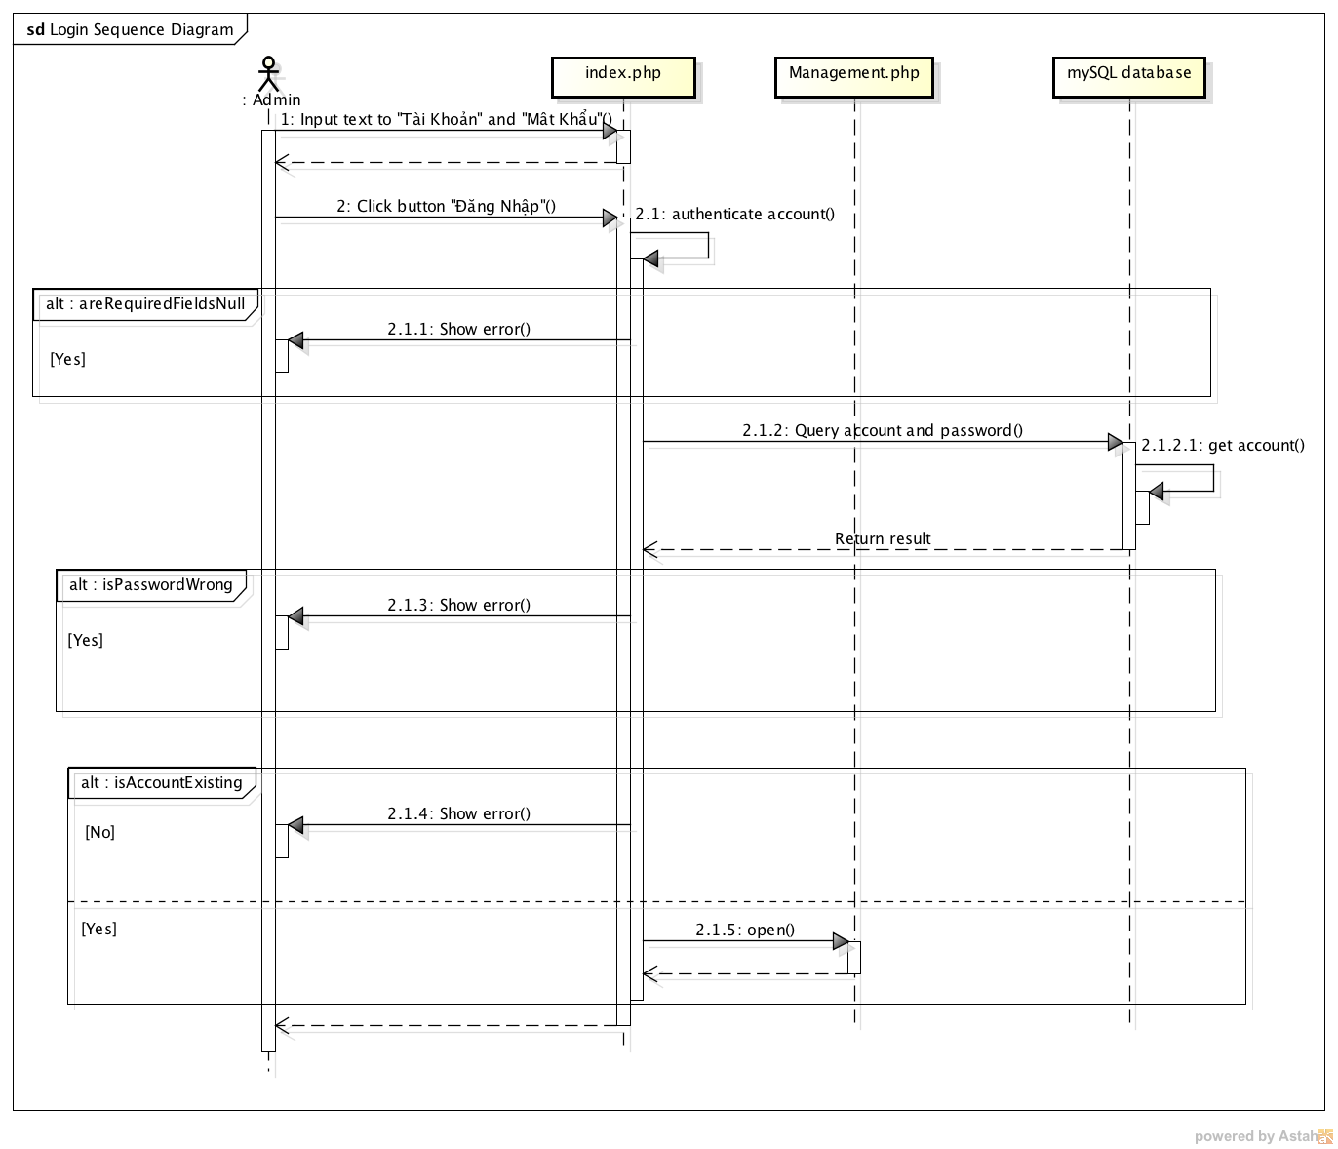

Figure : Login sequence diagram

### Logout

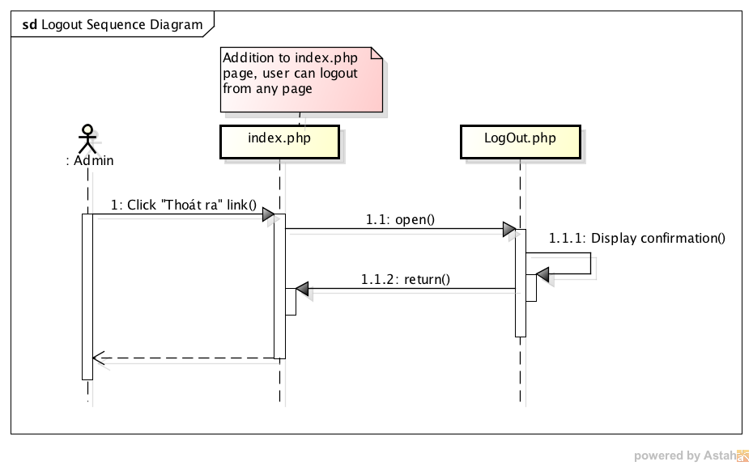

Figure : Logout sequence diagram

### Edit Profile

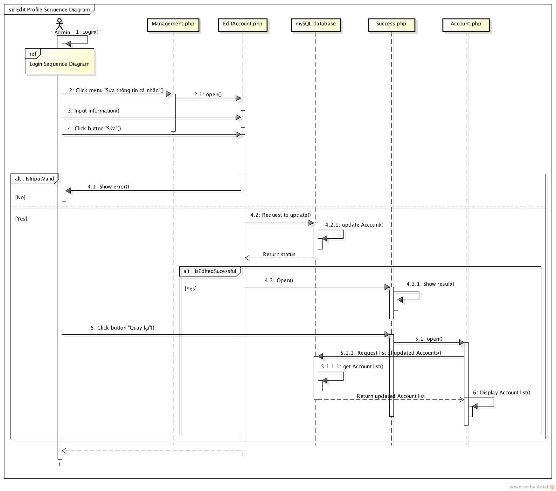

Figure : Edit profile sequence diagram

### View Account List

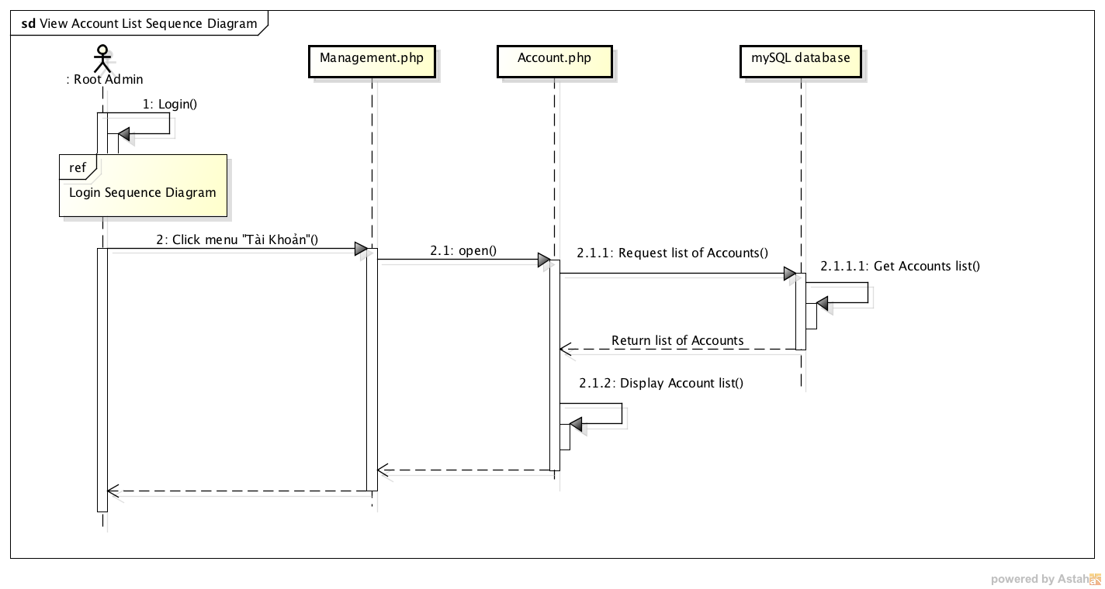

Figure : View Account List sequence diagram

### Add Account

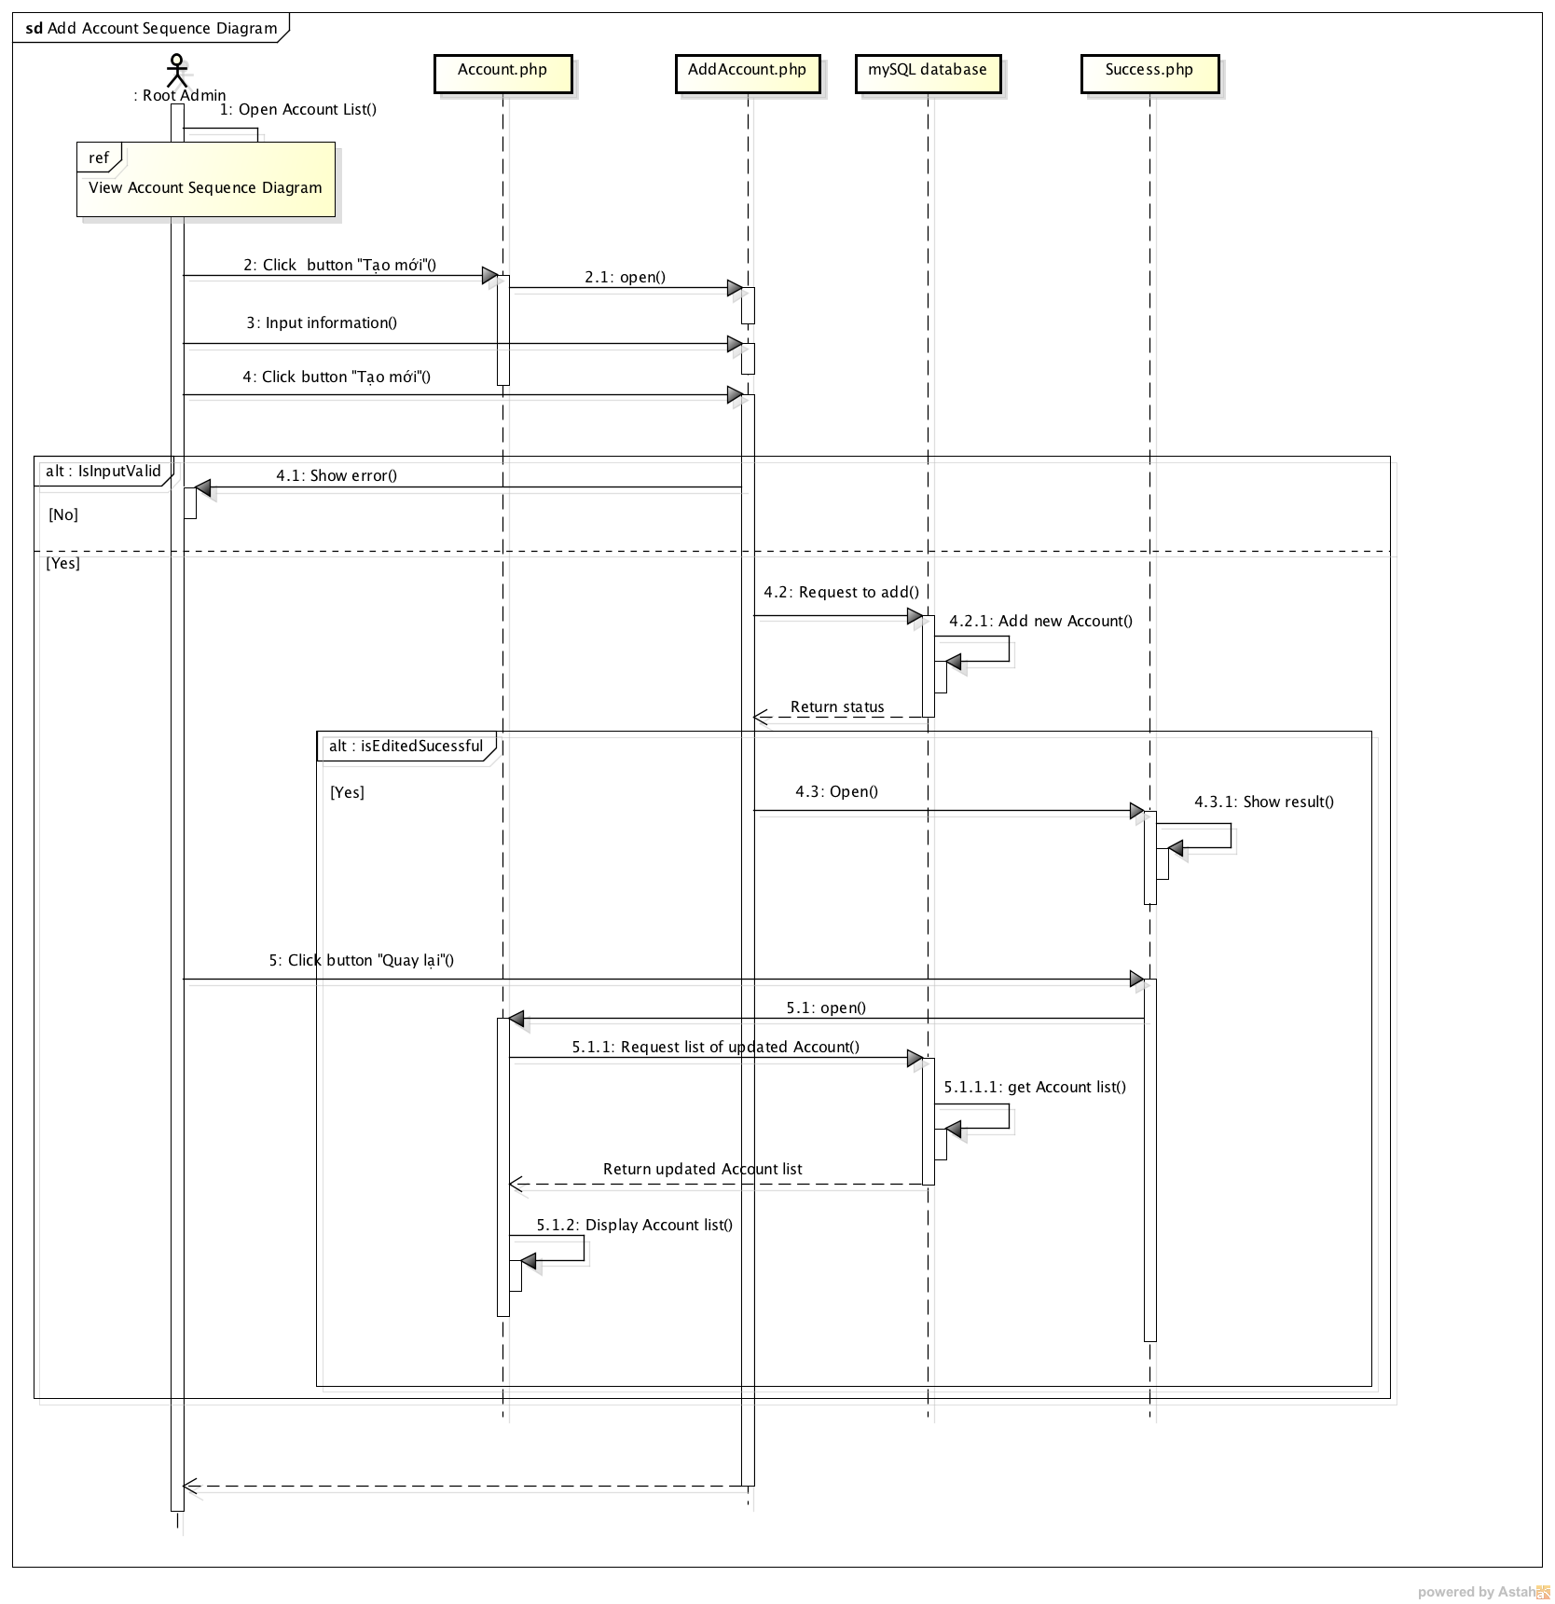

Figure : Add Account sequence diagram

### Modify Account

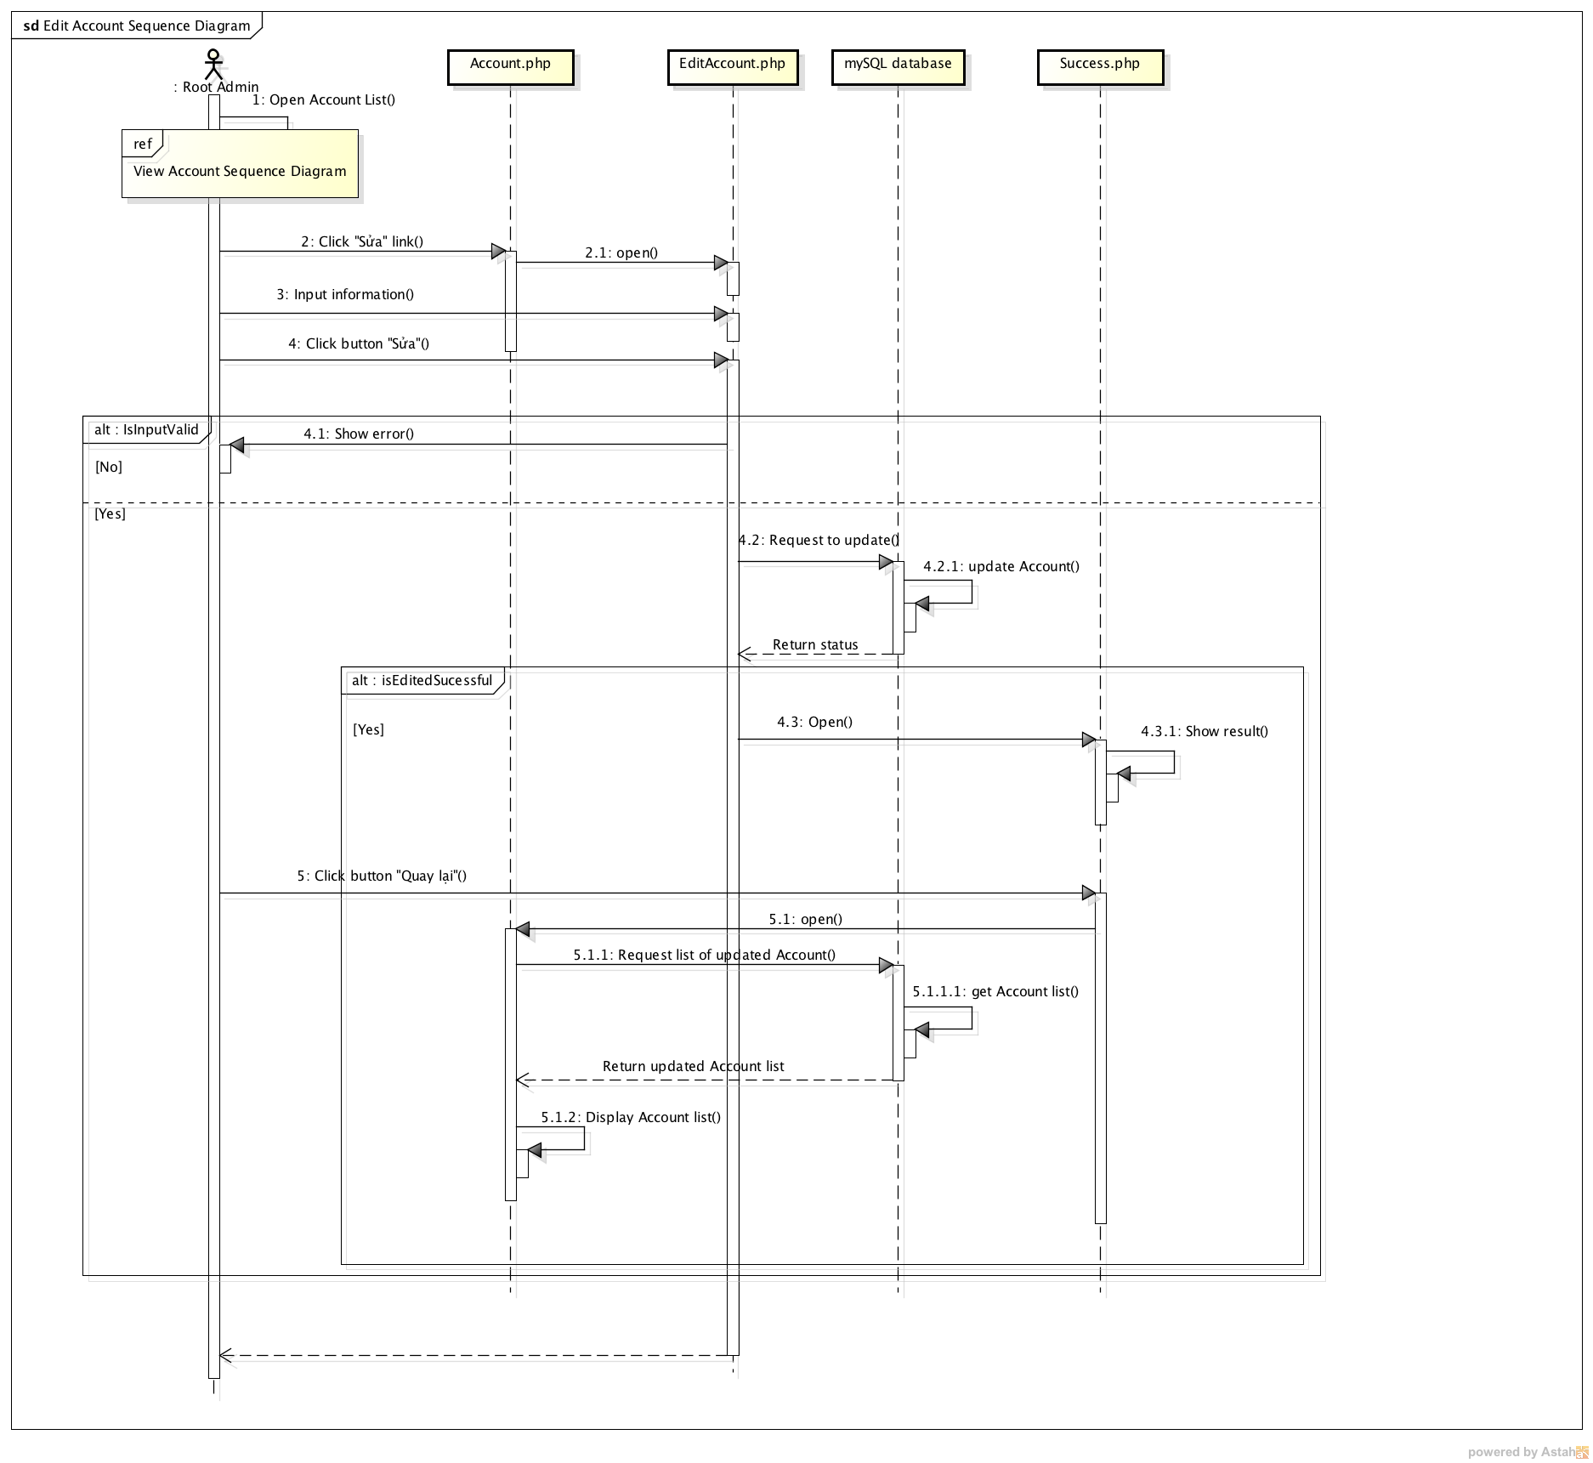

Figure : Modify Account sequence diagram

### Delete Account

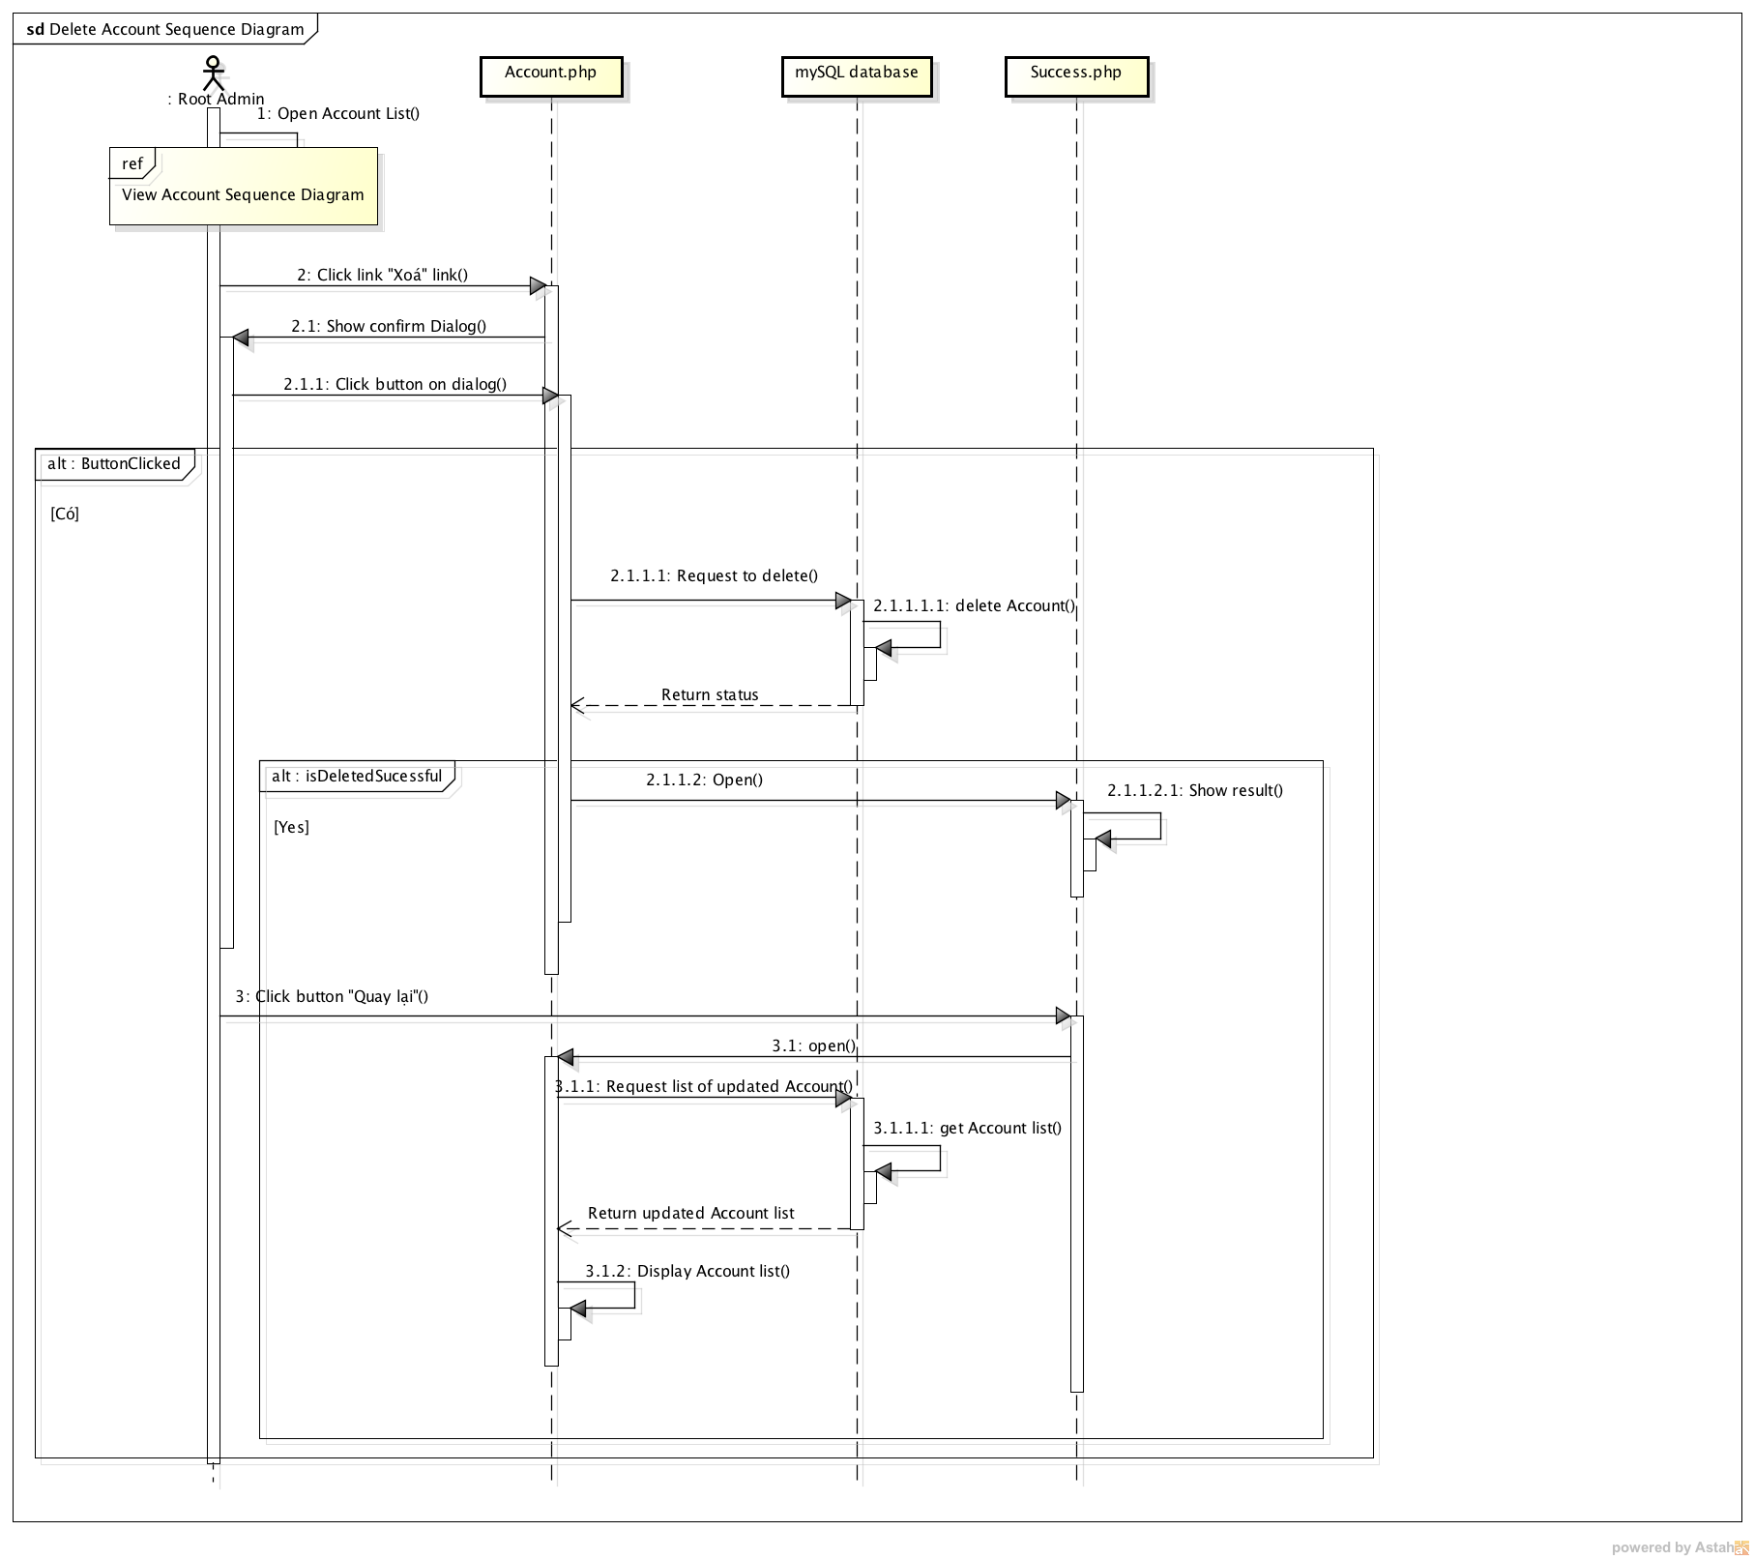

Figure : Delete Account sequence diagram

### View Fun Fact List

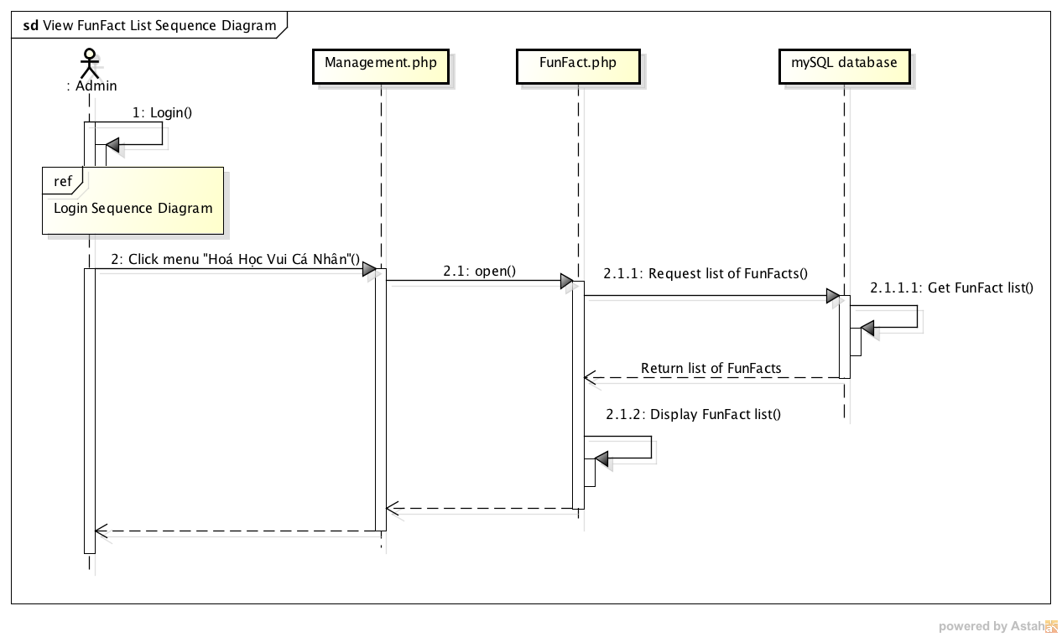

Figure : View Fun Fact List sequence diagram

### Add Fun Fact

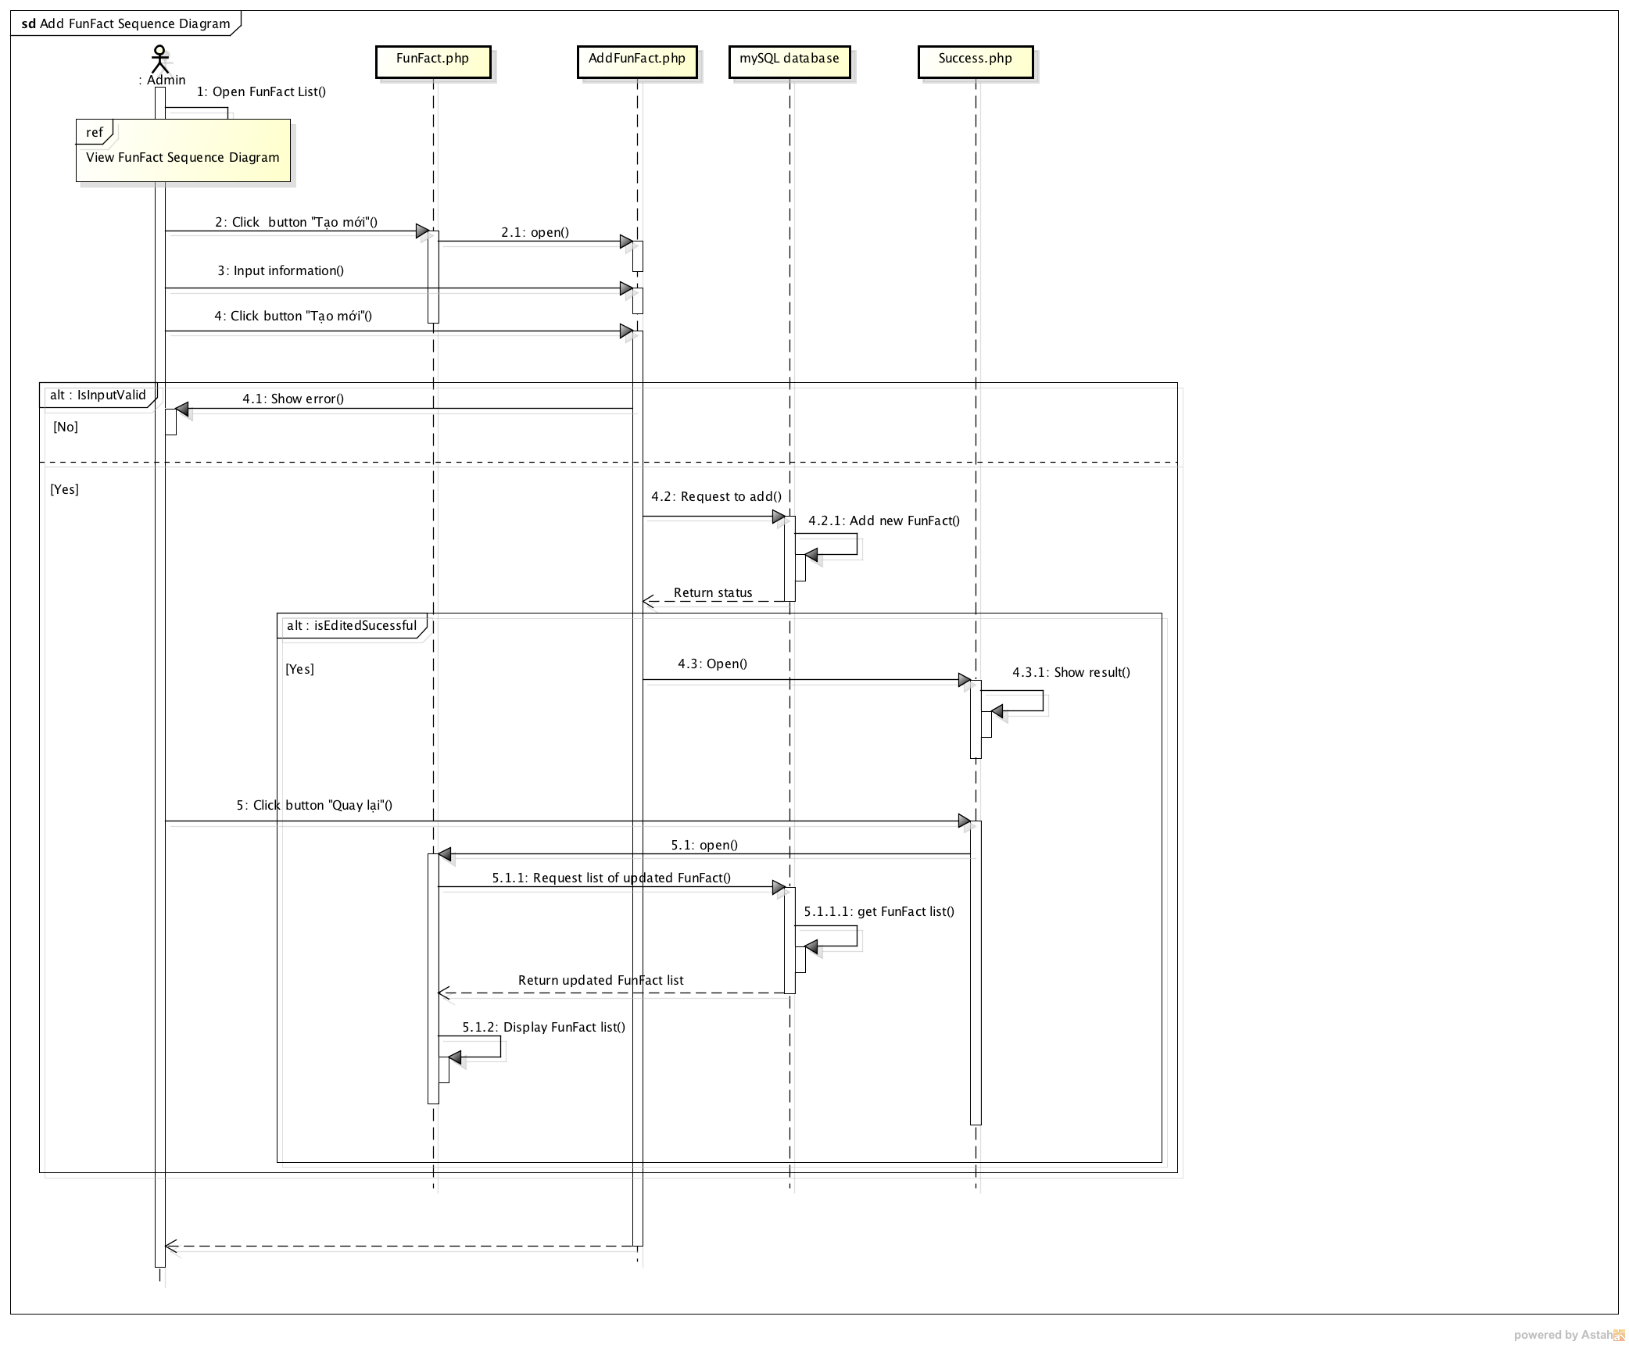

Figure : Add Fun Fact sequence diagram

### Modify Fun Fact

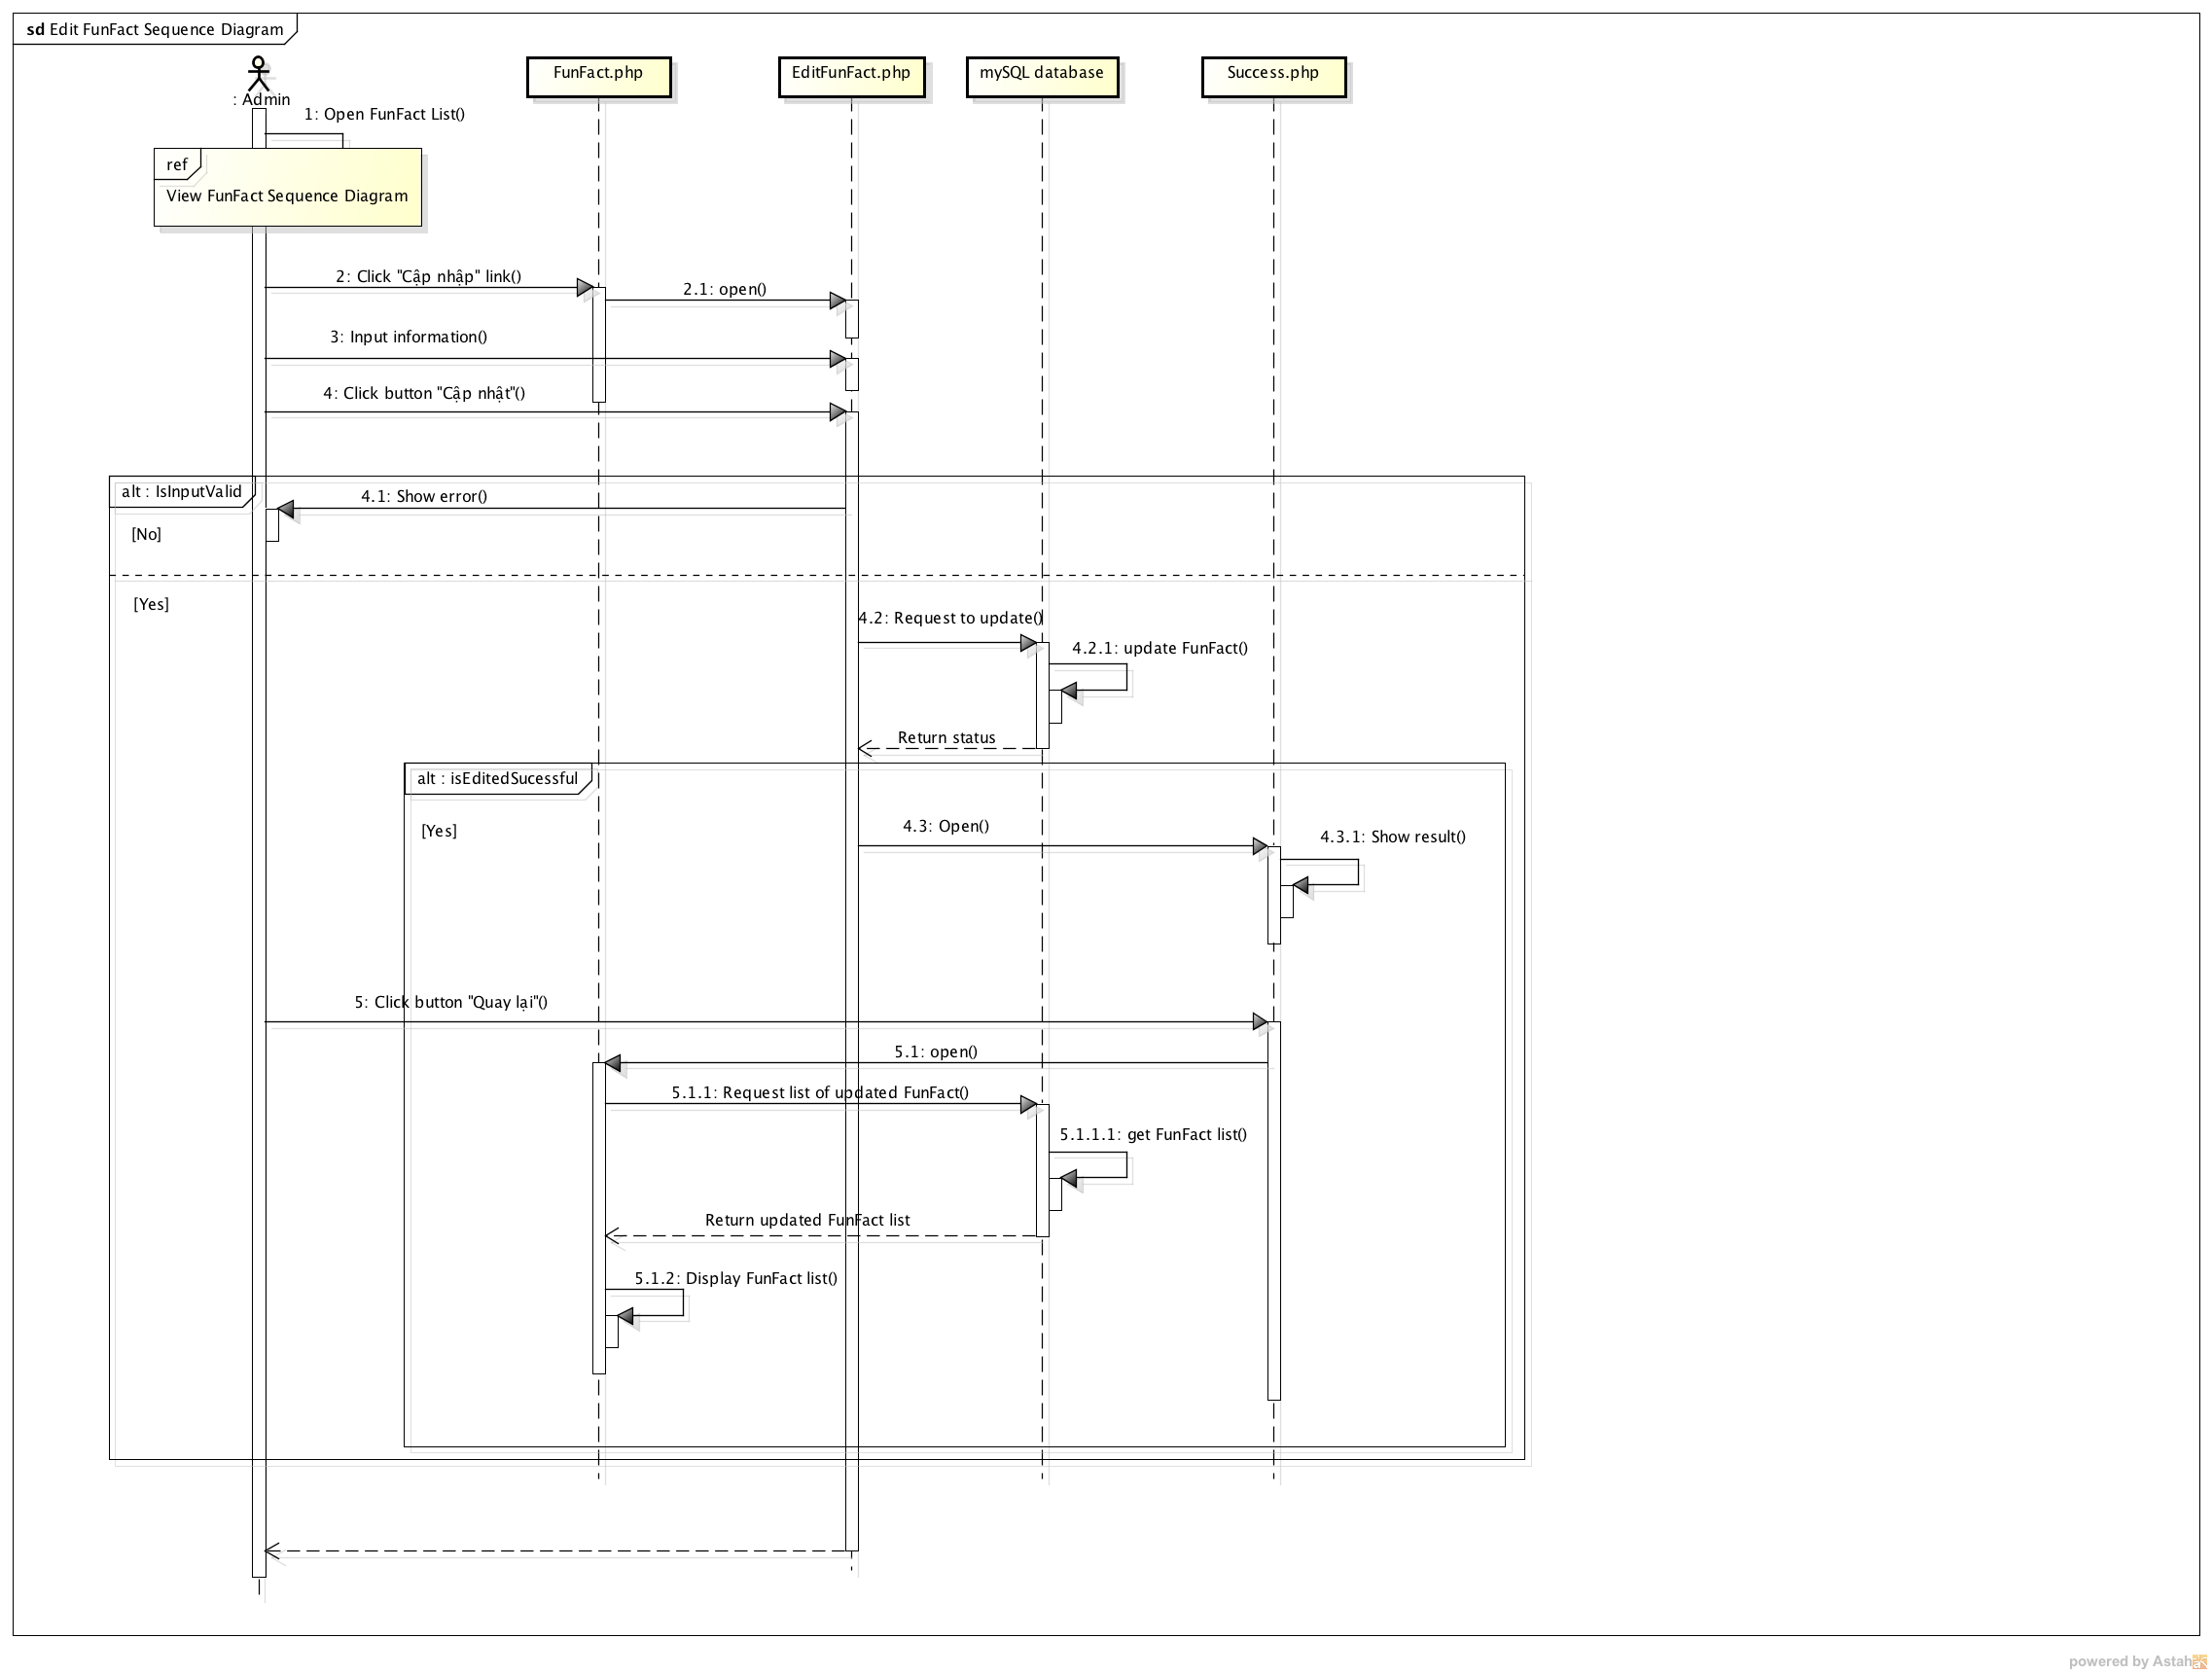

Figure : Modify Fun Fact sequence diagram

### Delete Fun Fact

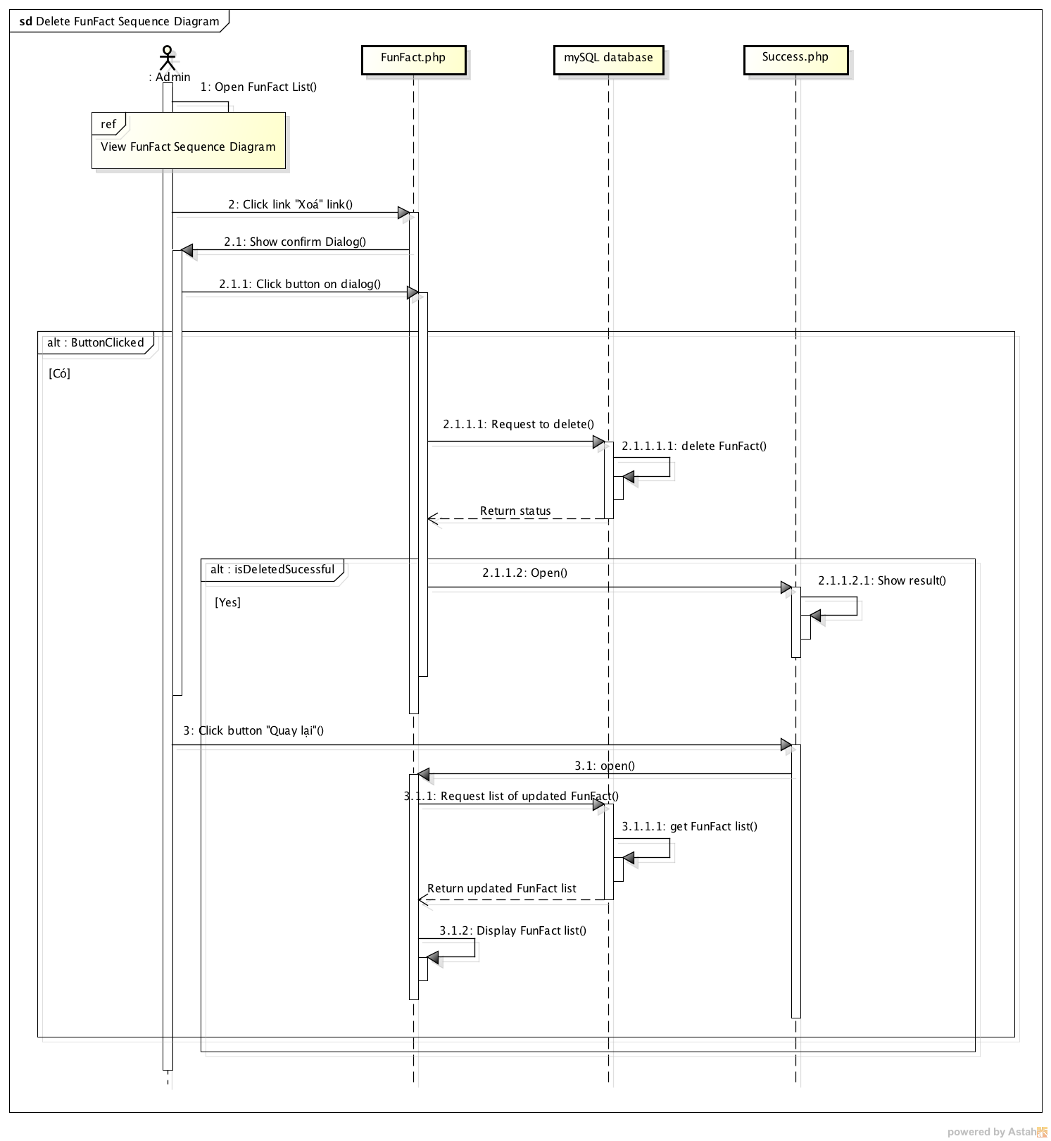

Figure : Delete Fun Fact sequence diagram

## Data Design

### ERD

#### Main Application

Below is ERD diagram of Easy Chemistry Main system. 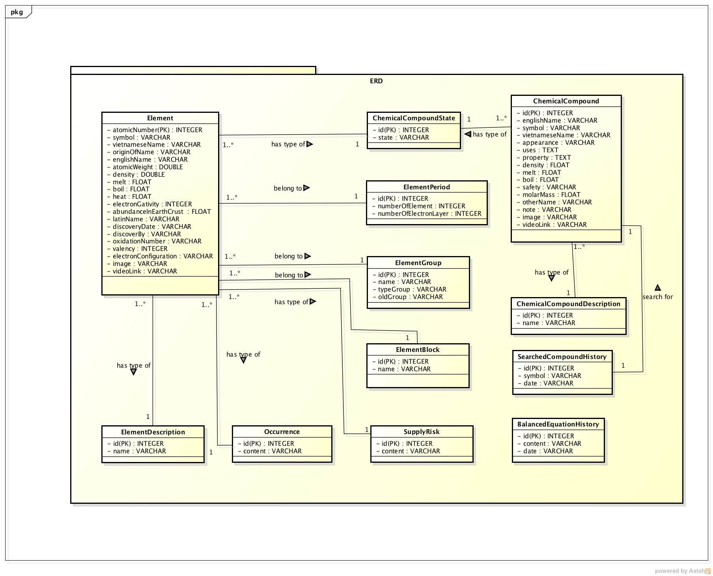

Figure : Main Application ERD

#### Admin application

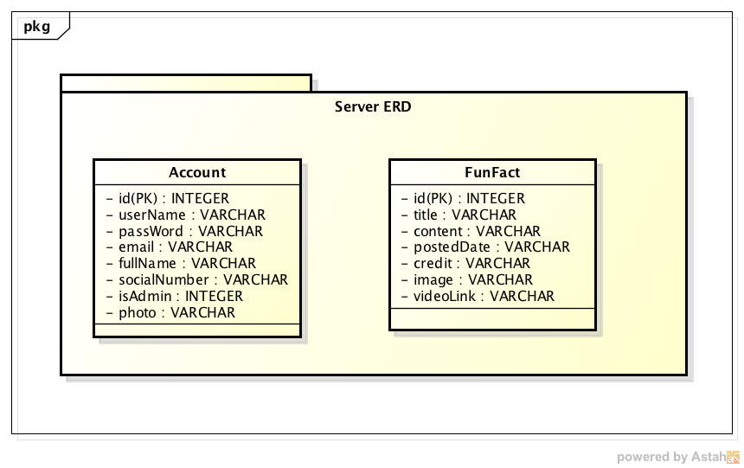

Figure : Admin application ERD

### Table Diagram

#### Main Application

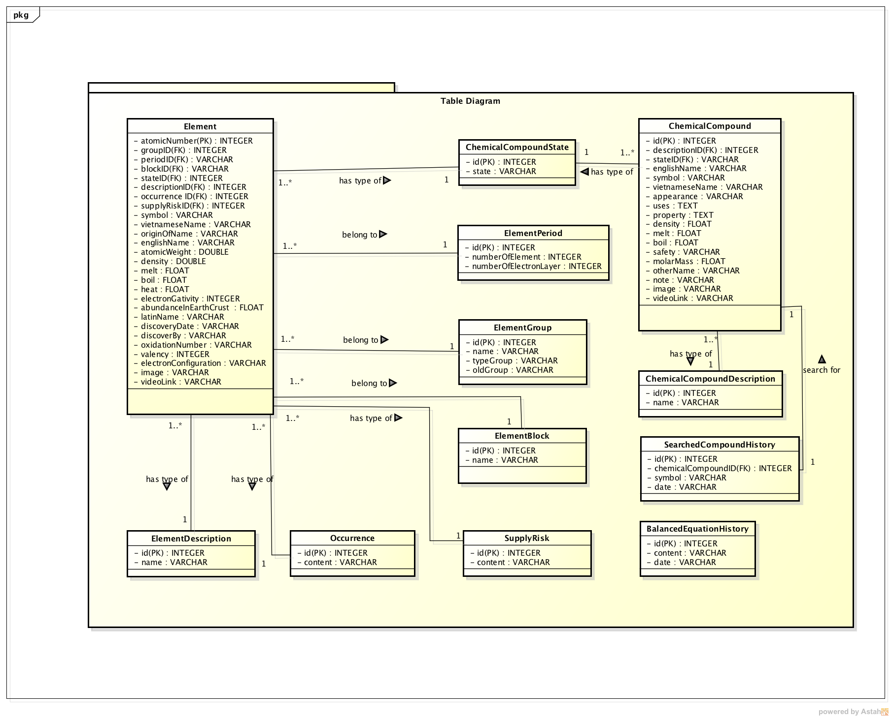

Figure : Main application table diagram

|  |  |  |
| --- | --- | --- |
| No | Table Name | Description |
| 1 | Element | Store all information of elements |
| 2 | ElementPeroid | Store all information of element’s period |
| 3 | ElementGroup | Store all information of element’s group |
| 4 | ElementBlock | Store all information of element’s block |
| 5 | ElementDescription | Store all information of element’s description |
| 6 | SupplyRisk | Store supply risk of elements. |
| 7 | Occurrence | Store occurrence of elements. |
| 8 | ChemicalCompound | Store all information of chemical compound |
| 9 | ChemicalCompoundState | Store all states of chemical compound and elements |
| 10 | ChemicalCompoundDescription | Store all information of chemical compound’s description |
| 11 | SearchedCompoundHistory | Store history of searched compounds |
| 12 | BalancedEquationHistory | Store history of balanced chemical reactions. |

#### Administration Application

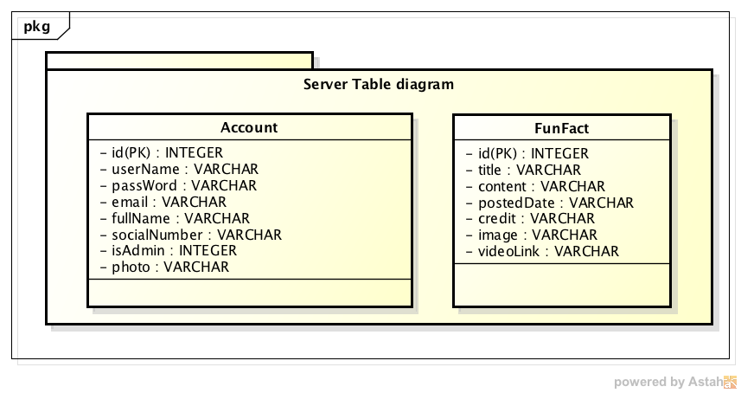

Figure : Administration Application table diagram

|  |  |  |
| --- | --- | --- |
| No | Table Name | Description |
| 1 | Account | Store all information of account |
| 2 | FunFact | Store all information of fun fact |

### Element table

|  |  |  |  |  |  |  |  |
| --- | --- | --- | --- | --- | --- | --- | --- |
| No | Field Name | Type | Null | Unique | P/F Key | Default | Description |
| 1 | atomicNumber | INTEGER |  | X | PK |  | Not auto number |
| 2 | groupID | INTEGER |  |  | FK |  | Foreign key linking to Group of element |
| 3 | periodID | INTEGER |  |  | FK |  | Foreign key linking to Period of element |
| 4 | blockID | INTEGER |  |  | FK |  | Foreign key linking to Block of element |
| 5 | stateID | INTEGER |  |  | FK |  | Foreign key linking to State of element |
| 6 | descriptionID | INTEGER |  |  | FK |  | Foreign key linking to Description of element |
| 7 | occurrenceID | INTEGER |  |  | FK |  | Foreign key linking to Occurrence of element |
| 8 | supplyRiskID | INTEGER |  |  | FK |  | Foreign key linking to Supply Risk of element |
| 9 | symbol | VARCHAR |  | X |  |  | Symbol of element |
| 10 | vietnameseName | VARCHAR | X |  |  |  | Vietnamese name of element |
| 11 | originOfName | VARCHAR | X |  |  |  | Name’ origin of element |
| 12 | englishName | VARCHAR | X |  |  |  | English name of element |
| 13 | atomicWeight | DOUBLE |  |  |  |  | Average atomic weight of element. |
| 14 | density | DOUBLE | X |  |  |  | Density of element. |
| 15 | melt | FLOAT | X |  |  |  | Melt degree of element. |
| 16 | boil | FLOAT | X |  |  |  | Boil degree of element. |
| 17 | heat | FLOAT | X |  |  |  | Heat degree of element. |
| 18 | electronegativity | INTEGER | X |  |  |  | Electronegativity of element. |
| 19 | abundanceInEarthCrust | FLOAT | X |  |  |  | Abundance of element in |
| 20 | latinName | VARCHAR | X |  |  |  | Latin name of element. |
| 21 | discoveryDate | VARCHAR | X |  |  |  | Discovery date of element. |
| 22 | discoverBy | VARCHAR | X |  |  |  | Name of human discovered element. |
| 23 | oxidationNumber | INTEGER | X |  |  |  | Oxidation Number of element. |
| 24 | valency | INTEGER | X |  |  |  | Valence of element. |
| 25 | electronConfiguration | VARCHAR | X |  |  |  | Electron Configuration of element. |
| 26 | image | VARCHAR | X |  |  |  | Store the path of the image |
| 27 | videoLink | VARCHAR | X |  |  |  | Store the link of the video |

### ElementPeriod table

|  |  |  |  |  |  |  |  |
| --- | --- | --- | --- | --- | --- | --- | --- |
| No | Field Name | Type | Null | Unique | P/F Key | Default | Description |
| 1 | id | INTEGER |  |  | PK |  | Auto Number |
| 2 | numberOfElement | INTEGER |  |  |  |  | Amount of element belongs to each period. |
| 3 | numberOfElectronLayer | INTEGER | X |  |  |  | Amount of electron layer belongs to each period. |

### ElementGroup table

|  |  |  |  |  |  |  |  |
| --- | --- | --- | --- | --- | --- | --- | --- |
| No | Field Name | Type | Null | Unique | P/F Key | Default | Description |
| 1 | id | INTEGER |  |  | PK |  | Auto Number |
| 2 | name | VARCHAR |  |  |  |  | Name of each element group |
| 3 | typeGroup | VARCHAR |  |  |  |  | New type of this group |
| 4 | oldGroup | VARCHAR | X |  |  |  | Old type of this group |

### ElementBlock table

|  |  |  |  |  |  |  |  |
| --- | --- | --- | --- | --- | --- | --- | --- |
| No | Field Name | Type | Null | Unique | P/F Key | Default | Description |
| 1 | id | INTEGER |  |  | PK |  | Auto Number |
| 2 | name | VARCHAR |  |  |  |  | Name of each element block |

### ElementDescription table

|  |  |  |  |  |  |  |  |
| --- | --- | --- | --- | --- | --- | --- | --- |
| No | Field Name | Type | Null | Unique | P/F Key | Default | Description |
| 1 | id | INTEGER |  |  | PK |  | Auto Number |
| 2 | name | VARCHAR |  |  |  |  | Name of each element description. |

### SupplyRisk

|  |  |  |  |  |  |  |  |
| --- | --- | --- | --- | --- | --- | --- | --- |
| No | Field Name | Type | Null | Unique | P/F Key | Default | Description |
| 1 | id | INTEGER |  |  | PK |  | Auto Number |
| 2 | content | VARCHAR |  |  |  |  | Supply risk of element. |

### Occurrence

|  |  |  |  |  |  |  |  |
| --- | --- | --- | --- | --- | --- | --- | --- |
| No | Field Name | Type | Null | Unique | P/F Key | Default | Description |
| 1 | id | INTEGER |  |  | PK |  | Auto Number |
| 2 | content | VARCHAR |  |  |  |  | Occurrence of element. |

### ChemicalCompound table

|  |  |  |  |  |  |  |  |
| --- | --- | --- | --- | --- | --- | --- | --- |
| No | Field Name | Type | Null | Unique | P/F Key | Default | Description |
| 1 | id | INTEGER |  |  | PK |  | Auto Number |
| 2 | descriptionID | INTEGER |  |  | FK |  | Foreign key link to description of compound |
| 3 | stateID | INTEGER |  |  | FK |  | Foreign key linking to state of compound |
| 4 | englishName | VARCHAR |  |  |  |  | English name of chemical compound |
| 5 | symbol | VARCHAR |  | X |  |  | Symbol of chemical compound |
| 6 | vietnameseName | VARCHAR | X |  |  |  | Vietnamese name of chemical compound |
| 7 | appearance | VARCHAR | X |  |  |  | Appearance of chemical compound |
| 8 | uses | TEXT | X |  |  |  | Uses of chemical compound |
| 9 | property | TEXT | X |  |  |  | Property of chemical compound |
| 10 | density | VARCHAR | X |  |  |  | Density of chemical compound |
| 11 | melt | FLOAT | X |  |  |  | Melt degree of chemical compound |
| 12 | boil | FLOAT | X |  |  |  | Boil degree of chemical l compound |
| 13 | safety | VARCHAR | X |  |  |  | The safety level of chemical compound |
| 14 | molarMass | FLOAT | X |  |  |  | Molar mass of chemical compound |
| 15 | otherName | VARCHAR | X |  |  |  | Other name of chemical compound |
| 16 | note | VARCHAR | X |  |  |  | Other note about chemical compound |
| 17 | image | VARCHAR | X |  |  |  | Store the path of the image |
| 18 | videoLink | VARCHAR | X |  |  |  | Store the link of the video |

### ChemicalCompoundState table

|  |  |  |  |  |  |  |  |
| --- | --- | --- | --- | --- | --- | --- | --- |
| No | Field Name | Type | Null | Unique | P/F Key | Default | Description |
| 1 | id | INTEGER |  |  | PK |  | Auto Number |
| 2 | state | VARCHAR |  | X |  |  | State of each chemical compound |

### ChemicalCompoundDescription table

|  |  |  |  |  |  |  |  |
| --- | --- | --- | --- | --- | --- | --- | --- |
| No | Field Name | Type | Null | Unique | P/F Key | Default | Description |
| 1 | id | INTEGER |  |  | PK |  | Auto Number |
| 2 | name | VARCHAR |  | X |  |  | Name of each chemical compound’s description. |

### SearchedCompoundHistory

|  |  |  |  |  |  |  |  |
| --- | --- | --- | --- | --- | --- | --- | --- |
| No | Field Name | Type | Null | Unique | P/F Key | Default | Description |
| 1 | id | INTEGER |  |  | PK |  | Auto Number |
| 2 | chemicalCompoundID |  |  |  | FK |  | Foreign key linking to searched compound |
| 3 | symbol | VARCHAR |  | X |  |  | Symbol of the compound which was searched. |
| 4 | date | VARCHAR |  |  |  |  | Date searched. |

### BalancedEquationHistory

|  |  |  |  |  |  |  |  |
| --- | --- | --- | --- | --- | --- | --- | --- |
| No | Field Name | Type | Null | Unique | P/F Key | Default | Description |
| 1 | id | INTEGER |  |  | PK |  | Auto Number |
| 2 | content | VARCHAR |  | X |  |  | Equation that was balanced. |
| 3 | date | VARCHAR |  |  |  |  | Date searched. |

### Account

|  |  |  |  |  |  |  |  |
| --- | --- | --- | --- | --- | --- | --- | --- |
| No | Field Name | Type | Null | Unique | P/F Key | Default | Description |
| 1 | id | INTEGER |  |  | PK |  | Auto Number |
| 2 | userName | VARCHAR |  | X |  |  | Username of account |
| 3 | passWord | VARCHAR |  |  |  |  | Password of account |
| 4 | email | VARCHAR |  |  |  |  | Email |
| 5 | fullName | VARCHAR |  |  |  |  | Full name of user |
| 6 | socialNumber | VARCHAR |  |  |  |  | The social number of user |
| 7 | isAdmin | INT |  |  |  |  | User is the Root Admin or not |
| 8 | photo | VARCHAR |  |  |  |  | Photo of user |

### Fun Fact

|  |  |  |  |  |  |  |  |
| --- | --- | --- | --- | --- | --- | --- | --- |
| No | Field Name | Type | Null | Unique | P/F Key | Default | Description |
| 1 | id | INTEGER |  |  | PK |  | Auto Number |
| 2 | title | VARCHAR |  | X |  |  | Title of the fact |
| 3 | content | VARCHAR |  |  |  |  | Content of the fact |
| 4 | postedDate | VARCHAR |  |  |  |  | Posted Date of the fact |
| 5 | credit | VARCHAR | x |  |  |  | Credit of the fact |
| 6 | image | VARCHAR |  |  |  |  | Image of the fact |
| 7 | videoLink | VARCHAR | x |  |  |  | Video link of the fact |

## Screen Design

### Screen Flow

#### Main Application

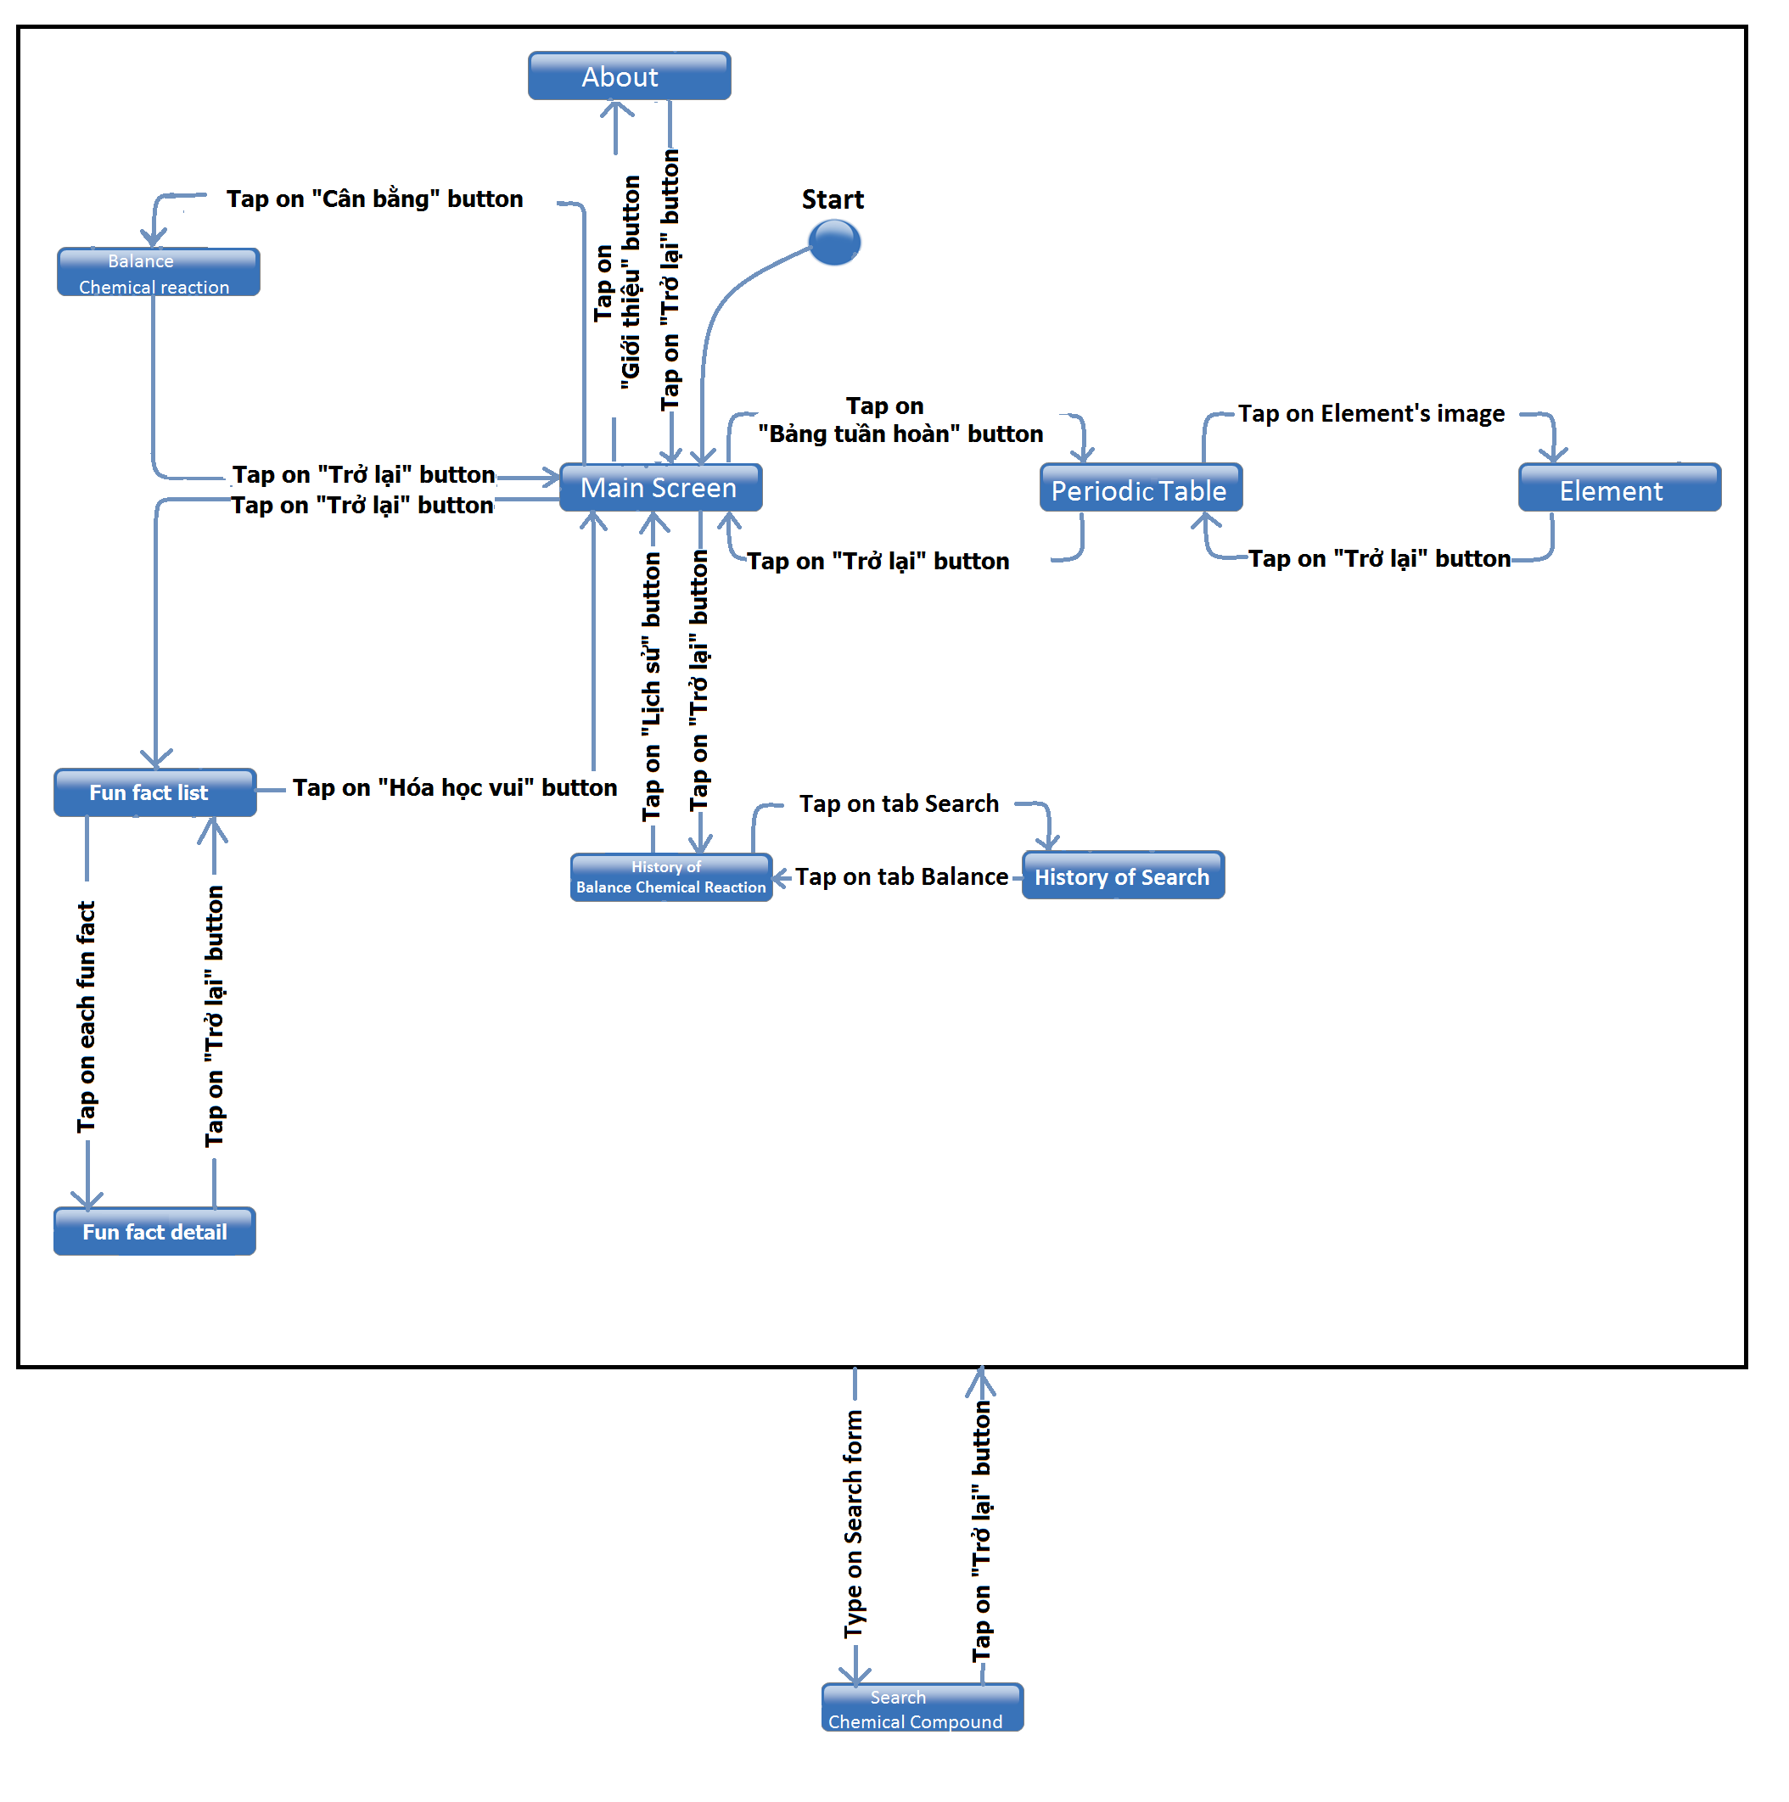

Figure : Main Application Screen Flow

|  |  |  |
| --- | --- | --- |
| No | Screen Name | Description |
| 1. | Main Screen | Where user can choose 1 of 3 options |
| 2. | Input Reactants Screen | Where user input reactants need to balanced. |
| 3. | Balance Chemical Reaction Screen | System displays result of balance chemical reaction. |
| 4. | Searched Chemical Compound Screen | User input compound then system display result of searching. |
| 5. | Periodic Table Screen | Display periodic table. |
| 6. | Element Screen | Display detail of each elements. |
| 7. | History of Balance Chemical Reaction Screen | Display history of chemical reaction which has already balanced. |
| 8. | History of Search Chemical Compound Screen | Display history of result searched. |
| 9. | About Screen | Introduce about application. |

##### Main screen

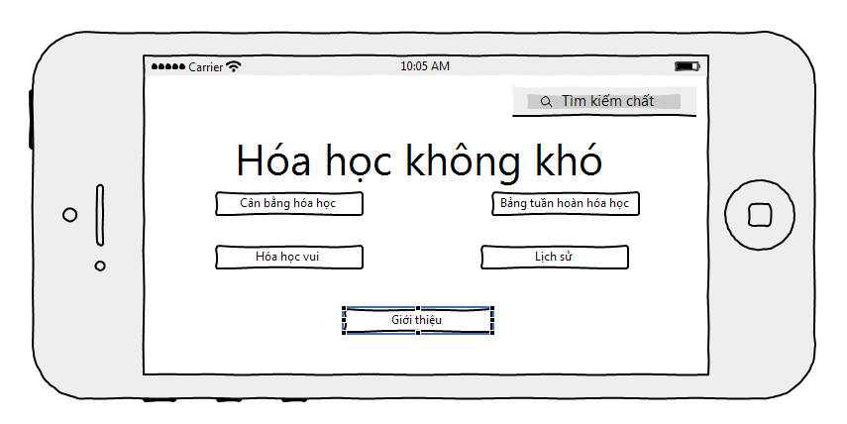

Figure : Main screen

|  |  |  |  |  |  |
| --- | --- | --- | --- | --- | --- |
| No | Component Name | Required | Format | Reference | Note |
| 1. | Chemistry Compound | Touch on | EditText | Search Chemical Compound Screen | Input text |
| 2. | Balance Chemical Reaction | Touch on | Button |  | Move to Input Reactants Screen |
| 3. | Periodic Table | Touch on | Button |  | Move to Periodic Table Screen. |
| 4. | History | Touch on | Button |  | Move to History of Balance Chemical Reaction Screen. |
| 5. | About | Touch on | Button |  | Move to About Screen. |

##### Balance Chemical Reaction Screen

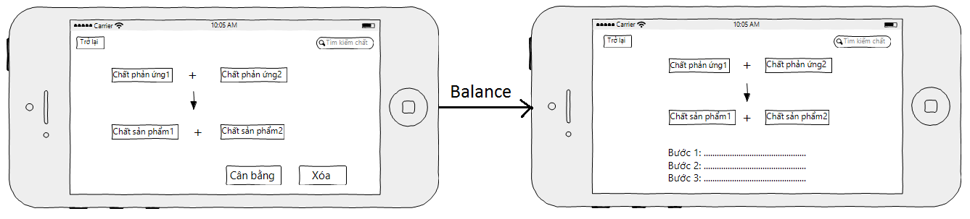

Figure : Balance Chemical Reaction Screen

|  |  |  |  |  |  |
| --- | --- | --- | --- | --- | --- |
| No | Component Name | Required | Format | Reference | Note |
| 1. | Back | Touch on | Icon | Main Screen | Back into previous screen. |
| 2. | Chemistry Compound | Touch on | EditText | Search Chemical Compound Screen | Input text |
| 3. | BalanceResult |  | TextView | Input Reactions Screen | This component include 4 sub-components:  - Reaction1  - Reaction2  - Product1  - Product2  Show result of balancing. |
| 4. | Step of balancing |  | TextView |  | Show each steps how to balance chemical reaction. |

##### Chemical Compound Detail Information Screen

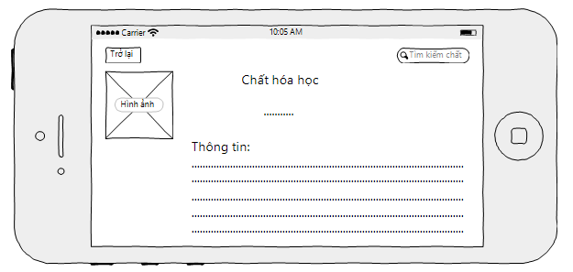

Figure : Chemical Compound Detail Information Screen

|  |  |  |  |  |  |
| --- | --- | --- | --- | --- | --- |
| No | Component Name | Required | Format | Reference | Note |
| 1. | Back | Touch on | Icon | Main Screen | Back into previous screen. |
| 2. | Chemistry Compound | Touch on | EditText | Search Chemical Compound Screen | Input text |
| 3. | CompoundImage |  | ImageView |  | View compound’s image. |
| 4. | CompoundName |  | TextView |  | View compound’s name. |
| 5. | CompoundInformation |  | TextView |  | View compound’s information. |

##### Periodic Table Screen

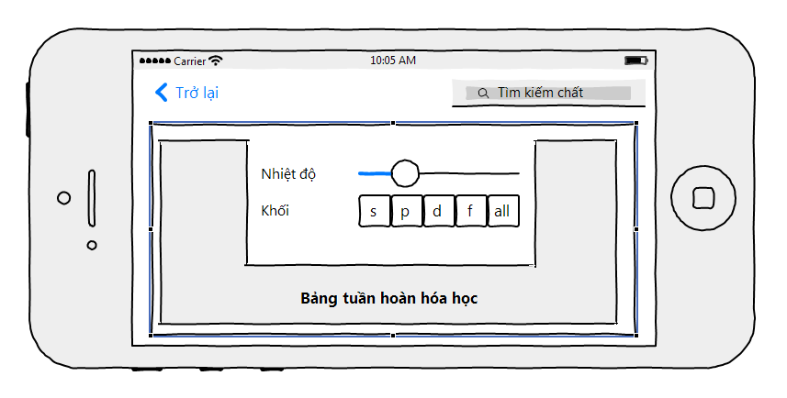

Figure : Periodic Table

|  |  |  |  |  |  |
| --- | --- | --- | --- | --- | --- |
| No | Component Name | Required | Format | Reference | Note |
| 1. | Back | Touch on | Icon | Main Screen | Back into previous screen. |
| 2. | Chemistry Compound | Touch on | EditText | Search Chemical Compound Screen | Input text |
| 3. | PeriodicTable |  | Icon |  | View whole period table. |
| 4. | TemperatureBar | Slide | Slider |  | Slide the bar to change the temperature |
| 5. | s | Touch on | Button | Periodic Table Change | Display only s block in the periodic table |
| 6. | p | Touch on | Button | Periodic Table Change | Display only p block in the periodic table |
| 7. | d | Touch on | Button | Periodic Table Change | Display only d block in the periodic table |
| 8. | f | Touch on | Button | Periodic Table Change | Display only f block in the periodic table |

##### Element Screen

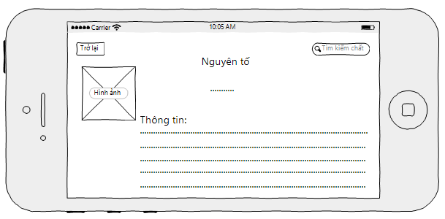

Figure : Element Screen

|  |  |  |  |  |  |
| --- | --- | --- | --- | --- | --- |
| No | Component Name | Required | Format | Reference | Note |
| 1. | Back | Touch on | Icon | Main Screen | Back into previous screen. |
| 2. | Chemistry Compound | Touch on | EditText | Search Chemical Compound Screen | Input text |
| 3. | ElementImage |  | ImageView | Periodic Table Screen | View element’s image. |
| 4. | ElementName |  | TextView | Periodic Table Screen | View element’s name. |
| 5. | ElementInformation |  | TextView | Periodic Table Screen | View element’s information. |

##### History of Balance Chemical Reaction

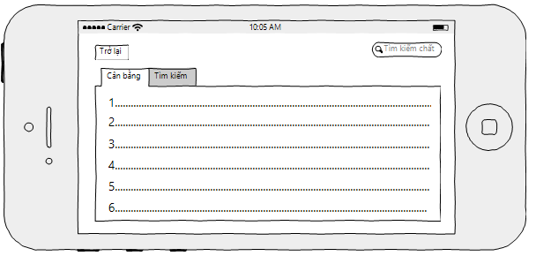

Figure : History of Balance Chemical Reaction

|  |  |  |  |  |  |
| --- | --- | --- | --- | --- | --- |
| No | Component Name | Required | Format | Reference | Note |
| 1. | Back | Touch on | Icon | Main Screen | Back into previous screen. |
| 2. | Chemistry Compound | Touch on | EditText | Search Chemical Compound Screen | Input text |
| 3. | BalanceHistory |  | Tab | Balance Chemical Reaction Screen | Link to Balance Chemical Reaction Screen |
| 4. | ListOfBalanceHistory |  | ListView | Balance Chemical Reaction Screen | View list of chemical reactions balanced. |

##### History of Search

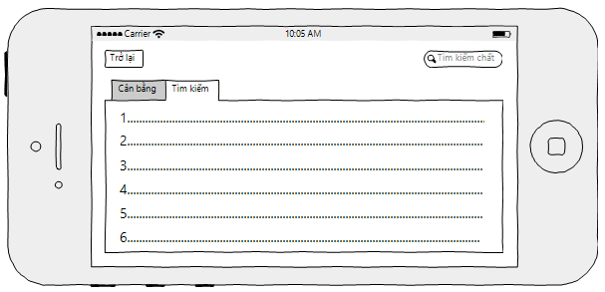

Figure : History of Search

|  |  |  |  |  |  |
| --- | --- | --- | --- | --- | --- |
| No | Component Name | Required | Format | Reference | Note |
| 1. | Back | Touch on | Icon | Main Screen | Back into previous screen. |
| 2. | Chemistry Compound | Touch on | EditText | Search Chemical Compound Screen | Input text |
| 3. | SearchHistory |  | Tab | Search Chemical Compound Screen | Link to Search Chemical Compound Screen |
| 4. | ListOfSearchHistory |  | ListView | Search Chemical Compound Screen | View list of searching. |

##### Fun Facts

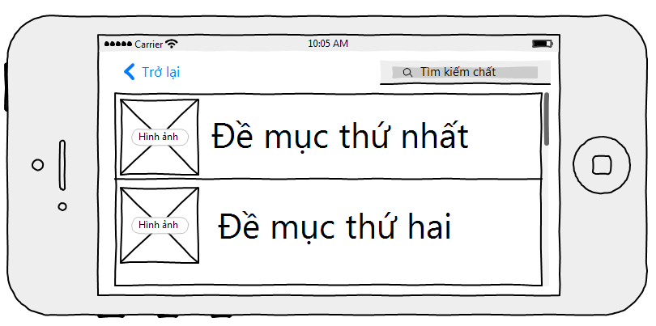

Figure : Fun Facts

|  |  |  |  |  |  |
| --- | --- | --- | --- | --- | --- |
| No | Component Name | Required | Format | Reference | Note |
| 1. | Back | Touch on | Icon | Main Screen | Back into previous screen. |
| 2. | Chemistry Compound | Touch on | EditText | Search Chemical Compound Screen | Input text |
| 3. | FunFactImage |  | ImageView |  | Image of fun fact |
| 4. | ListOfFunFact | Touch on | ListView | Fun Fact Detail Screen | Detail information of a fun fact |

##### Fun Fact Detail

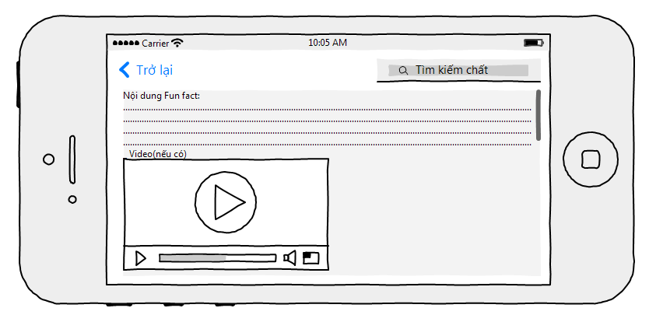

Figure : Fun Fact Detail

|  |  |  |  |  |  |
| --- | --- | --- | --- | --- | --- |
| No | Component Name | Required | Format | Reference | Note |
| 1. | Back | Touch on | Icon | Main Screen | Back into previous screen. |
| 2. | Chemistry Compound | Touch on | EditText | Search Chemical Compound Screen | Input text |
| 3. | FunFactImage |  | ImageView |  | Image of fun fact |
| 4. | FunFactInformation |  | TextView |  | Information of a fun fact |
| 5. | FunFactVideo | Touch on | VideoView | The video is play | Video of a fun fact (optional) |

##### About

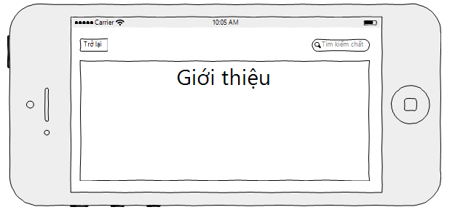

Figure : About Screen

|  |  |  |  |  |  |
| --- | --- | --- | --- | --- | --- |
| No | Component Name | Required | Format | Reference | Note |
| 1. | Back | Touch on | Icon | Main Screen | Back into previous screen. |
| 2. | Chemistry Compound | Touch on | EditText | Search Chemical Compound Screen | Input text |
| 3. | IntroductionDiaglog |  | Dialog |  | Show Application Information |

#### Administration Application

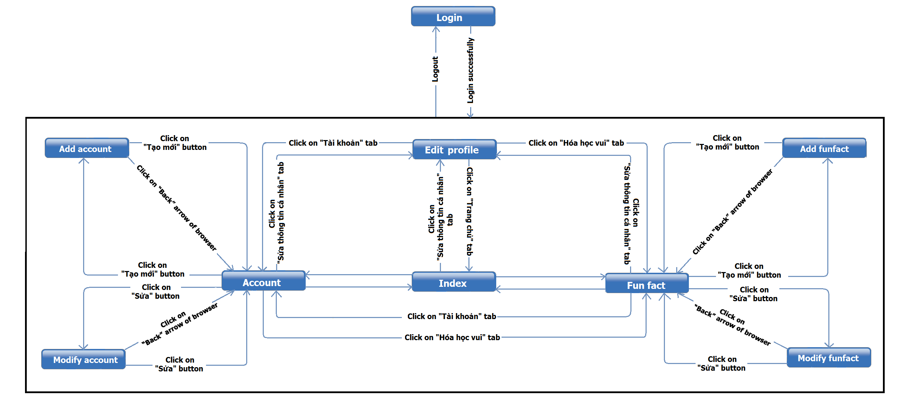

Figure : Administration Application Screen Flow

|  |  |  |
| --- | --- | --- |
| No | Screen Name | Description |
| 1. | Login Screen | Allow users to enter the username and password to login to the system |
| 2. | Index Screen | Greeting users and information about the system |
| 3. | Edit Profile Screen | Allow users to edit their own account |
| 4. | Fun Fact | Allow users to view the list of fun facts and take other action |
| 5. | Add fun fact | Allow users to add the new fun fact |
| 6. | Modify fun fact | Allow users to edit the exited fun fact |
| 7. | Account | Allow users to view the list of accounts and take other action |
| 8. | Add account | Allow users to add the new account |
| 9. | Modify account | Allow users to edit the exited account |

##### Login Screen

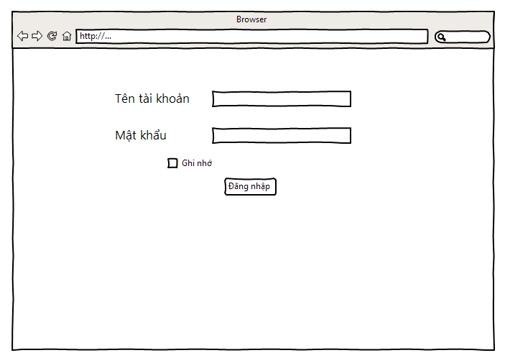

Figure : Login Screen

|  |  |  |  |  |  |
| --- | --- | --- | --- | --- | --- |
| No | Component Name | Required | Format | Reference | Note |
| 1. | Username |  | TextBox |  | Enter username |
| 2. | Password |  | TextBox |  | Enter password |
| 3. | RememberMe | Select | CheckBox |  | Allow user to remember his/her own username and password |
| 4. | LoginButton | Click on | Button | Index Screen | Redirect to index screen if login successfully |
| 5. | LogOut |  | Hyperlink |  |  |

##### Index Screen

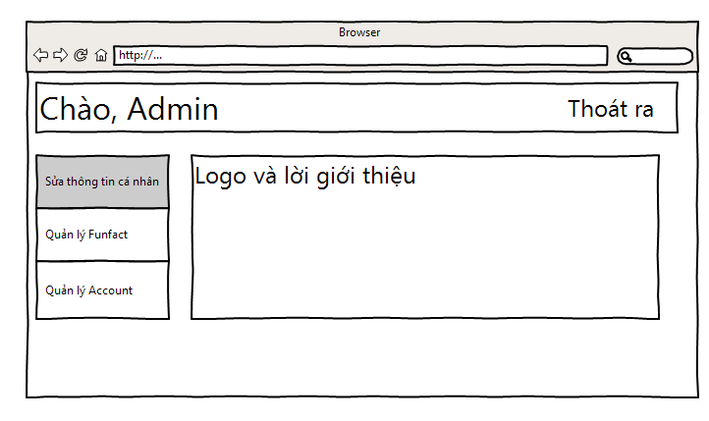

Figure : Index Screen

|  |  |  |  |  |  |
| --- | --- | --- | --- | --- | --- |
| No | Component Name | Required | Format | Reference | Note |
| 1. | LogOut |  | Hyperlink | Login Screen |  |
| 2. | ChangeProfile |  | Hyperlink | Change Profile Screen | Redirect to Change Account Owner Profile Screen |
| 3. | FunFactManagement |  | Hyperlink | Fun Fact Manage Screen |  |
| 4. | AccountManagement |  | Hyperlink | Account Manage Screen |  |
| 5. | Greeting |  | TextView |  | Greeting and information of the application |

##### Edit Profile Screen

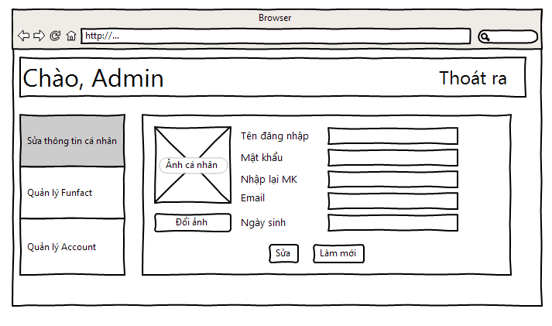

Figure : Edit Profile

|  |  |  |  |  |  |
| --- | --- | --- | --- | --- | --- |
| No | Component Name | Required | Format | Reference | Note |
| 1. | LogOut |  | Hyperlink | Login Screen |  |
| 2. | FunFactManagement |  | Hyperlink | Fun Fact Manage Screen |  |
| 3. | AccountManagement |  | Hyperlink | Account Manage Screen |  |
| 4 | Avatar |  | Image |  | Account Owner Avatar |
| 5. | ChangeAva |  | Button | File Browser | Browser the needed image |
| 6. | Password |  | TextBox |  | Change Password |
| 7. | RePassword |  | TextBox |  | Re-enter password |
| 8. | Email |  | TextBox |  | Change email |
| 9. | DateOfBirth |  | TextBox |  | Change date of birth |
| 10. | Modify | Click On | Button |  |  |
| 11. | Refresh | Click On | Button |  |  |

##### Fun Fact Screen

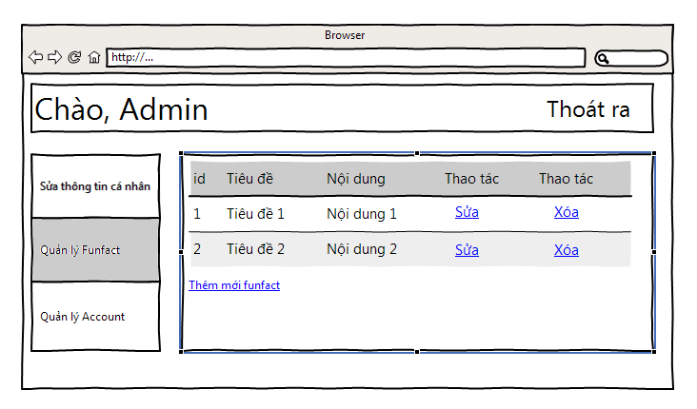

Figure : Fun Fact Screen

|  |  |  |  |  |  |
| --- | --- | --- | --- | --- | --- |
| No | Component Name | Required | Format | Reference | Note |
| 1. | LogOut |  | Hyperlink | Login Screen |  |
| 2. | ChangeProfile |  | Hyperlink | Change Profile Screen | Redirect to Change Account Owner Profile Screen |
| 3. | AccountManagement |  | Hyperlink | Account Manage Screen |  |
| 4. | FunFactList |  | ListView |  | List of Fun Facts |
| 5. | EditFunFact |  | Hyperlink | Edit Fun Fact Screen | Redirect to Edit Fun Fact Screen |
| 6. | DeleteFunFact |  | Hyperlink | Delete the fact |  |
| 7. | FunFactAddNew |  | Button | Add Fun Fact Screen | Redirect to Add New Fun Fact Screen |

##### Add Fun Fact Screen

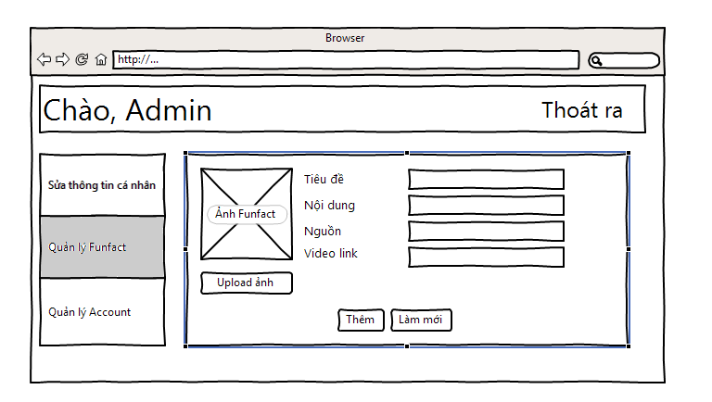

Figure : Add Fun Fact Screen

|  |  |  |  |  |  |
| --- | --- | --- | --- | --- | --- |
| No | Component Name | Required | Format | Reference | Note |
| 1. | LogOut |  | Hyperlink | Login Screen |  |
| 2. | ChangeProfile |  | Hyperlink | Change Profile Screen | Redirect to Change Account Owner Profile Screen |
| 3. | FunFactManagement |  | Hyperlink | Fun Fact Manage Screen |  |
| 4. | AccountManagement |  | Hyperlink | Account Manage Screen |  |
| 5. | FactImageDefault |  | Image |  | Default image of the fun fact |
| 6. | UploadFactImage |  | Button | File Browser | Browser the needed image |
| 7. | Title |  | TextBox |  | Enter fact title |
| 8. | Content |  | TextBox |  | Enter fact content |
| 9. | Credit |  | TextBox |  | Enter credit information |
| 10. | VideoLink |  | TextBox |  | Enter link of the video |
| 11. | FunFactAddNew | Click On | Button |  |  |
| 12. | Refresh | Click On | Button |  |  |

##### Edit Fun Fact Screen

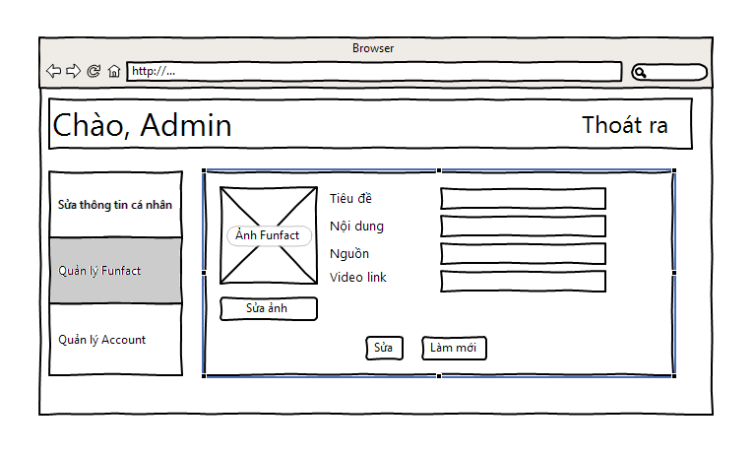

Figure : Edit Fun Fact Screen

|  |  |  |  |  |  |
| --- | --- | --- | --- | --- | --- |
| No | Component Name | Required | Format | Reference | Note |
| 1. | LogOut |  | Hyperlink | Login Screen |  |
| 2. | ChangeProfile |  | Hyperlink | Change Profile Screen | Redirect to Change Account Owner Profile Screen |
| 3. | FunFactManagement |  | Hyperlink | Fun Fact Manage Screen |  |
| 4. | AccountManagement |  | Hyperlink | Account Manage Screen |  |
| 5. | FactImage |  | Image |  | Image of the fun fact |
| 6. | ChangeFunFactImage |  | Button | File Browser | Browser the needed image |
| 7. | Title |  | TextBox |  | Edit fact title |
| 8. | Content |  | TextBox |  | Edit fact content |
| 9. | Credit |  | TextBox |  | Edit credit information |
| 10. | VideoLink |  | TextBox |  | Edit link of the video |
| 11. | Modify | Click On | Button |  |  |
| 12. | Refresh | Click On | Button |  |  |

##### Account Screen

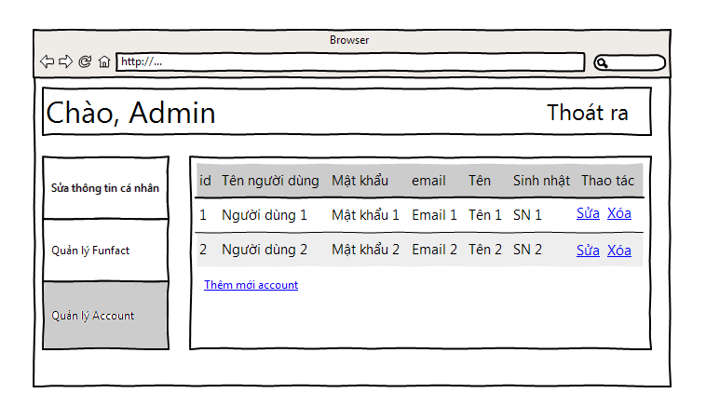

Figure : Account Screen

|  |  |  |  |  |  |
| --- | --- | --- | --- | --- | --- |
| No | Component Name | Required | Format | Reference | Note |
| 1. | LogOut |  | Hyperlink | Login Screen |  |
| 2. | ChangeProfile |  | Hyperlink | Change Profile Screen | Redirect to Change Account Owner Profile Screen |
| 3. | FunFactManagement |  | Hyperlink | Fun Fact Manage Screen |  |
| 4. | AccountList |  | ListView |  | List of Accounts |
| 5. | EditAccount |  | Hyperlink | Edit Account Screen | Redirect to Edit Fun Fact Screen (Root Administrator Only) |
| 6. | DeleteAccount |  | Hyperlink | Delete Account | (Root Administrator Only) |
| 7. | AccountAddNew |  | Button | Add New Account Screen | Redirect to Add New Fun Fact Screen |

##### Add Account Screen

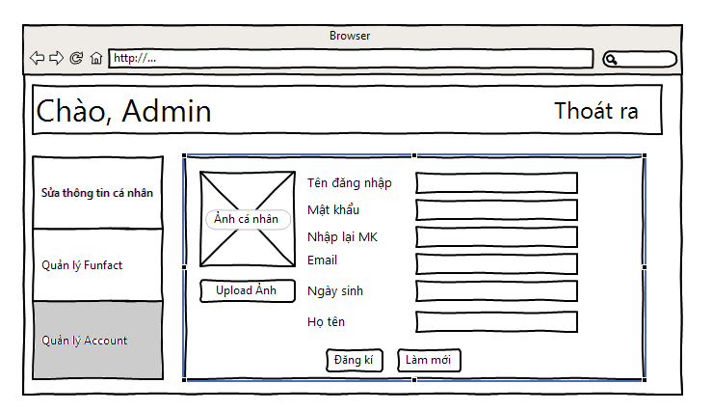

Figure : Add Account Screen

|  |  |  |  |  |  |
| --- | --- | --- | --- | --- | --- |
| No | Component Name | Required | Format | Reference | Note |
| 1. | LogOut |  | Hyperlink | Login Screen |  |
| 2. | ChangeProfile |  | Hyperlink | Change Profile Screen | Redirect to Change Account Owner Profile Screen |
| 3. | FunFactManagement |  | Hyperlink | Fun Fact Manage Screen |  |
| 4. | AccountManagement |  | Hyperlink | Account Manage Screen |  |
| 5. | AvatarDefault |  | Image |  | Default Image |
| 6. | UploadAvatar |  | Button | File Browser | Browser the needed image |
| 7. | Username |  | TextBox |  | Enter username |
| 8. | Password |  | TextBox |  | Enter Password |
| 9. | RePassword |  | TextBox |  | Re-enter password |
| 10. | Email |  | TextBox |  | Enter email |
| 11. | DateOfBirth |  | TextBox |  | Enter date of birth |
| 12. | FullName |  | TextBox |  | Enter full name |
| 13. | AccountAddNew | Click On | Button |  |  |
| 14. | Refresh | Click On | Button |  |  |

##### Edit Account Screen

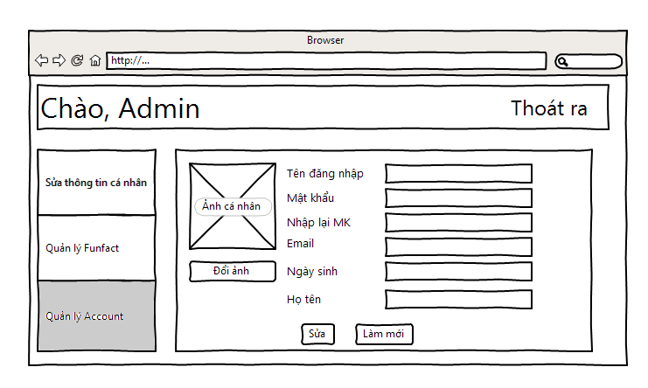

Figure : Edit Account Screen

|  |  |  |  |  |  |
| --- | --- | --- | --- | --- | --- |
| No | Component Name | Required | Format | Reference | Note |
| 1. | LogOut |  | Hyperlink | Login Screen |  |
| 2. | ChangeProfile |  | Hyperlink | Change Profile Screen | Redirect to Change Account Owner Profile Screen |
| 3. | FunFactManagement |  | Hyperlink | Fun Fact Manage Screen |  |
| 4. | AccountManagement |  | Hyperlink | Account Manage Screen |  |
| 5. | Avatar |  | Image |  | Default Image |
| 6. | ChangeAvatar |  | Button | File Browser | Browser the needed image |
| 7. | Username |  | TextBox |  | Change username |
| 8. | Password |  | TextBox |  | Change Password |
| 9. | RePassword |  | TextBox |  | Re-enter password |
| 10. | Email |  | TextBox |  | Change email |
| 11. | DateOfBirth |  | TextBox |  | Change date of birth |
| 12. | FullName |  | TextBox |  | Change full name |
| 13. | Modify | Click On | Button |  |  |
| 14. | Refresh | Click On | Button |  |  |

# Software Source Code



## Main application

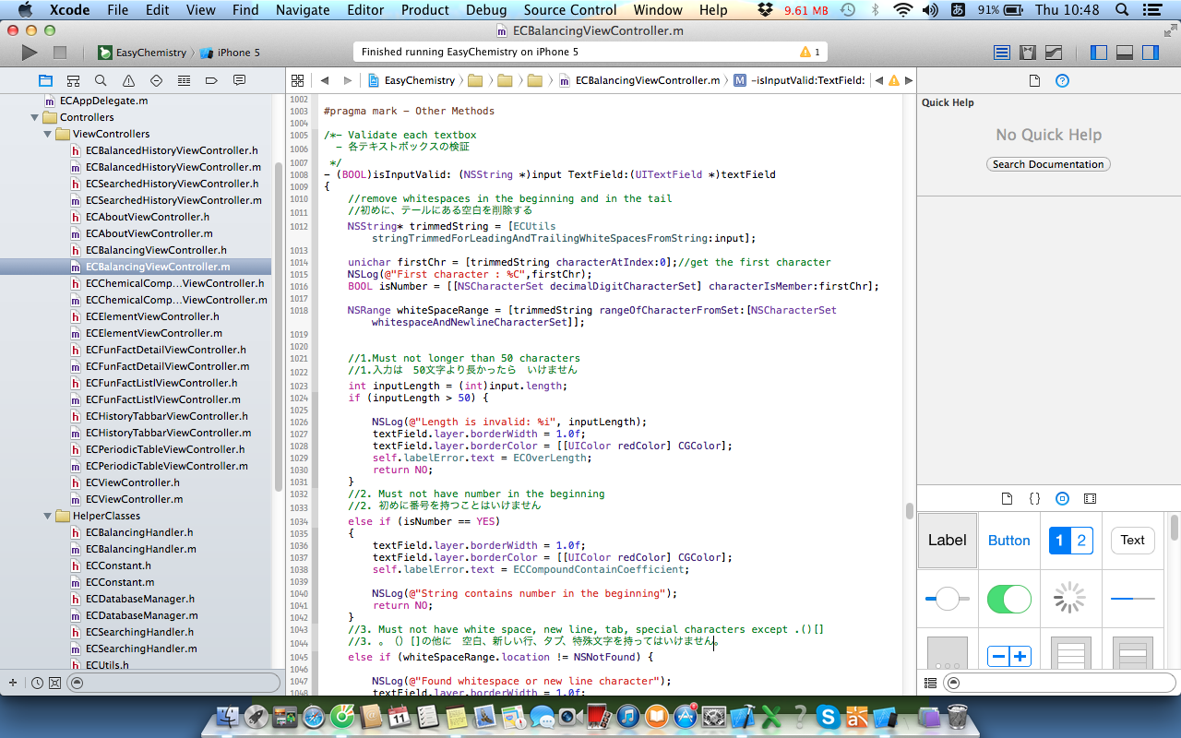

Figure : Main Application Code

## Administration application

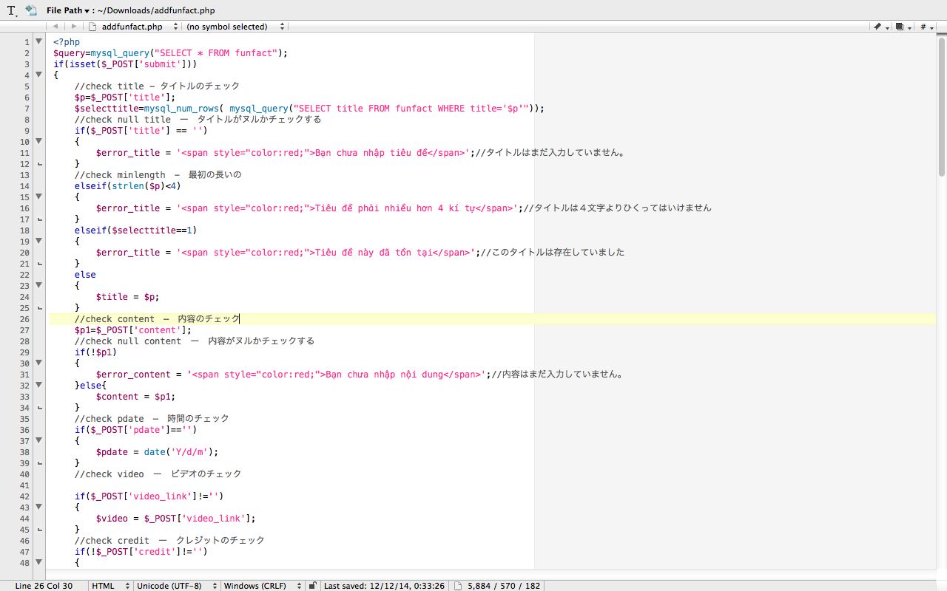

Figure : Administration Application Code

# Software Testing



## Test Plan

### Requirement for Test

#### Test Items

|  |  |  |  |  |
| --- | --- | --- | --- | --- |
| No | Name of features and functions | Outline of features and functions | Number of Test case  (Estimate) | Note |
| 1 | Main Screen | Display Main Screen | 2 | Subproject 1 |
| Move to other screens | 16 | Subproject 1 |
| 2 | Balance | Display Balance Chemical Reaction Screen | 6 | Subproject 1 |
| Input Reactants and Products | 22 | Subproject 1 |
| Balance Chemical Reaction | 1006 | Subproject 1 |
| 3 | Periodic | View Periodic Table | 1 | Subproject 1 |
| View Element | 124 | Subproject 1 |
| 4 | Search | Search Chemical Compound | 44 | Subproject 1 |
| 5 | History | History of Balance | 5 | Subproject 1 |
| History of Search | 5 | Subproject 1 |
| 6 | About | Display introduction of the application | 1 | Subproject 1 |
| 7 | Performance | Performance | 68 | Subproject 1 |
| 8 | Common | Common | 6 | Subproject 1 |
| 9 | Admin | Login by root admin | 24 | Subproject 2 |
| 10 | Display Index page by root admin | 1 | Subproject 2 |
| 11 | Edit profile by root admin | 16 | Subproject 2 |
| 12 | Add fun fact by root admin | 19 | Subproject 2 |
| 13 | Modify fun fact by root admin | 19 | Subproject 2 |
| 14 | Delete fun fact by root admin | 1 | Subproject 2 |
| 15 | Add account by root admin | 19 | Subproject 2 |
| 16 | Modify account by root admin | 18 | Subproject 2 |
| 17 | Delete account by root admin | 1 | Subproject 2 |
| 18 | Logout by root admin | 8 | Subproject 2 |
| 19 |  | Login by admin | 25 | Subproject 2 |
| 20 |  | Edit profile by admin | 16 | Subproject 2 |
| 21 |  | Add fun fact by admin | 19 | Subproject 2 |
| 22 |  | Modify fun fact by admin | 19 | Subproject 2 |
| 23 |  | Delete fun fact by admin | 1 | Subproject 2 |
| 24 |  | Logout by admin | 8 | Subproject 2 |
| 25 | Admin_System | Check function of application when suffering action from outside. | 7 | Subproject 2 |
| 26 | Client_System | Check function of application after executing action from outside. | 2 | Subproject 2 |

#### Acceptance Test Criteria

List of criteria to define what levels of test quality are sufficient to move to the next testing phase:

* Test coverage: 100%
* Successful Test coverage: 90%
* Number of Test cases (Unit/Integration/System Test cases): 1508
* Number of defects/Weighted defects: 3~4 defects/KLOC

List of criteria which are based on to accept the products:

* Number of UTC/KLOC: 80 UTC/KLOC
* Number or Weighted: 3~4 defects/KLOC
* Statement coverage: 90%
* Branch coverage: 100%
* Path coverage: 100%

### Test Strategy

### Test Type

#### Function Testing

|  |  |
| --- | --- |
| Test Objective | Ensure proper target-of-test functionality, including navigation, data entry, processing, and retrieval. |
| Technique | Execute each use case, use-case flow, or function, using valid and invalid data, to verify the following:  -    The expected results occur when valid data is used.  -    The appropriate error or warning messages are displayed when invalid data is used.  -    Each business rule is properly applied.  - Use Test tool. |
| Completion Criteria | -   All planned tests have been executed.  -   All identified defects have been addressed and closed. |
| Special Considerations | Identify or describe those items or issues (internal or external) that impact the implementation and execution of function test. |

#### User Interface Testing

|  |  |
| --- | --- |
| Test Objective | Verify the following:  Navigation through the target-of-test properly reflects business functions and requirements, including navigation bar, all of pages.  Objects and characteristics, such as menus, size, position, state, and focus conform to standards. |
| Technique | Create or modify tests for each page to verify proper navigation and object states for each application and objects. |
| Completion Criteria | Each page successfully verified to remain consistent with benchmark version or within acceptable standard. |
| Special Considerations | Not all properties for custom and third party objects can be accessed. |

#### Data and Database Integrity Testing

|  |  |
| --- | --- |
| Test Objective | Ensure database access methods and processes function properly and without data corruption. |
| Technique | Invoke each database access method and process, seeding each with valid and invalid data or requests for data.  Inspect the database to ensure the data has been populated as intended, all database events occurred properly, or review the returned data to ensure that the correct data was retrieved for the correct reasons. |
| Completion Criteria | All database access methods and processes function as designed and without any data corruption. |
| Special Considerations | Testing may require a DBMS development environment or drivers to enter or modify data directly in the databases.  Processes should be invoked manually.  Small or minimally sized databases (limited number of records) should be used to increase the visibility of any non-acceptable events. |

#### Performance Testing

|  |  |
| --- | --- |
| Test Objective | Verify performance behaviors for designated transactions or business functions under the following conditions:   * Normal anticipated workload( Normal time to load a page) * Anticipated worst case workload (Longest time to load a page) |
| Technique | Use Test Procedures developed for Function or Business Cycle Testing.  Modify data files to increase the number of transactions or the scripts to increase the number of iterations each transaction occurs.  Scripts should be run on one machine (best case to benchmark single user, single transaction) and be repeated with multiple clients (virtual or actual). |
| Completion Criteria | Single Transaction or single user:  Successful completion of the test scripts without any failures and within the expected or required time allocation per transaction.  Multiple transactions or multiple users:  Successful completion of the test scripts without any failures and within acceptable time allocation. |
| Special Considerations | Comprehensive performance testing includes having a background workload on the server.  There are several methods that can be used to perform this, including:  “Drive transactions” directly to the server, usually in the form of Structured Query Language (SQL) calls.  Create “virtual” user load to simulate many clients, usually several hundred.  Remote Terminal Emulation tools are used to accomplish this load. This technique can also be used to load the network with “traffic”.  Use multiple physical clients, each running test scripts to place a load on the system.  Performance testing should be performed on a dedicated machine or at a dedicated time.  This permits full control and accurate measurement.  The databases used for Performance Testing should be either actual size or scaled equally. |

#### Regression Testing

|  |  |
| --- | --- |
| Test Objective | Regression testing is to validate modified parts of the software, to make sure that the modification does not cause errors in other parts. |
| Technique | Reuse the set of test cases from an existing test suite to test a modified module.  Execute that set of test cases. |
| Completion Criteria | All test cases are performed and passed  All selected test cases are performed and passed |

### Test stage

|  |  |  |  |  |
| --- | --- | --- | --- | --- |
| Type of Tests | Stage of Test | | | |
| **Unit** | **Integration** | **System** | **Acceptance** |
| Function Test | X | X | X | X |
| User Interface test | X |  | X |  |
| Performance Tests | X | X |  |  |
| Date integrity test |  | X | X |  |

## Resource

### Human Resource

|  |  |  |  |
| --- | --- | --- | --- |
| Worker/Doer | Role | Specific Responsibilities/Comments | Location |
| Nguyen Thuy Hanh | Test Leader | Manage Test resource and assign test tasks  Create TP  Review TC  Create Test report | FPT University, Vietnam |
| Bach Thi Le Thanh | Coder | Create Unit Test Case  Execute unit test | FPT University, Vietnam |
| Pham Thi Minh Ngoc | Coder | Create Unit Test Case  Execute unit test | FPT University, Vietnam |
| Tran Anh Tuan | Coder | Create Unit Test Case  Execute unit test | FPT University, Vietnam |

### Test Management

#### Test Management

Test management is practice of organizing and controlling the process and artifacts required for the testing effort.

The general goal of test management is to allow teams to plan, develop, execute, and assess all testing activities within the overall software development effort. This includes coordinating efforts of all those involved in the testing effort, tracking dependencies and relationships among test assets and most importantly, defining, measuring and tracking quality goals.

* **Test planning:** is the overall set of tasks that address the questions of why, what, where and when to test.
* **Test authoring:** is a process of capturing the specific steps required to complete a given test.
* **Test execution:** consists of running the tests by assembling sequences of test scripts into a suit of test.
* **Test reporting:** is how the various results of the testing effort are analyzed and communicated. This is used to determine the current status of project testing, as well as the overall level of quality of the application or system.

#### Defect Management

Defect management is crucial to closing the loop between requirements, implementation and verification and validation. Traditional defect tracking management, implemented in a standalone fashion, can no longer address the complexity and pace of change in modern software development. Defect management processes must be tightly interlinked with all of the other software development processes. The defect management process contains the following elements:

* **Defect Discovery**: Identification and reporting of potential defects. The defect tracking software must be simple enough so that people will use it, but ensure that the minimum necessary information is captured. The information captured here should be enough to reproduce the defect and allow development to determine root cause and impact.
* **Defect Analysis & Prioritization:** The development team determines if the defect report corresponds to an actual defect, if the defect has already been reported, and what the impact and priority of the defect is. Prioritization and scheduling of the defect resolution is often part of the overall change management process for the software development organization.
* **Defect Resolution:**  Here the development team determines the root cause; implements the changes needed to fix the defect, and documents. The details of the resolution in the defect management software, including suggestions on how to verify the defect is fixed. In organizations using Software Product Lines approaches, or other shared component approaches, defect resolution may need to be coordinated across multiple branches of development.
* **Defect Verification:** The build containing the resolution to the defect is identified, and testing of the build is performed to ensure the defect truly has been resolved, and that the resolution has not introduced side effects or regressions. Once all affected branches of development have been verified as resolved, the defect can be closed.

## Test Environment

### Hardware

* **iPhone5s:**
* Screen: DVGA, 4.0", 640 x 1136 pixels
* CPU: Apple A7, Dual-core, 1.3 GHz
* RAM: 1 GB
* Operating system: iOS 8.1
* Main camera: 8.0 MP, Full HD 1080p@30fps
* Extra camera:1.2 MP
* Storage: 16 GB
* SD card: No
* Capacity of battery: 1560 mAh
* **iPhone 5:**
* Screen: DVGA, 4.0", 640 x 1136 pixels
* CPU: Apple A6, Dual-core, 1.3 GHz
* RAM: 1 GB
* Operating system: iOS 8.1
* Main camera: 8.0 MP, Full HD 1080p@30fps
* Extra camera:1.2 MP
* Storage: 16 GB
* SD card: No
* Capacity of battery: 1440 mAh
* **Mac Book Air 2014:**
* CPU: Intel, Core i5 Haswell, 4260U, 1.40 GHz
* RAM: DDR3L(On board), 4GB (Onboard)
* Hard disk: SSD, 128 GB
* Screen: wide 11.6 inch, HD (1366 x 768 pixels)
* induction: No
* Graphics: Intel HD Graphics 5000, Share
* Optical disc: No
* Operating system: Mac OS X
* Battery Lithium- polymer

### Software

* **Operating system:**
* Client: iOS 7.0 or higher
* Server: Window 8.1

## Test milestones

|  |  |  |  |
| --- | --- | --- | --- |
| Milestone Task | Effort (pd) | Start Date | End Date |
| **Subproject 1** | | | |
| Create Test Plan | Test Leader | October 2nd, 2014 | October 2nd, 2014 |
| Review & update TP | Project Team and Test Leader | October 2nd, 2014 | October 2nd, 2014 |
| Create Unit Test case | Developer | October 3rd, 2014 | October 3rd, 2014 |
| Review & update UTC | Project Team | October 6th, 2014 | October 6th, 2014 |
| Create Integration Test case | Tester | October 7th, 2014 | October 7th, 2014 |
| Review & Update Integration TC | Project Team and Tester | October 8th, 2014 | October 8th, 2014 |
| Create System Test case | Tester | October 7th, 2014 | October 7th, 2014 |
| Review & Update System TC | Project Team and Tester | October 8th, 2014 | October 8th, 2014 |
| Execute Unit Test | Tester | November 7th, 2014 | November 14th, 2014 |
| Execute Integration test | Tester | November 17th, 2014 | November 21st, 2014 |
| Execute System test | Tester | November 24th, 2014 | December 3rd, 2014 |
| **Subproject 2** | | | |
| Update TP | Project Team and Test Leader | December 4th, 2014 | December 4th, 2014 |
| Create Unit Test case | Developer | December 5th, 2014 | December 5th, 2014 |
| Review & update UTC | Project Team | December 5th, 2014 | December 5th, 2014 |
| Create Integration Test case | Tester | December 6th, 2014 | December 6th, 2014 |
| Review & Update Integration TC | Project Team and Tester | December 6th, 2014 | December 6th, 2014 |
| Create System Test case | Tester | December 7th, 2014 | December 7th, 2014 |
| Review & Update System TC | Project Team and Tester | December 7th, 2014 | December 7th, 2014 |
| Execute Unit Test | Tester | December 8th, 2014 | December 10th, 2014 |
| Execute Integration test | Tester | December 11th, 2014 | December 13th, 2014 |
| Execute System test | Tester | December 14th, 2014 | December 16th, 2014 |

## Deliverables

|  |  |  |  |
| --- | --- | --- | --- |
| No | Deliverables | Language | Delivered Date |
| 1 | Test Plan | English | December 16th, 2014 |
| 2 | Unit Test cases | English and Japanese | December 16th, 2014 |
| 3 | Integration Test Cases | English and Japanese | December 16th, 2014 |
| 4 | System Test cases | English and Japanese | December 16th, 2014 |
| 5 | Defect log | English and Japanese | December 16th, 2014 |
| 6 | Test reports | English | December 16th, 2014 |

## Test Report

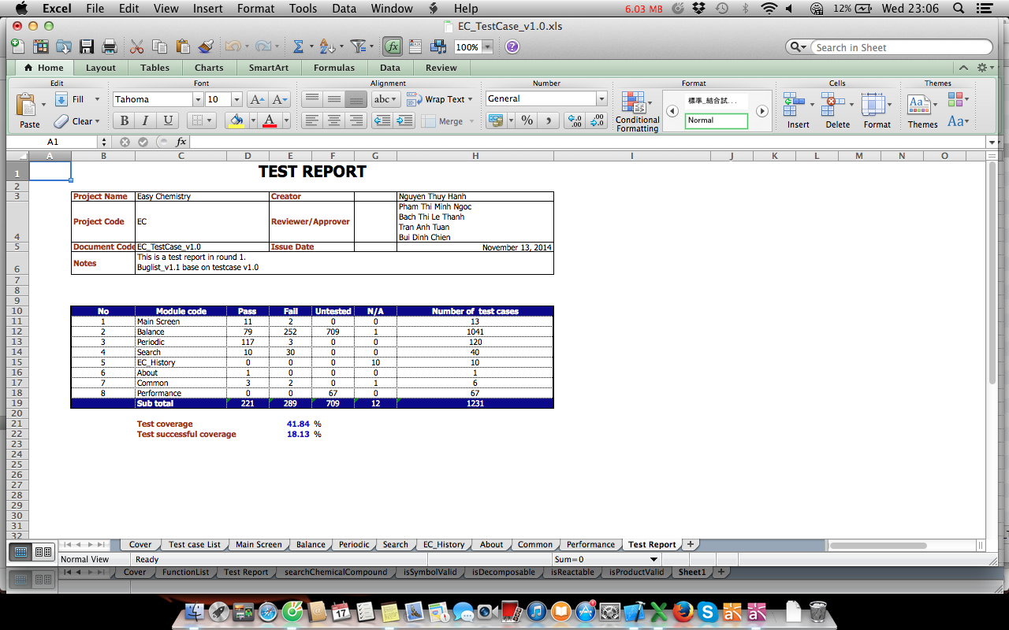

Figure : Test Report 1

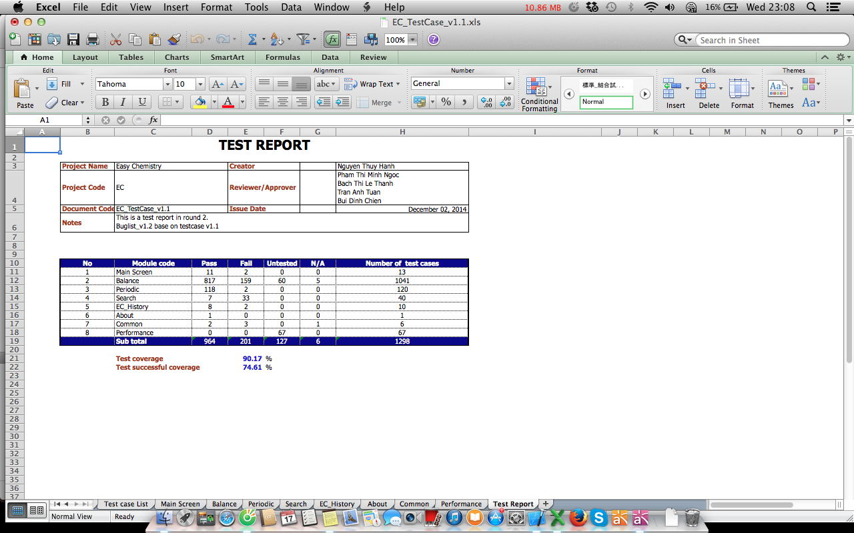

Figure : Test Report 2

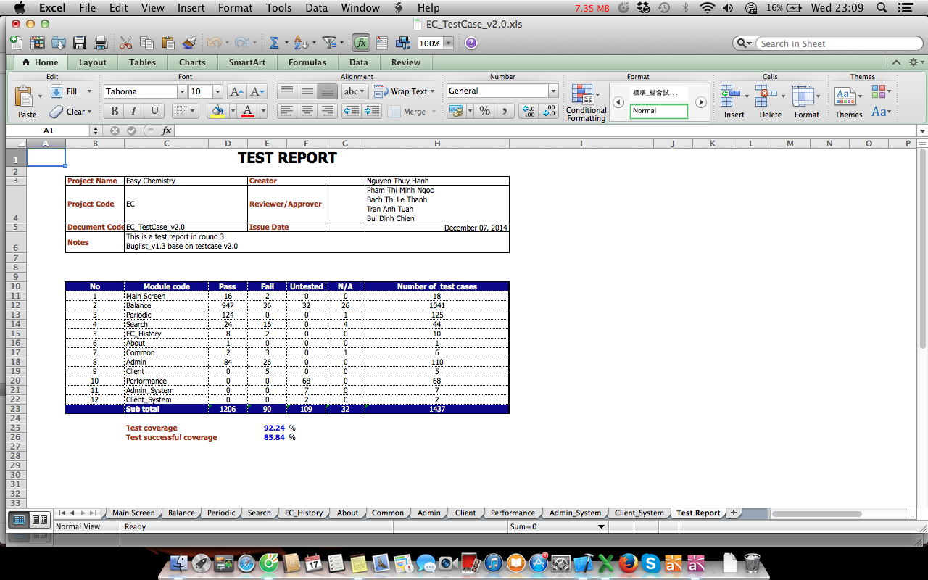

Figure : Test report 3

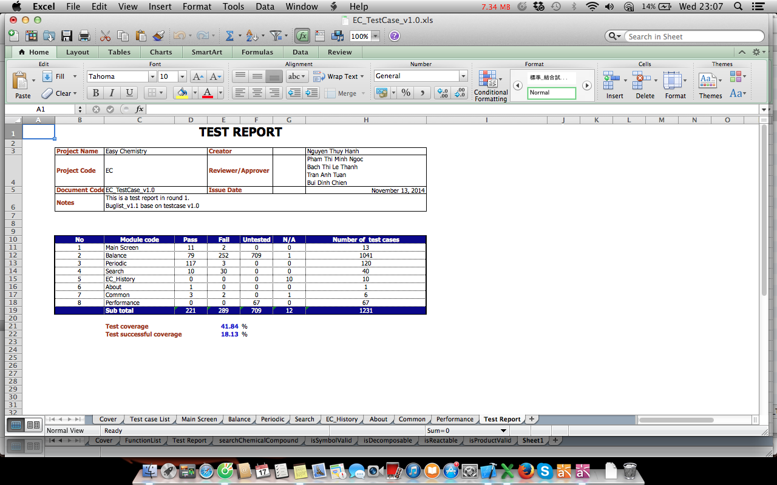

Figure : Test report 4

# User Guide



## Installation Guide

### English Version

#### Prerequisites

This section contains the list of prerequisites that must be fulfilled before install can begin.

* An iPhone 5 or 5S running an iOS 7.0 or higher
* 15 MB free or higher

#### Installation Procedures

Tap on the icon of the App Store, search for “Easy Chemistry” Application then tap on GET button.

#### Uninstall Procedures

Tap and hold the icon of the EC application then tap on the x symbol in the corner of the icon.

### Japanese Version

#### 前提条件

このセクションでは、インストール開始ができるために以前に満たさなければならない前提条件のリストが含まれています。

* iOS7.0以上でのiPhone5や5S
* メモリは15MBい上、無料

#### インストール手順

App Storeのアイコンをタップし、「Easy Chemistry」アプリケーションを検索し、「GET」ボタンをタップする。

#### アンインストール手順

「Easy Chemistry」アプリケーションのアイコンをタップし、そのままにアイコンを持ち、アイコンの隅の「x」記号をタップする。

## User Manual

### Main Application

#### Home Screen

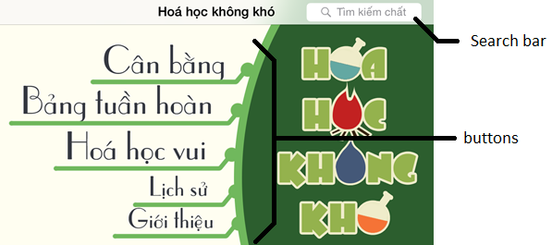

At home screen, we will see:

1. Search bar: using for compounds searching
2. Buttons: using for the next needed action depend on users by the following:
   1. Balance chemical reaction
   2. Periodic table
   3. Fun Facts
   4. History
   5. About

#### Compound Detail Screen

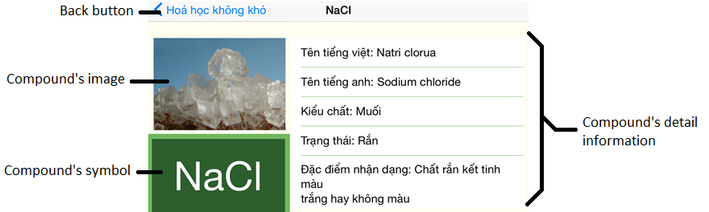

At the Compound Detail Screen, we will see:

1. Back button: back to the previous screen
2. Compound’s image: the image of the searched compound
3. Compound’s symbol: the symbol of the searched compound
4. Compound’s detail information: the detail information of the searched compound

#### Balance Screen

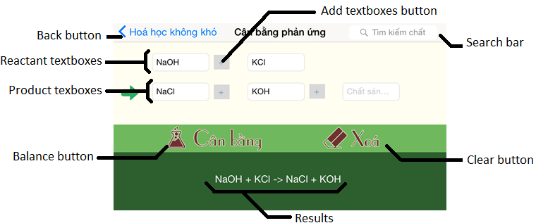

At the Balance Screen, we will see:

1. Search bar: using for compounds searching
2. Back button: back to the previous screen
3. Reactant textboxes: using for insert the reactant compounds to the reaction
4. Product textboxes: using for insert the product compounds to the reaction
5. Add textboxes button: using for add more textboxes to insert reactant or product
6. Balance button: using to see the results of the balanced chemical reaction
7. Clear button: using for clearing all the text in the textboxes
8. Results: is the results of the balanced chemical reaction

#### Periodic Table Screen

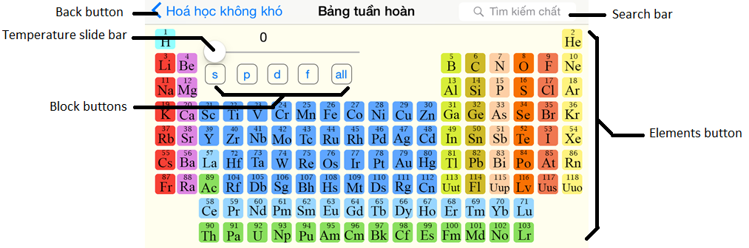

At the Periodic Table Screen, we will see:

1. Search bar: using for compounds searching
2. Back button: back to the previous screen
3. Temperature slide bar: using for changing the temperature to see the state of elements
4. Block buttons: using for seeing the elements of each block
5. Elements button: using for displaying elements detail information

#### Element Detail Screen

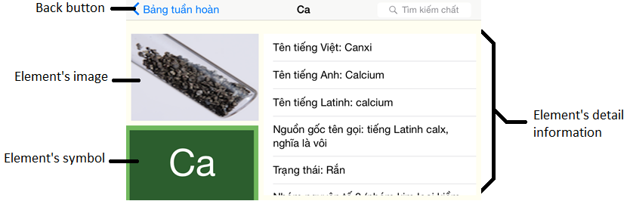

At the Element Detail Screen, we will see:

1. Back button: back to the previous screen
2. Compound’s image: the image of the searched compound
3. Compound’s symbol: the symbol of the searched compound
4. Compound’s detail information: the detail information of the searched compound

#### Fun Facts List Screen

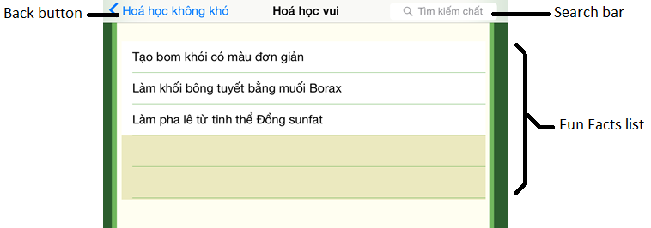

At the Fun Facts list Screen, we will see:

1. Search bar: using for compounds searching
2. Back button: back to the previous screen
3. Fun Facts list: list of the latest fun facts that user can choose for more information

#### Fun Fact Detail Screen

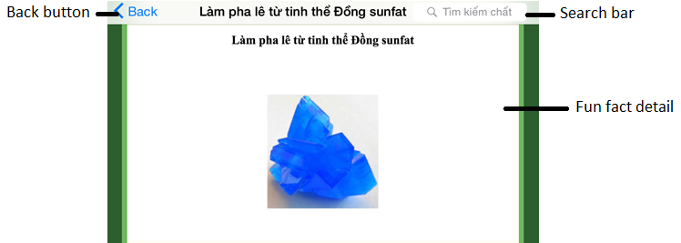

At the Fun Fact Detail Screen, we will see:

1. Search bar: using for compounds searching
2. Back button: back to the previous screen
3. Fun Fact detail: detail information of the chosen fun fact

#### Balanced Reactions Histrory Screen

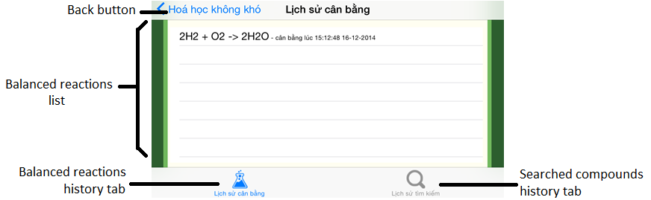

At the Balanced Reactions Histrory Screen, we will see:

1. Back button: back to the previous screen
2. Balanced reactions list
3. Balanced reactions history tab
4. Searched compounds history tab

#### Seacrhed Compounds Histrory Screen

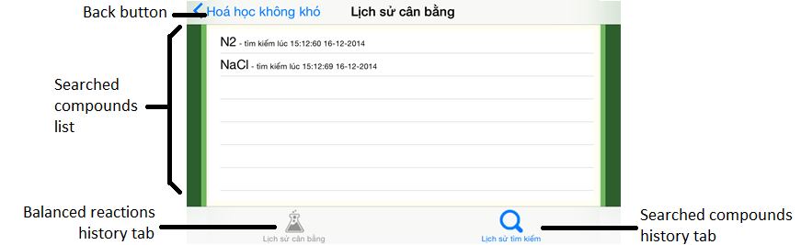

At the Seacrhed Compounds Histrory Screen, we will see:

1. Back button: back to the previous screen
2. Searched compounds list
3. Balanced reactions history tab
4. Searched compounds history tab

#### About Screen

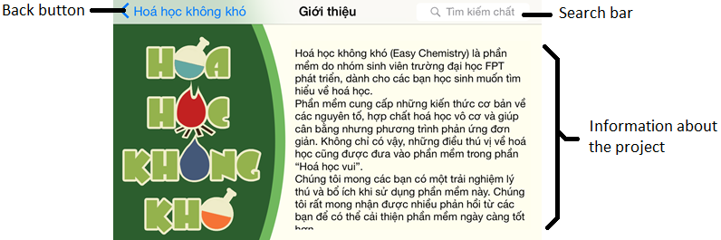

At the About Screen, we will see:

1. Search bar: using for compounds searching
2. Back button: back to the previous screen
3. Information about the project

### Administration Application

#### Login Screen

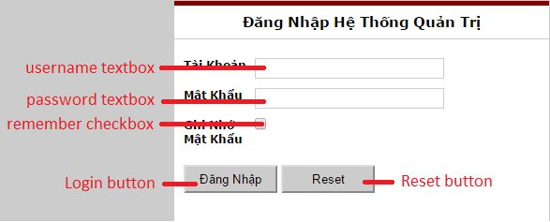

At the Login Screen, we will see:

1. Username textbox: using for user to fill his/her username
2. Password textbox: using for user to fill his/her password
3. Remember checkbox: using for user to check that he/she want to remember his/her username and password for the next time login
4. Login button: using to log in to the system
5. Reset button: using for user to clear every single textbox

#### Banner

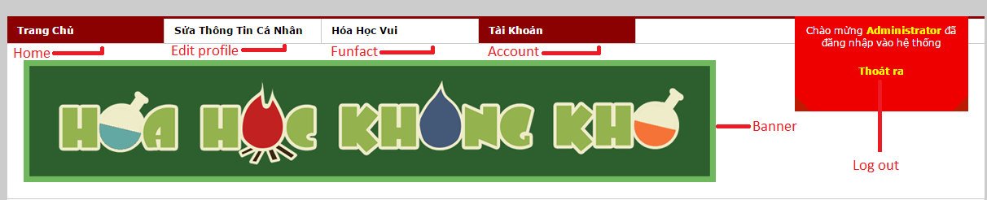

After login to the system, on the top of the screen, we will see:

1. Home button: using for user to go to the Home Screen
2. Edit Profile button: using for user to go to the Edit Profile Screen
3. Fun Fact button: using for user to go to the Fun Fact Management Screen
4. Account button: using for user to go to the Account Management Screen
5. Log out: is the hyperlink using for user to log out of the system
6. Banner: the banner of the system

#### Home Screen

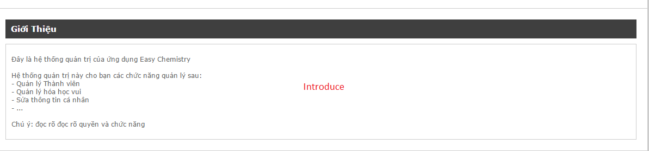

After login to the system, at the home screen, we will see to greeting of the system

#### Edit Profile Screen

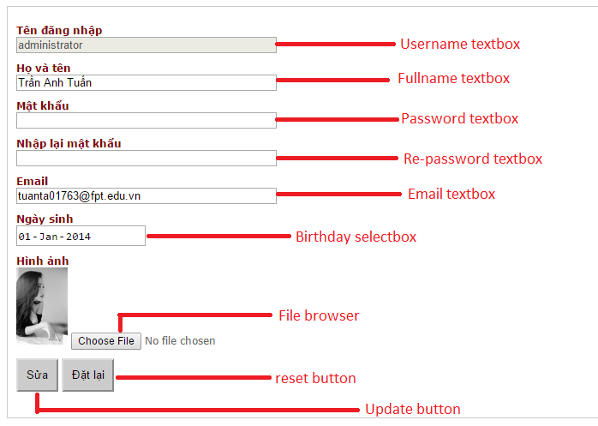

At the Edit Profile Screen, we will see:

1. Username textbox: show the username of the user
2. Full name textbox: show the full name of the user
3. Password textbox
4. Re-password textbox
5. Birthday selectbox: using for user to select his/her birthday
6. File browser: using for user to browse the needed picture
7. Update button: using for user to update his/her profile after changing any field
8. Reset button: using for user to clear all every textbox

#### Fun Fact Management Screen

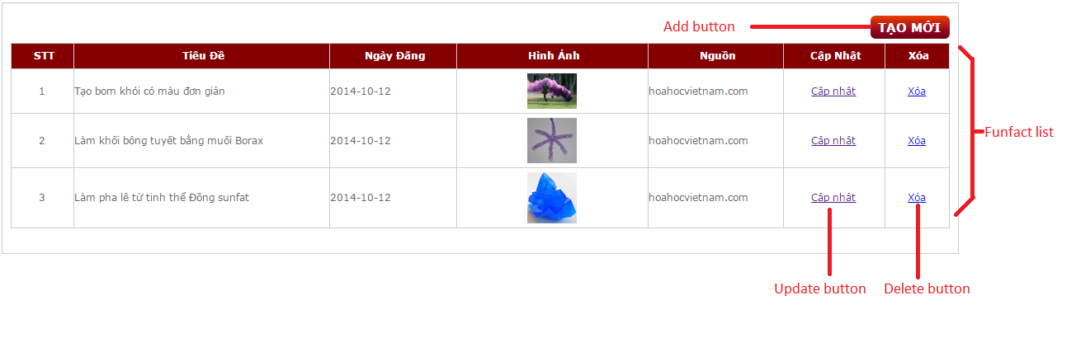

At the Fun Fact Management Screen, we will see:

1. Add button: using for user to add a new fun fact
2. Fun Fact list: is the list of the add facts
3. Update button: using for user to update the corresponding to a fun fact
4. Delete button: using for user to delete the corresponding to a fun fact

#### Add New Fun Fact Screen

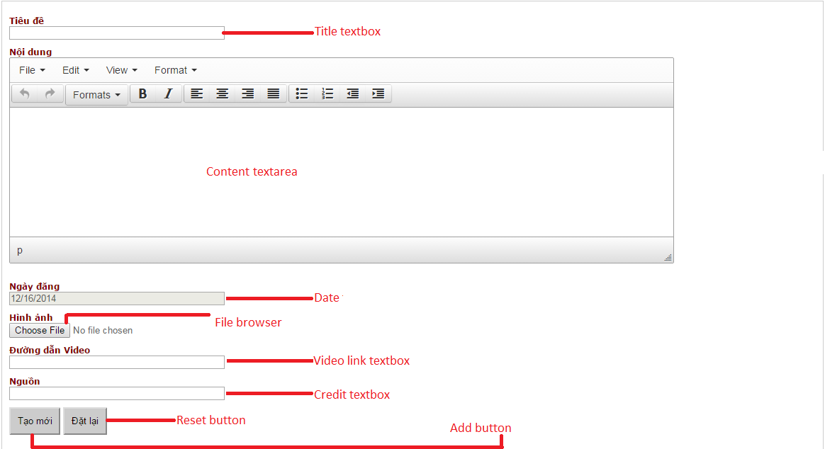

At the Add New Fun Fact Screen, we will see:

1. Title textbox: using for user to fill the title of the fun fact
2. Content textarea: using for user to enter the content of the fun fact
3. Date: Posted date (filled automatically)
4. File browser button: using for user to add the picture of the fun fact
5. Video link textbox: using for user to enter the video link of the fun fact
6. Credit textbox: using for user to enter the credit of the fun fact
7. Add button: using for user to add the new fun fact
8. Reset button: using for user to clear all every textbox

#### Update Fun Fact Screen

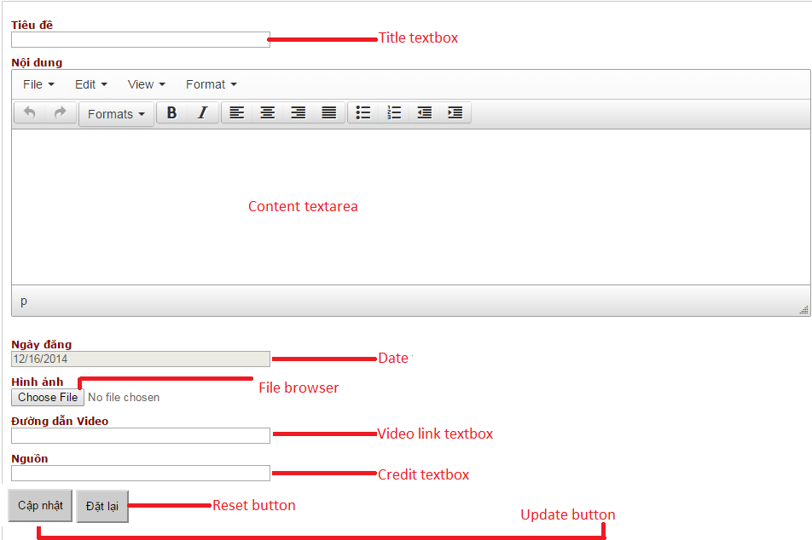

At the Add New Fun Fact Screen, we will see:

1. Title textbox: using for user to update the title of the fun fact
2. Content textarea: using for user to enter the content of the fun fact
3. Date: Posted date (filled automatically)
4. File browser button: using for user to add the picture of the fun fact
5. Video link textbox: using for user to enter the video link of the fun fact
6. Credit textbox: using for user to enter the credit of the fun fact
7. Update button: using for user to update the new fun fact
8. Reset button: using for user to clear all every textbox

#### Account Management Screen

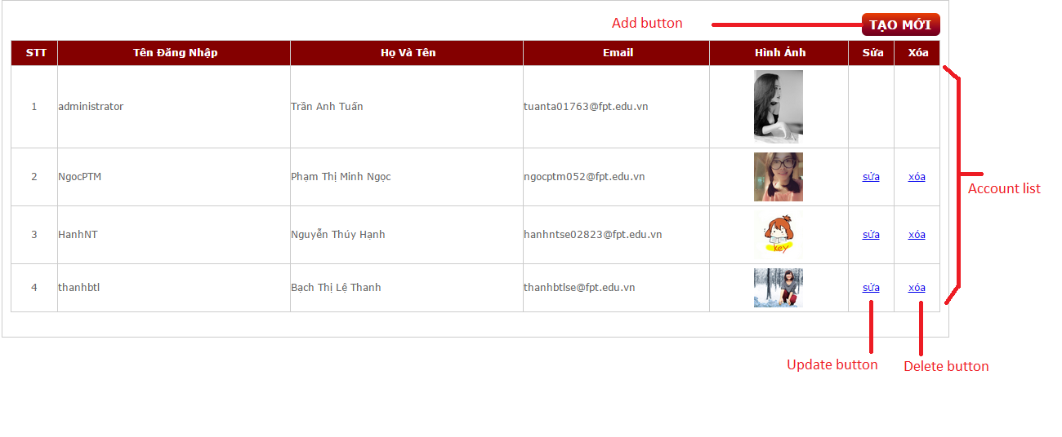

At the Account Management Screen, we will see:

1. Add button: using for user to add a new account
2. Account list: is the list of the add accounts
3. Update button: using for user to update the corresponding to an account
4. Delete button: using for user to delete the corresponding to an account

#### Add New Account Screen

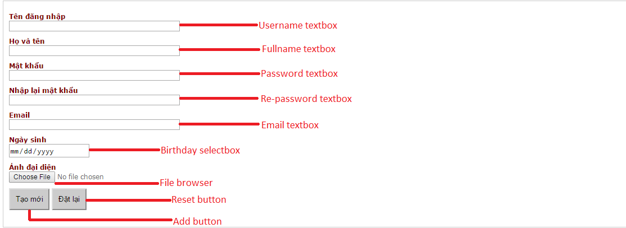

At the Add New Account Screen, we will see:

1. Username textbox: using for user to enter the username of the new account
2. Full name textbox: using for user to enter the full name of the new account
3. Password textbox: using for user to enter the password of the new account
4. Re-password textbox: using for user to re-enter the password of the new account
5. Birthday selectbox: using for user to select the birthday
6. File browser: using for user to browse the needed picture
7. Add button: using for user to add new account
8. Reset button: using for user to clear every textbox

#### Update Account Screen

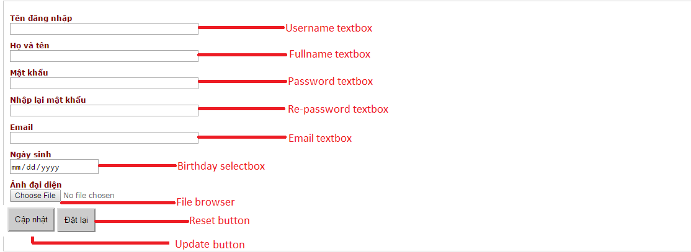

At the Update Account Screen, we will see:

1. Username textbox: using for user to enter the username of the account
2. Full name textbox: using for user to enter the full name of the account
3. Password textbox: using for user to enter the password of the account
4. Re-password textbox: using for user to re-enter the password of the account
5. Birthday selectbox: using for user to select the birthday
6. File browser: using for user to browse the needed picture
7. Update button: using for user to update the account
8. Reset button: using for user to clear every textbox

# Conclusion

This was the first time all team members have created an absolutely new software and executed it in specific developed process. That’s why we could not avoid mistakes or lack of experiences. However, we managed to end this capstone project completely. By the aspect of technique, we appreciated all development tools, integrated development Environment of iOS. On the other hand, this project gave us an opportunity to improve team work skill, communication, organization skill, planning skill and also earn some experiences about new operating system. All skill which people has just studied at school, now we have a chance to practice in reality. Especially we are learned about FPT Software process that helps us have a basic knowledge before working later. Due to the time of achieving project, we realized the more interesting of chemistry and the understanding deeply about this field. Lots of people thought that chemistry is hard to study and helpless. Actually, chemistry is much closed to life. People can do some experiments based on the chemical reactions. Our application provides necessary information and news which surely makes people change their mind.

## Future works

There are many factors lead us to limit the scope of project. So, we planned a future develop. Firstly, we not only balance the chemical reactions but also show how to balance step by step. This helps student more understand a way to deal with a chemical reaction. At the present, we just balance the reactions by the law of conservation of mass. Thus, we want to use the law of conservation of electron. Thirdly, our application can give information about both organic and inorganic compound and deal with its reactions. Finally, English and Japanese are also supported. We hope all people from all around the world can find that chemistry is interesting like our feeling and get higher achieve about chemistry.

# Appendixes

This session is only some sample meeting minutes, progress report, Q&A and database. Check out the attached CD for more information.



## Meeting minutes

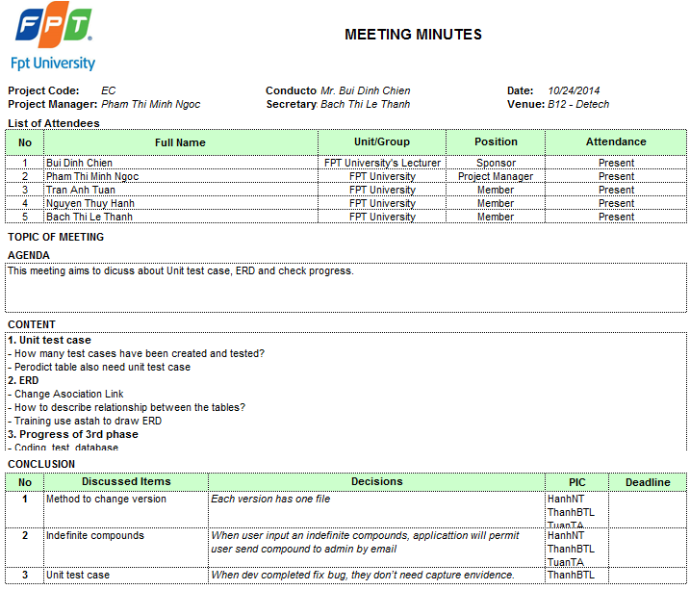

Figure : Meeting minutes English version sample

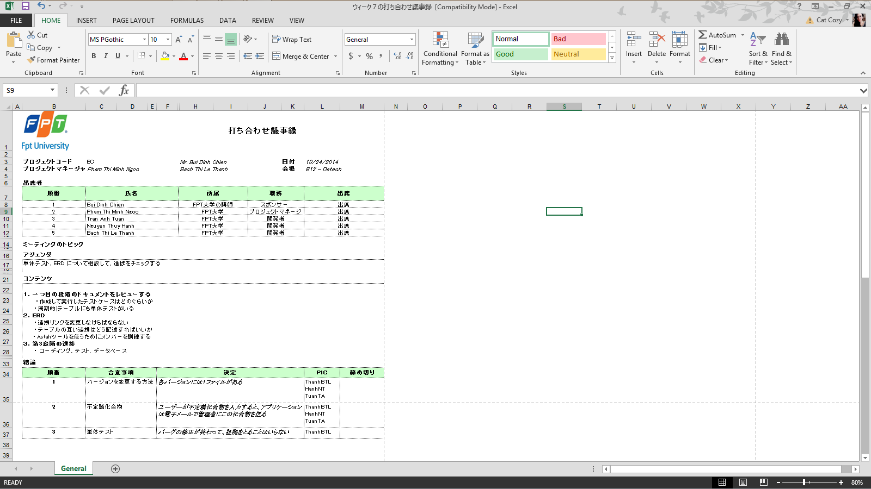

Figure : Meeting minutes Japanese version sample

## Progress Report

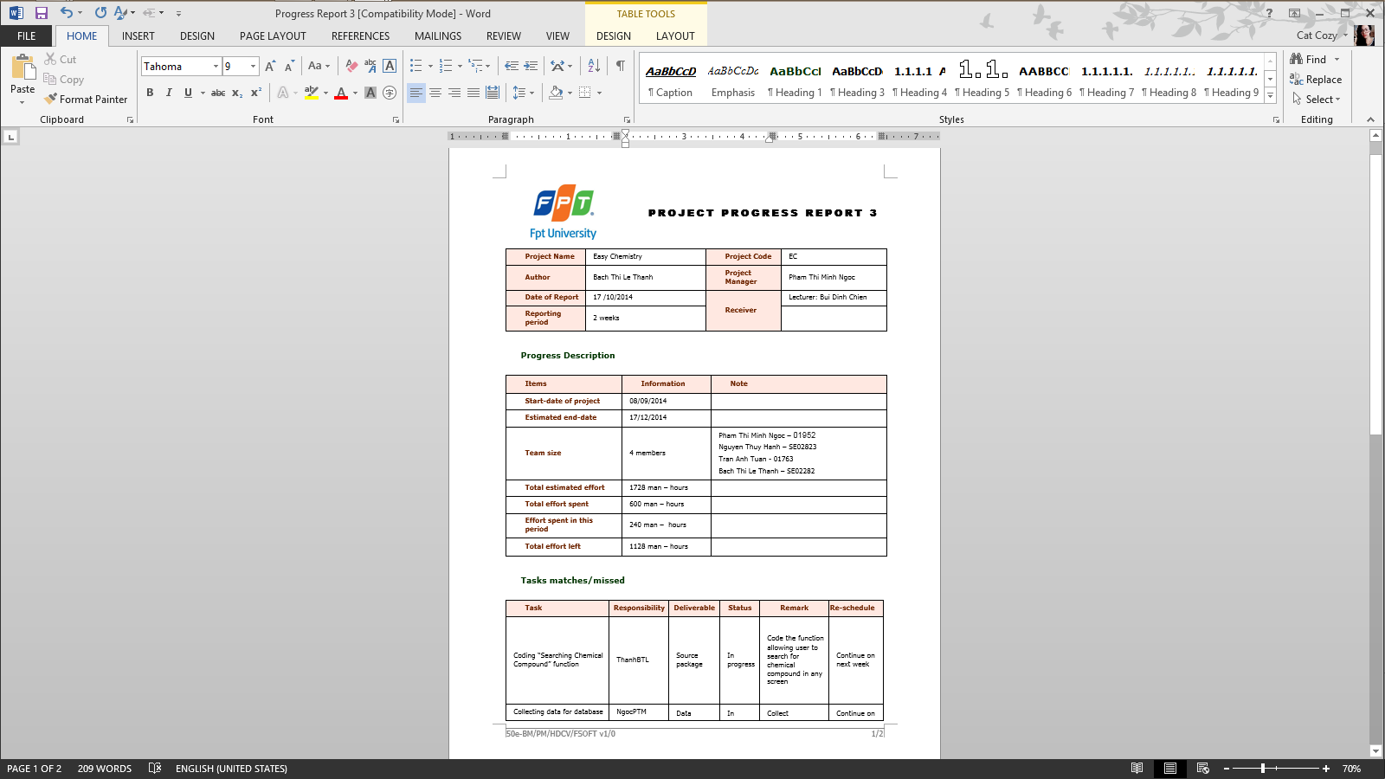

Figure : Progress Report English version sample

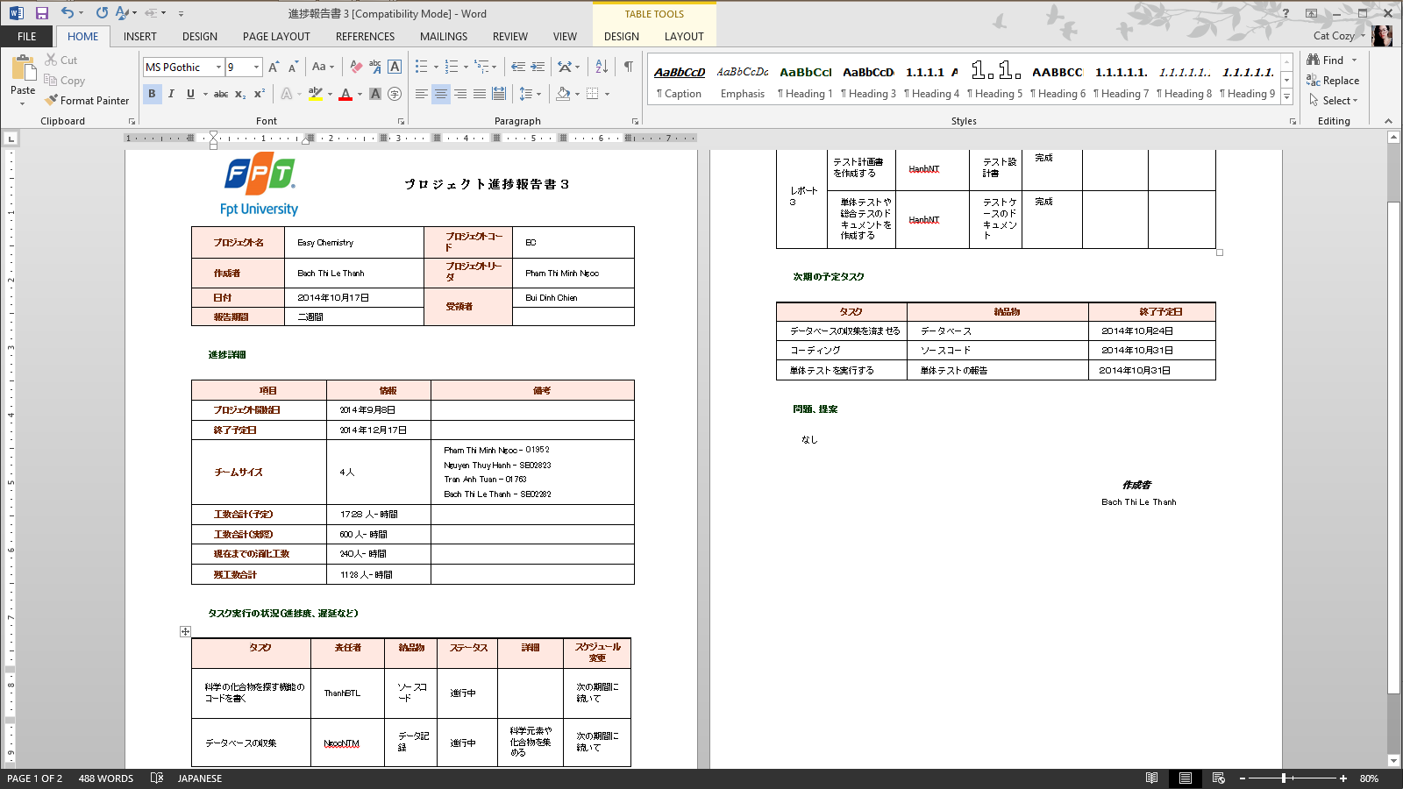

Figure : Progress Report Japanese version sample

## Q&A

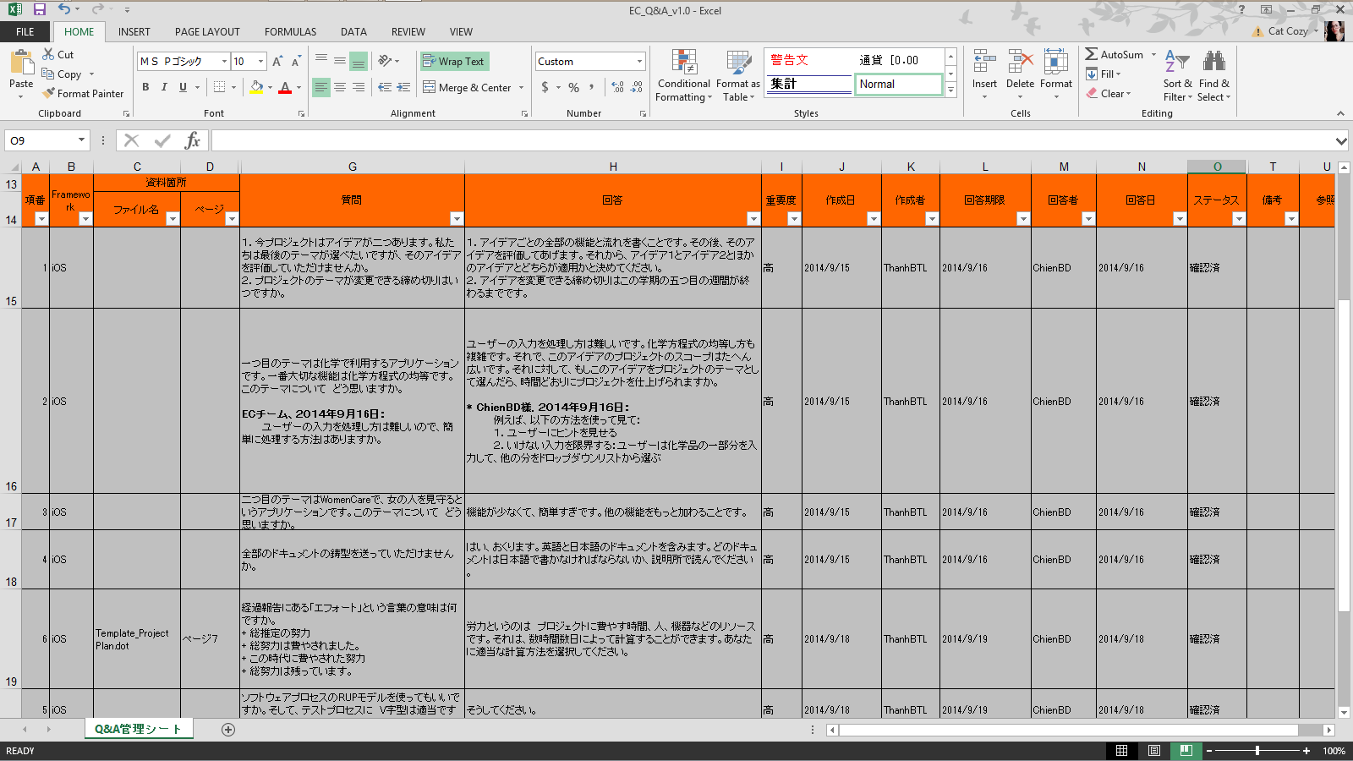

Figure : Q&A sample

## Database

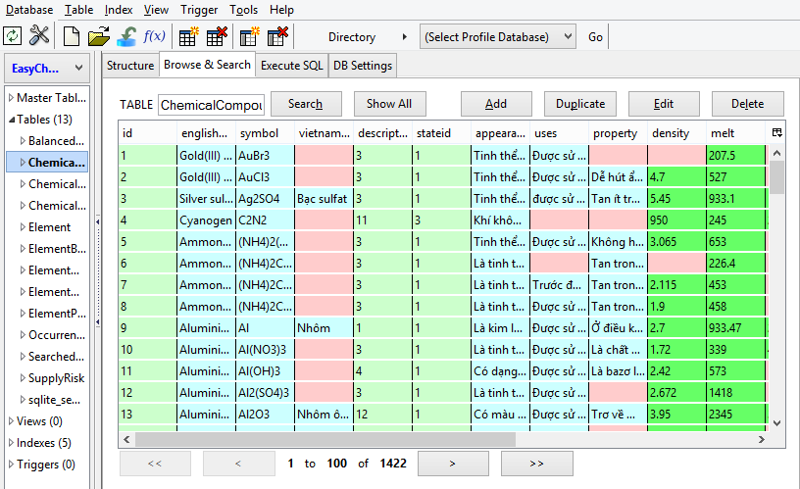

Figure : Database sample

# Reference

|  |  |
| --- | --- |
| No | Reference |
| 1 | Easy Chemistry Project |
| 2 | FSoft Template |
| 3 | The Royal Society of Chemistry: http://www.rsc.com |
| 4 | About Education: http://chemistry.about.com/ |
| 5 | Chemistry textbook from grade 8 to 12 |
| 6 | Advance Study Guide Chemistry (eBook) |